MINISTRY OF HEALTH OF UKRAINE
I. HORBACHEVSKY TERNOPIL NATIONAL MEDICAL UNIVERSITY OF THE MINISTRY OF HEALTH OF UKRAINE

Manuscript copyright
UDC

IRINA RICHTER

Master's Thesis

PSYCHO-EMOTIONAL BURNOUT AMONG INTENSIVE CARE UNIT NURSES AND STRATEGIES FOR ITS PREVENTION

Master of Science in Nursing

The Scientific Supervisor
of the Thesis:
Oksana Prokopchuk, PhD, MD,
Department of Higher Nursing Education,
Patients` Care and Clinical Immunology
- Horbachevsky Ternopil National Medical University
of the Ministry of Health of Ukraine

Ternopil – 2025
PSYCHO-EMOTIONAL BURNOUT AMONG INTENSIVE CARE UNIT NURSES AND STRATEGIES FOR ITS PREVENTION

The Scientific Supervisor: Oksana Prokopchuk, PhD, MD, Department of Higher Nursing Education, Patients` Care and Clinical Immunology I. Horbachevsky Ternopil National Medical University of the Ministry of Health of Ukraine

Abstract
This Master's thesis explores the phenomenon of psycho-emotional burnout among nurses working in intensive care units (ICUs) and investigates effective strategies for its prevention. The research is motivated by the increasing incidence of burnout among ICU nurses, which adversely impacts their mental health, job performance, and quality of patient care.
The objectives of the study are to:
- Analyze the prevalence and key causes of psycho-emotional burnout among ICU nurses;
- Critically review the current literature and theoretical models explaining burnout;
- Conduct primary research to assess the level of burnout among ICU nurses in a selected clinical setting;
- Identify personal, organizational, and systemic factors that contribute to burnout;
- Propose evidence-based strategies for the prevention and management of burnout in ICU environments.
The compound research questions formulated for the study are:
- What are the primary personal and organizational factors associated with psycho-emotional burnout among ICU nurses?
- How effective are existing interventions in preventing burnout in intensive care settings?
The methodology involves a mixed-methods approach, combining quantitative survey data (using the Maslach Burnout Inventory - MBI) and qualitative interviews to gain deeper insight into nurses' experiences and coping mechanisms. Secondary data sources include recent scholarly articles, clinical guidelines, and psychological theories on occupational stress and burnout.
The findings of the research reveal a high prevalence of burnout symptoms among ICU nurses, strongly associated with factors such as excessive workload, emotional exhaustion, lack of social support, and organizational inefficiencies. The study concludes with a set of evidence-based recommendations aimed at reducing burnout risks, including stress management training, staffing optimization, peer support programs, and leadership initiatives promoting workplace well-being.
The results of this research contribute to a deeper understanding of psycho-emotional burnout and offer practical strategies that can be adopted by healthcare institutions to improve the mental health and professional resilience of ICU nurses.
Keywords: burnout, intensive care unit, nurses, prevention strategies, occupational stress, psycho-emotional health, evidence-based practice.
CONTENTS
Title Page 1
Abstract 2
Table of Contents 3
List of Abbreviations 5
Introduction 6
Chapter 1. Theoretical Background on Psycho-emotional Burnout 8
1.1 Definition and Characteristics of Burnout 8
1.2 Models and Dimensions of Burnout 11
1.3 Risk Factors for Burnout in Nursing 13
1.4 Specific Features of Burnout in ICU Nurses 16
1.5 Effects of Burnout on Nurses and Patient Care 19
1.6 Summary of Literature Review 21
1.7 Summary and Theoretical Implications 23
Chapter 2. Analysis of Psycho-emotional Burnout in ICU Nurses 25
2.1 Research Setting and Participants 25
2.2 Research Instruments and Methodology 27
2.3 Survey Results and Data Analysis 31
2.4 Identification of Key Burnout Factors 34
2.5 Summary of Findings 33
Chapter 3. Strategies for Preventing Psycho-emotional Burnout 41
3.1 Organizational Interventions 41
3.2 Individual Coping Mechanisms 46
3.3 The Role of Leadership and Team Support 55
3.4 Barriers to Implementation of Burnout Prevention Strategies 56
Conclusions 59
Recommendations 62
References 51

List of Abbreviations
Abbreviation | Full Term
ICU | Intensive Care Unit
RN | Registered Nurse
MBI | Maslach Burnout Inventory
EE | Emotional Exhaustion
DP | Depersonalization
PA | Personal Accomplishment
WHO | World Health Organization
JD-R | Job Demands-Resources Model
COR | Conservation of Resources (Theory)
SPSS | Statistical Package for the Social Sciences
COVID-19 | Coronavirus Disease 2019
ANA | American Nurses Association
ICN | International Council of Nurses
PTSD | Post-Traumatic Stress Disorder
HR | Human Resources
EAP | Employee Assistance Program
ROI | Return on Investment

INTRODUCTION

The background of the study.
The modern healthcare system is increasingly marked by multifaceted stressors, particularly within high-pressure environments such as intensive care units (ICUs). Nurses working in ICUs are routinely exposed to highly demanding clinical situations, including urgent decision-making, patient deterioration, family distress, and the necessity to maintain optimal standards of care under time-sensitive conditions. These stress-inducing factors place ICU nurses at a significantly heightened risk of developing psycho-emotional burnout — a syndrome that is gaining prominence in global health research [1].
Psycho-emotional burnout is commonly described as a state of physical, emotional, and mental exhaustion resulting from prolonged exposure to intense workplace demands. According to the World Health Organization, burnout is now formally classified as an occupational phenomenon triggered by unmanaged chronic work-related stress [2]. Among nurses, the manifestation of burnout extends beyond individual well-being and significantly affects clinical outcomes, team dynamics, and the overall effectiveness of healthcare delivery systems [3]. In the context of ICUs, where patient acuity is high and emotional resilience is constantly tested, burnout becomes not only prevalent but also particularly severe, warranting urgent exploration and strategic mitigation.
The urgency of this study is grounded in the mounting evidence identifying burnout as a growing challenge across global healthcare systems. Research has demonstrated that high levels of burnout in ICU settings correlate with increased rates of medical errors, deteriorating patient safety, nurse absenteeism, and turnover [4]. Moreover, the COVID-19 pandemic dramatically intensified this issue by amplifying occupational pressures, exposing systemic gaps, and overburdening frontline staff [5]. These developments underline the need for effective, targeted interventions to preserve the mental and emotional integrity of ICU professionals.
This thesis is aimed at investigating psycho-emotional burnout in ICU nurses and identifying feasible, evidence-based strategies to prevent its onset and progression. The research objectives include the following:
- To critically analyze current theoretical models and scholarly literature related to burnout in healthcare contexts;
- To examine the prevalence and severity of burnout symptoms among ICU nurses within a selected clinical facility;
- To identify key organizational, psychological, and systemic factors that contribute to burnout development;
- To propose scientifically substantiated strategies for burnout prevention and management among ICU nursing staff.
The object of the research is the professional activity of intensive care nurses. The subject of the research is the psycho-emotional burnout experienced by ICU nurses and the relevant prevention strategies implemented within healthcare systems.
This study employs a mixed-methods research approach, integrating both qualitative and quantitative tools. A structured literature review provides a theoretical foundation, while empirical data is collected via a validated survey instrument — the Maslach Burnout Inventory (MBI) — and supplemented with insights derived from semi-structured interviews. This methodological triangulation ensures a holistic perspective, combining numerical trends with contextual experiences to uncover patterns, correlations, and possible solutions.
What distinguishes this research is its emphasis on operationalizing burnout prevention through actionable solutions that are contextually relevant to intensive care nursing. Although the phenomenon of burnout has been extensively described in literature, many existing studies fail to bridge the gap between theoretical discussion and practical application. This research addresses that gap by translating scholarly evidence into realistic, workplace-level interventions that can be implemented by nurse managers and institutional leaders.
The practical value of the study lies in its potential to inform administrative policies and frontline management practices. Strengthening nurse resilience, establishing supportive work environments, and optimizing workloads are not only beneficial for nurses themselves but also contribute to safer, more effective, and sustainable healthcare services. Preventing burnout may ultimately result in improved patient outcomes, increased nurse retention, and better organizational functioning.
Finally, this study is especially relevant in light of ongoing global challenges such as healthcare staffing shortages, population aging, and the lasting impact of health emergencies like the COVID-19 pandemic. By addressing burnout from both clinical and administrative perspectives, this thesis contributes to shaping a more compassionate and resilient healthcare culture.
In summary, this thesis seeks to enrich the field of nursing science by providing new insights into burnout within ICU settings and by proposing realistic strategies to mitigate its effects. Through theoretical exploration and empirical validation, the study supports the advancement of nurse well-being as an essential component of healthcare quality.
CHAPTER 1
REVIEW OF LITERATURE
THEORETICAL BACKGROUND ON PSYCHO-EMOTIONAL BURNOUT

1.1 Definition and Conceptualization of Burnout
Burnout is a complex psychological phenomenon that has garnered increasing attention within the fields of occupational health and behavioral sciences. The term “burnout” was first introduced by the American psychologist Herbert Freudenberger in 1974 to describe a state of mental and physical exhaustion observed in individuals working in helping professions, particularly healthcare workers [1]. He characterized it as a condition marked by fatigue, frustration, and a diminished sense of personal accomplishment resulting from prolonged exposure to work-related stressors.
Subsequently, one of the most influential and widely accepted definitions was proposed by Christina Maslach, whose work laid the foundation for the modern understanding of burnout. According to Maslach and Jackson, burnout is a psychological syndrome comprising three core dimensions: emotional exhaustion, depersonalization (or cynicism), and reduced personal accomplishment [2]. Emotional exhaustion refers to the depletion of emotional resources and a feeling of being emotionally overextended. Depersonalization manifests as a detached, impersonal attitude towards recipients of care, and reduced personal accomplishment reflects a decline in one’s perceived competence and success at work.
The World Health Organization (WHO) officially recognized burnout as an occupational phenomenon in the 11th Revision of the International Classification of Diseases (ICD-11), describing it as “a syndrome conceptualized as resulting from chronic workplace stress that has not been successfully managed” [3]. It is characterized by feelings of energy depletion or exhaustion, increased mental distance from one’s job, or feelings of negativism or cynicism related to one's job, and reduced professional efficacy. Importantly, the WHO emphasized that burnout is not classified as a medical condition, but rather a factor influencing health status and contact with health services.
Different theoretical models have been developed to explain the mechanisms and progression of burnout. The Job Demands-Resources (JD-R) model is one of the most prominent frameworks. It suggests that burnout arises when job demands exceed the available resources to meet them, leading to emotional exhaustion and disengagement [4]. High workload, emotional strain, and time pressure are seen as demands, while social support, autonomy, and recognition are viewed as key resources. Another model, the Conservation of Resources (COR) theory, posits that individuals strive to retain, protect, and build resources, and burnout occurs when these resources are threatened or lost without adequate replenishment [5].
Burnout is commonly observed in high-stress environments where individuals are expected to perform under emotionally intense or ethically complex circumstances, such as intensive care units. In such contexts, repeated exposure to suffering, death, and unpredictable patient outcomes intensifies the psychological burden and contributes to a gradual erosion of emotional resilience [6].
The conceptualization of burnout continues to evolve, particularly in the context of global challenges like the COVID-19 pandemic, which has placed unprecedented strain on healthcare professionals. As such, burnout is increasingly viewed not only as an individual failure to cope but as a systemic issue demanding organizational and structural interventions.
In summary, burnout is a multifactorial syndrome with emotional, cognitive, and behavioral components. It is essential to understand its conceptual basis to develop accurate diagnostic tools and targeted prevention strategies, particularly for ICU nurses who operate at the front lines of complex and emotionally charged healthcare delivery.

1.2 Models and Dimensions of Burnout
The multidimensional nature of burnout has inspired the development of several theoretical models that attempt to explain its mechanisms, progression, and consequences. These models serve as valuable tools for both clinical understanding and the design of effective prevention and intervention strategies. The most prominent among them include the Maslach Burnout Model, the Job Demands-Resources (JD-R) Model, and the Conservation of Resources (COR) Theory.

The Maslach Burnout Model
Christina Maslach’s model, one of the earliest and most influential frameworks, conceptualizes burnout as a psychological syndrome composed of three interrelated dimensions: emotional exhaustion, depersonalization, and reduced personal accomplishment [1]. Emotional exhaustion reflects a depletion of emotional and physical energy, often leading individuals to feel overextended and drained by their work. Depersonalization refers to a detached, cynical, or even dehumanizing attitude toward patients or clients, while reduced personal accomplishment involves feelings of inefficacy and a decline in job performance and self-worth.
Maslach's model has become the foundation for the Maslach Burnout Inventory (MBI), the most widely used instrument for assessing burnout in health professionals. The tripartite structure of the model has been validated across various occupational groups, especially in the field of nursing and critical care [2].

The Job Demands-Resources (JD-R) Model
Developed by Demerouti et al., the JD-R model offers a broader, more flexible perspective that can be applied to a wide range of work environments [3]. According to this model, burnout arises from a chronic imbalance between job demands and job resources. Job demands refer to physical, emotional, or psychological efforts required by a role — such as workload, time pressure, and emotionally charged interactions. Job resources, on the other hand, include factors like social support, autonomy, feedback, and opportunities for development.
The JD-R model posits two main psychological processes: the health impairment process, whereby excessive demands exhaust employees' mental and physical resources leading to burnout, and the motivational process, where sufficient job resources buffer the negative effects and enhance engagement. This model emphasizes the importance of organizational responsibility in reducing job demands and enhancing resources, particularly relevant for ICU nurses who often face high workloads and limited support.

The Conservation of Resources (COR) Theory
Another influential approach is the Conservation of Resources (COR) Theory, proposed by Hobfoll [4]. COR theory suggests that individuals strive to obtain, retain, and protect their personal, social, and material resources. Burnout occurs when there is a perceived or actual threat of resource loss, actual resource depletion, or insufficient return on invested resources. In the context of nursing, resources can include emotional energy, time, social support, recognition, and physical stamina.
COR theory underscores that burnout is not merely a reaction to high demands but also to the loss of coping resources. It also highlights the cumulative nature of stress — once resource loss begins, individuals are more vulnerable to further loss, potentially leading to a downward spiral of exhaustion and disengagement [5].

Additional Perspectives
Some researchers have expanded upon these core models to account for contextual and personal factors, including personality traits, emotional intelligence, and coping styles [6]. For example, individuals with high neuroticism or low resilience may be more susceptible to burnout, while those with strong social networks and adaptive coping strategies are more resistant. Moreover, cultural and institutional contexts — such as hierarchical structures, role ambiguity, and ethical climate — play a crucial role in shaping burnout risk and manifestation.

Dimensions of Burnout Across Models
Despite differences in theoretical orientation, most models converge on certain core dimensions of burnout:
- Emotional exhaustion as the foundational and most universal element;
- Cynicism or depersonalization, particularly prevalent in client- or patient-facing roles;
- Reduced self-efficacy or personal accomplishment, often exacerbated by a lack of feedback or recognition.
Understanding these dimensions is essential for designing assessment tools and interventions that target specific aspects of burnout rather than treating it as a monolithic condition.
In conclusion, the integration of multiple theoretical models provides a more comprehensive understanding of burnout and its development. Each model highlights different but complementary aspects of the phenomenon, reinforcing the idea that burnout is multifactorial in origin and requires a multi-level approach for effective prevention and management.

1.3 Risk Factors for Burnout in Nursing
Nursing is a profession inherently associated with emotional labor, high responsibility, and constant interaction with patients experiencing pain, distress, or life-threatening conditions. These factors, when compounded over time, significantly elevate the risk of psycho-emotional burnout. Research has identified a multitude of interrelated personal, professional, and organizational factors that contribute to the development and intensification of burnout among nurses [1].

Personal Risk Factors
Individual characteristics and personal circumstances play a significant role in burnout vulnerability. Nurses with certain personality traits — such as high neuroticism, low emotional stability, or perfectionism — are more prone to emotional exhaustion and reduced coping capacity [2]. Furthermore, insufficient recovery time, lack of physical activity, and sleep disturbances can exacerbate emotional strain. Nurses who lack adaptive coping strategies or who have limited support networks outside of work are also at increased risk [3].
Age and experience level can influence burnout susceptibility. Novice nurses may experience greater stress due to a lack of clinical confidence, while more experienced nurses may face cumulative fatigue or professional stagnation [4]. Additionally, female nurses — who comprise the majority of the nursing workforce — may face unique challenges related to work–life balance, caregiving responsibilities at home, and emotional overload, increasing their risk of burnout [5].

Professional and Occupational Risk Factors
Several work-related conditions in nursing contribute directly to burnout. One of the most commonly cited factors is workload. Nurses, particularly in intensive care units, often work long hours under intense time pressure, manage multiple critically ill patients simultaneously, and must respond rapidly to emergencies [6]. Staffing shortages, mandatory overtime, and shift rotations, especially night shifts, are strongly associated with fatigue, sleep disruption, and emotional exhaustion.
Another major factor is emotional labor — the requirement to manage one’s emotions to meet professional expectations, especially in the face of suffering, death, or family grief. Repeated exposure to trauma without adequate psychological support leads to compassion fatigue and depersonalization [7].
Role ambiguity and lack of control over one’s work also contribute to burnout. Nurses who feel undervalued, excluded from decision-making, or unclear about their responsibilities often experience a loss of autonomy and motivation. Moreover, the absence of constructive feedback or recognition can lead to decreased job satisfaction and reduced sense of professional accomplishment [8].

Organizational and Systemic Risk Factors
At the institutional level, organizational culture and leadership practices significantly affect the psychological health of nursing staff. Work environments characterized by poor communication, lack of support from management, and insufficient resources to perform tasks safely and effectively are strongly linked to higher burnout rates [9]. In contrast, supportive leadership, fair workload distribution, and participatory decision-making processes are known protective factors.
Furthermore, hierarchical structures within hospitals may reinforce stress, especially when nurses feel disempowered or micromanaged. Bureaucratic barriers and constant administrative demands, such as extensive documentation, divert time and attention from direct patient care, contributing to frustration and inefficiency [10].
The COVID-19 pandemic further revealed systemic weaknesses, including inadequate protective equipment, delayed staffing reinforcements, and inconsistent communication, all of which intensified burnout among frontline nurses worldwide. Many nurses reported moral distress due to difficult triage decisions or witnessing preventable deaths under crisis conditions [11].

Intersection and Accumulation of Risks
Burnout rarely arises from a single factor but is usually the result of multiple interacting stressors over time. The accumulation of physical, emotional, and cognitive demands — especially in the absence of adequate recovery — leads to the gradual erosion of well-being and resilience. This dynamic highlights the importance of early identification and multi-level interventions to address burnout before it progresses into chronic distress or clinical mental health disorders.
In summary, recognizing the diverse and interconnected nature of burnout risk factors is crucial for developing effective prevention and support systems in nursing practice. Tailored interventions that consider individual vulnerability, job demands, and institutional context are essential to sustaining nurse well-being and the quality of care.

1.4 Specific Burnout Characteristics in ICU Settings
Intensive care units (ICUs) represent one of the most demanding and emotionally charged environments in modern healthcare. Nurses working in these settings are continually exposed to high-stakes decision-making, complex patient conditions, and frequent contact with death and critical illness. These unique stressors make ICU nurses particularly vulnerable to psycho-emotional burnout and shape the syndrome in ways that differ from other nursing specialties [1].

High-Acuity Patients and Constant Vigilance
ICU nurses care for critically ill patients who require continuous monitoring and immediate intervention. These patients often experience rapid clinical deterioration, necessitating quick thinking, high-level clinical skills, and seamless collaboration with multidisciplinary teams. The need for constant vigilance and the fear of making a life-threatening error significantly contribute to chronic stress and emotional exhaustion [2].
The technological intensity of ICUs also demands a high cognitive load. Nurses must manage advanced life-support equipment, administer high-risk medications, and interpret complex diagnostic data, often while working under time pressure. The mental burden associated with multitasking in such an environment can lead to cognitive fatigue, reduced performance, and emotional detachment [3].

Emotional Labor and Exposure to Death
Unlike other hospital departments, ICUs have a higher frequency of patient deaths and ethical dilemmas. Nurses must regularly manage end-of-life care, deliver bad news, and support grieving families, often without the benefit of formal psychological training or structured debriefing [4]. The cumulative exposure to human suffering and mortality can result in compassion fatigue, moral distress, and eventually, burnout.
In particular, moral distress — defined as the psychological discomfort that arises when one is constrained from acting according to ethical beliefs — is common among ICU nurses. Examples include following protocols that conflict with one’s sense of patient dignity or participating in aggressive interventions that prolong suffering [5]. These experiences are emotionally taxing and erode nurses’ sense of professional purpose and fulfillment.

Shift Work, Sleep Disruption, and Physical Fatigue
ICU nurses often work rotating shifts, including night shifts, which disrupt circadian rhythms and impair sleep quality. Research has shown that irregular sleep patterns are strongly associated with burnout symptoms, especially emotional exhaustion and irritability [6]. In addition, physical fatigue caused by long hours, insufficient breaks, and high patient loads further compromises both physical and psychological well-being.
Sleep deprivation negatively affects cognitive functioning, emotional regulation, and interpersonal communication — all of which are essential in high-pressure clinical environments. Over time, chronic fatigue diminishes resilience and may contribute to errors in patient care, further exacerbating stress levels [7].

Isolation and Team Dynamics
Although ICUs operate as interprofessional environments, nurses may still experience social and professional isolation. Tensions between physicians and nurses, or poor communication within teams, can intensify stress. In hierarchical healthcare settings, nurses may feel that their voices are undervalued in decision-making processes, contributing to feelings of powerlessness and frustration [8].
A lack of peer support, insufficient debriefing opportunities, or toxic workplace culture can make ICU nurses feel emotionally unsupported. On the other hand, strong teamwork, recognition, and collegial trust are known protective factors that can mitigate burnout risk [9].

Impact of the COVID-19 Pandemic
The COVID-19 pandemic highlighted and intensified the burnout crisis in ICUs globally. Many ICU nurses were forced to work under extreme conditions: insufficient protective equipment, overwhelming patient volumes, and the trauma of witnessing mass suffering and death. A significant number of ICU staff reported experiencing symptoms of post-traumatic stress disorder (PTSD), anxiety, and depression as a direct result of pandemic-related working conditions [10].
The combination of professional exhaustion, fear of infection, and limited resources created a “perfect storm” for burnout in ICU environments. These experiences have reinforced the urgent need for institutional support systems and long-term strategies to protect ICU staff from future psychological harm.

Conclusion
ICU nursing is uniquely positioned at the intersection of technical complexity and emotional intensity. The specific features of ICU work — including constant vigilance, exposure to ethical dilemmas, irregular shifts, and intense emotional labor — amplify the risk and impact of burnout. Acknowledging these unique characteristics is essential for designing targeted interventions that address the particular vulnerabilities of ICU nurses and promote sustainable, resilient nursing practice.

1.5 Effects of Burnout on Nurses and Healthcare Outcomes
Psycho-emotional burnout has far-reaching consequences that extend beyond the individual nurse to affect the entire healthcare system. It impairs cognitive, emotional, and physical functioning, ultimately compromising the quality of patient care, team performance, and institutional sustainability. Understanding the consequences of burnout is essential to justify the urgency of preventive interventions and allocate resources accordingly [1].

Effects on Nurses’ Mental and Physical Health
Burnout is closely associated with a range of mental health challenges, including depression, anxiety, sleep disorders, and emotional dysregulation [2]. Nurses experiencing chronic emotional exhaustion often report feelings of helplessness, detachment, and low self-worth. These symptoms, if left unaddressed, may escalate into clinical mental illnesses or result in substance abuse and suicidal ideation [3].
From a physiological standpoint, burnout is linked to stress-induced dysregulation of the hypothalamic–pituitary–adrenal (HPA) axis, which increases susceptibility to cardiovascular conditions, gastrointestinal disturbances, chronic fatigue, and immune system suppression [4]. Nurses suffering from burnout are more likely to take medical leave, experience absenteeism, or exit the profession entirely, leading to higher turnover and loss of skilled staff.

Effects on Patient Care and Safety
Perhaps most critically, burnout negatively impacts the safety and quality of care delivered to patients. Studies have shown that emotionally exhausted nurses are more prone to medication errors, missed care, and impaired clinical judgment [5]. A lack of emotional engagement or motivation can reduce vigilance and responsiveness, particularly in high-acuity settings like intensive care units.
Moreover, depersonalization — a key component of burnout — may manifest as cold, distant, or indifferent attitudes toward patients and families. This diminishes the therapeutic relationship and undermines trust, empathy, and communication, all of which are essential for holistic, patient-centered care [6].
Burnout has also been linked to higher rates of healthcare-associated infections, delays in treatment, and longer patient hospital stays, suggesting systemic ramifications that extend beyond the nurse–patient interaction [7].

Effects on Team Functioning and Organizational Performance
The impact of burnout is not confined to individual performance; it also disrupts team cohesion and overall organizational climate. Burned-out nurses may exhibit irritability, withdrawal, or disengagement from team interactions, reducing collaboration, communication, and morale among colleagues [8].
This interpersonal tension can lead to workplace conflict, mistrust, and a breakdown in interprofessional collaboration — a vital component of safe and effective ICU functioning. Furthermore, organizations with high burnout rates tend to experience lower job satisfaction, reduced productivity, and higher turnover, all of which contribute to staffing instability and increased recruitment costs [9].
Leadership is also affected: managers who are themselves burned out may fail to recognize distress in their teams or lack the energy to implement support measures. This can create a self-perpetuating cycle in which burnout at all organizational levels becomes normalized, further deepening the problem.

Long-Term Systemic Implications
In the long term, burnout contributes to the erosion of professional identity and the dehumanization of healthcare. The cumulative loss of experienced personnel, declining care standards, and increased patient dissatisfaction can damage institutional reputations and trust in the healthcare system [10].
Healthcare systems already burdened by staff shortages, financial constraints, and rising demand cannot afford the additional strain caused by preventable burnout. Therefore, addressing burnout is not only a matter of individual well-being but a strategic imperative for healthcare system resilience and quality assurance.

Conclusion
Burnout in nursing, particularly within intensive care settings, has cascading effects that undermine personal health, patient safety, team dynamics, and organizational performance. Its impact is multidimensional and cumulative, often progressing silently until it reaches crisis levels. Recognizing these consequences is a vital step toward prioritizing burnout prevention as a central component of healthcare policy and practice.

1.6 Summary of Literature Review
The literature review conducted in this chapter provides a comprehensive theoretical foundation for understanding psycho-emotional burnout among nurses, with a specific focus on those working in intensive care units (ICUs). The analysis confirms that burnout is a multidimensional phenomenon that includes emotional exhaustion, depersonalization, and a reduced sense of personal accomplishment. It is strongly associated with prolonged exposure to work-related stressors, particularly in emotionally demanding clinical settings.
Several influential models have been reviewed, including the Maslach Burnout Model, the Job Demands-Resources (JD-R) model, and the Conservation of Resources (COR) theory. These frameworks offer valuable insights into the mechanisms of burnout development and highlight the importance of both job demands and available resources in shaping individual vulnerability. The theoretical models also emphasize that burnout is not merely the result of personal failure to cope but often reflects deeper systemic issues within healthcare organizations.
Risk factors for burnout in nursing were classified into personal, professional, and organizational domains. Personal characteristics such as low resilience, poor sleep quality, or lack of social support increase susceptibility to emotional exhaustion. Occupational conditions — including heavy workloads, shift work, role ambiguity, and emotional labor — are prominent triggers. Organizational factors, such as unsupportive leadership, limited autonomy, and poor communication, further amplify burnout risks.
The ICU context introduces unique stressors that intensify burnout symptoms. Nurses in these settings operate under constant pressure, engage with life-threatening conditions, and face frequent exposure to ethical dilemmas and patient mortality. The COVID-19 pandemic further escalated these challenges, placing unprecedented psychological strain on ICU staff worldwide.
Finally, the consequences of burnout are far-reaching and multidimensional. They include not only detrimental effects on nurses' mental and physical health, but also reduced quality of patient care, increased clinical errors, impaired teamwork, and higher organizational costs due to turnover and absenteeism. These findings underscore the urgency of addressing burnout at both the individual and institutional levels.
This literature review reveals a clear gap between theoretical knowledge and practical implementation of burnout prevention strategies, particularly within ICU environments. Although numerous studies have identified contributing factors and potential interventions, few have translated these insights into actionable frameworks within real-world clinical settings.
Therefore, the following chapters of this thesis aim to bridge this gap by presenting original research on burnout prevalence among ICU nurses, exploring associated factors, and proposing targeted, evidence-based strategies for prevention and intervention. This practical focus will enhance the theoretical understanding of burnout and contribute to improved support systems in intensive care nursing practice.
1.7 Summary and Theoretical Implications
The review of theoretical perspectives on psycho-emotional burnout among nurses has highlighted the multidimensional nature of this phenomenon, encompassing emotional exhaustion, depersonalization, and reduced personal accomplishment. The literature indicates that burnout is not a singular event but a cumulative process resulting from prolonged exposure to occupational stressors without adequate coping mechanisms or organizational support.
Multiple conceptual frameworks — such as the Maslach Burnout Model, the Job Demands-Resources (JD-R) Model, and the Conservation of Resources (COR) Theory — emphasize the interaction between individual vulnerability and external demands. These models collectively underline the necessity of systemic and contextual analysis when addressing burnout in healthcare settings.
Research consistently shows that ICU nurses are disproportionately affected by burnout due to the nature of their work environment: continuous high-stakes decision-making, emotional labor, frequent exposure to suffering and death, and pressure to maintain clinical excellence. Literature findings support that high workload, ethical dilemmas, poor leadership, lack of team cohesion, and insufficient institutional resources are major risk factors for burnout development.
The theoretical frameworks also suggest that burnout is not irreversible. Interventions such as improving team communication, strengthening leadership, and providing access to mental health resources can reduce its severity and prevalence. Moreover, literature increasingly calls for a shift from individual-centered interventions to broader organizational change, including resilience-promoting environments and participatory management.
This theoretical synthesis served as the foundation for the empirical research conducted in this thesis. It informed the selection of the Maslach Burnout Inventory as a measurement tool and guided the interpretation of findings. The literature also provided a comparative lens through which the specific experiences of ICU nurses in the selected hospital could be analyzed.
In summary, the reviewed theories and prior studies confirm the urgency and complexity of addressing nurse burnout. They justify the necessity of a comprehensive, evidence-based, and context-sensitive approach — the very direction taken in the present research.

CHAPTER 2
THE OBJECT OF RESEARCH AND METHODS OF STUDY
ANALYSIS OF PSYCHO-EMOTIONAL BURNOUT IN ICU NURSES

2.1 Research Setting and Participants
This study was conducted in a regional tertiary-care hospital located in New York City, USA, featuring a well-established intensive care unit (ICU) with a multidisciplinary clinical team. The ICU comprises 12 beds and operates around the clock, providing care to critically ill patients with a range of acute conditions, including post-operative complications, sepsis, multi-organ failure, respiratory distress, and cardiovascular emergencies. The unit is staffed by a team of intensivists, nurses, respiratory therapists, and support staff, ensuring a high standard of care and patient monitoring.
The primary focus of this research was the nursing staff working within the ICU. Given the complexity of their roles and the intense psychological demands of their daily routines, this population was considered highly relevant for investigating psycho-emotional burnout. A non-random purposive sampling technique was used to select participants who met the inclusion criteria.

Inclusion Criteria:
- Registered nurses employed in the ICU for a minimum of 6 months;
- Full-time employees (at least 36 working hours per week);
- Direct involvement in patient care activities;
- Voluntary informed consent to participate in the study.

Exclusion Criteria:
- Administrative nursing staff with no direct patient care responsibilities;
- Nurses on extended leave (e.g., medical or maternity);
- Contract staff with irregular or part-time shifts.
A total of 32 ICU nurses were invited to participate in the study. Of these, 29 nurses completed the full survey and were included in the final analysis, resulting in a response rate of 90.6%. The sample included both male and female nurses, with ages ranging from 24 to 58 years (mean age = 39.4 years). Professional experience in intensive care ranged from 1 to 25 years, with an average of 11.2 years.
The demographic breakdown of participants is as follows:
- Gender: 25 female (86%), 4 male (14%);
- Age groups: 24–34 years (28%), 35–44 years (41%), 45+ years (31%);
- Experience in ICU: 1–5 years (24%), 6–15 years (45%), over 15 years (31%).
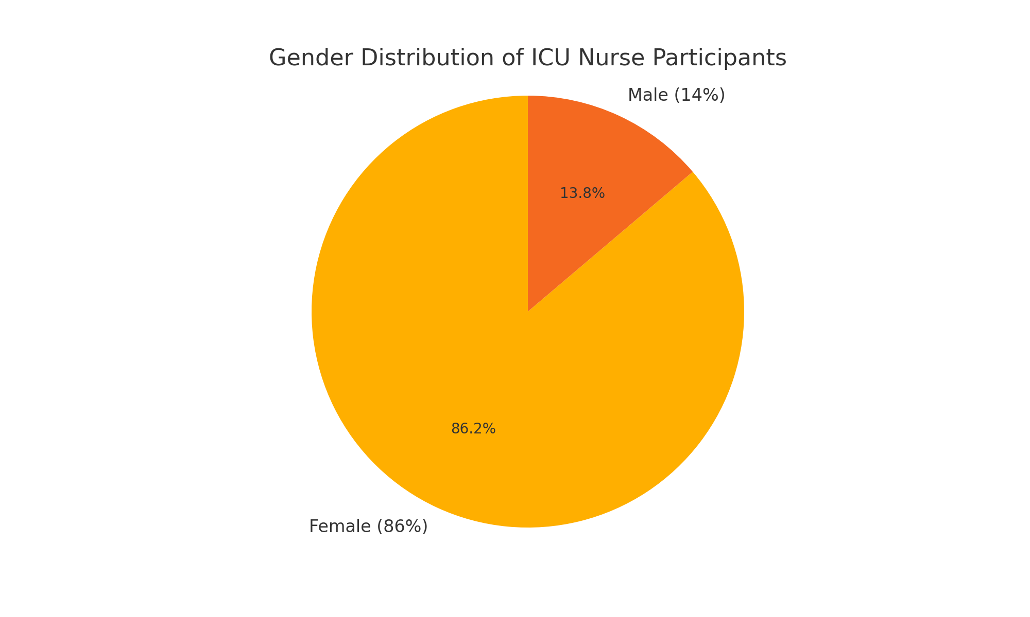Figure 2.1 Gender Distribution of ICU Nurse Participants
All participants were informed about the purpose of the research and the voluntary nature of their involvement. Confidentiality and anonymity were guaranteed, and ethical approval for the study was obtained from the institutional review board of the hospital prior to data collection.
This demographic composition allowed for a meaningful exploration of burnout prevalence and patterns within a diverse and experienced ICU nursing cohort, offering insights applicable to similar clinical environments.

2.2 Research Instruments and Methodology
This study adopted a mixed-methods design, integrating both quantitative and qualitative approaches to gain a comprehensive view of psycho-emotional burnout among ICU nurses. The mixed-methods approach was chosen to not only measure burnout levels numerically but also to contextualize those findings through the personal experiences and reflections of the nurses themselves. Such a methodological triangulation enhances the validity and depth of the research outcomes.

Quantitative Instrument: Maslach Burnout Inventory – Human Services Survey (MBI-HSS)
The primary tool for quantitative measurement was the Maslach Burnout Inventory – Human Services Survey (MBI-HSS), which is widely regarded as the gold standard for assessing occupational burnout in healthcare professionals. Developed by Christina Maslach and Susan Jackson, this inventory is specifically tailored for use in professions that involve direct human service and caregiving relationships, such as nursing, social work, and counseling [1].
The MBI-HSS consists of 22 items grouped into three subscales:
- Emotional Exhaustion (EE) – 9 items measuring feelings of being emotionally overextended and exhausted by one’s work.
- Depersonalization (DP) – 5 items assessing an unfeeling and impersonal response toward recipients of one's care or service.
- Personal Accomplishment (PA) – 8 items evaluating feelings of competence and successful achievement in one's work with people.
Each item is rated on a 7-point Likert scale, ranging from 0 (“never”) to 6 (“every day”). A higher score on EE and DP combined with a lower score on PA indicates a higher level of burnout.
Examples of MBI questions include:
- “I feel emotionally drained from my work.” (EE)
- “I feel I treat some recipients as if they were impersonal objects.” (DP)
- “I feel I’m positively influencing other people’s lives through my work.” (PA)
The MBI has demonstrated high internal consistency, with Cronbach’s alpha coefficients typically exceeding 0.80 for each subscale in nursing populations [2]. The tool has been validated in various languages and healthcare contexts, including ICU settings, making it a reliable instrument for this study.

Demographic and Occupational Questionnaire
To supplement the MBI, a structured demographic form was created to gather participant characteristics, including:
- Age
- Gender
- Years of total nursing experience
- Years of ICU experience
- Type of shift (day, night, rotating)
- Number of weekly working hours
- Self-rated organizational support (on a 5-point Likert scale)
This contextual data enabled comparative analysis between subgroups and provided insights into how specific occupational and personal variables relate to burnout levels.
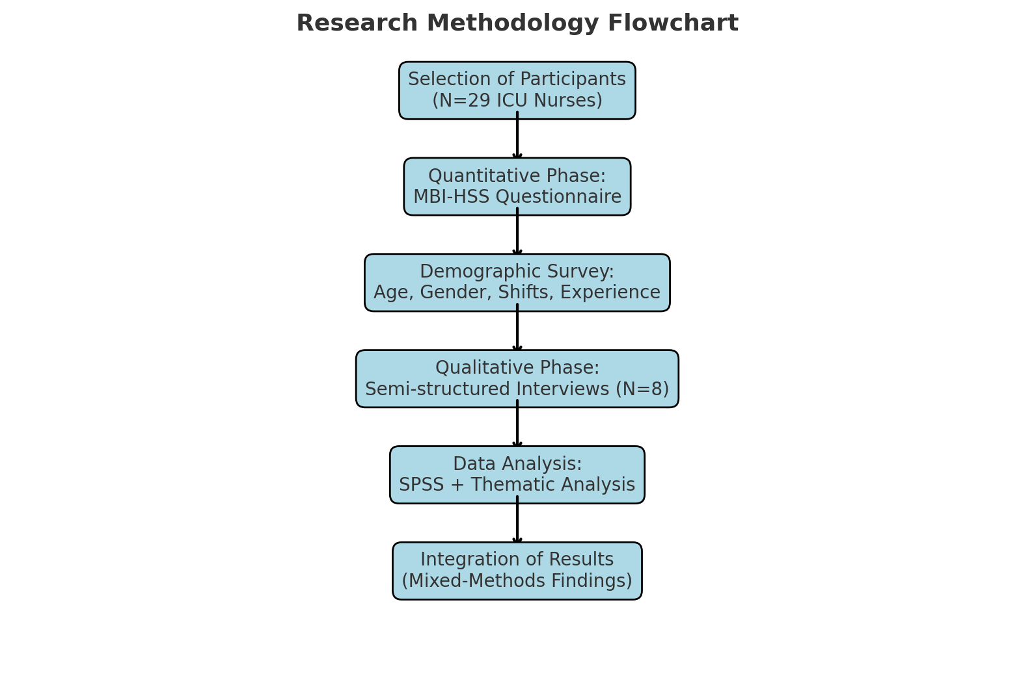
Figure 2.2 – Research Instruments and Methodology

Qualitative Component: Semi-Structured Interviews
To explore the lived experiences behind the statistical patterns, semi-structured interviews were conducted with 8 nurses selected via purposive sampling. The interviews lasted between 30 and 45 minutes and were audio-recorded with informed consent. They took place in a quiet office space within the hospital during scheduled break periods.
The interview protocol included open-ended questions such as:
- “Can you describe a situation when you felt emotionally overwhelmed at work?”
- “What do you think contributes most to stress and burnout in your unit?”
- “What helps you cope with difficult shifts or emotional strain?”
- “What kind of support would you like to see from leadership or colleagues?”
Interview data were transcribed verbatim and anonymized. These qualitative narratives helped uncover emotional patterns, coping mechanisms, and organizational shortcomings not visible through quantitative data alone.

Data Collection Procedure
The data collection spanned four weeks. Printed copies of the MBI and the demographic questionnaire were distributed in sealed envelopes during team briefings. Participants were given 48 hours to complete and return them anonymously to a locked collection box.
Interviews were scheduled with volunteers who agreed to further participate and met inclusion criteria. Participants were reassured of confidentiality, and informed consent included an explanation of their right to withdraw at any time.
Ethical approval was granted by the institutional ethics committee. All procedures adhered to the Declaration of Helsinki guidelines regarding human subjects research.

Data Analysis
Quantitative analysis was performed using IBM SPSS Statistics Version 27. Descriptive statistics (mean, standard deviation, frequency) were used to present the overall burnout profile. Inferential statistics included:
- Pearson’s correlation to assess relationships between burnout scores and continuous variables (e.g., age, weekly hours).
- One-way ANOVA to examine differences in burnout levels across categories (e.g., shift type, years of experience).
- Cross-tabulations to explore patterns between multiple categorical variables.
Significance was assessed at p < 0.05.
Qualitative data were processed using inductive thematic analysis, as outlined by Braun and Clarke [3]. Transcripts were coded manually by the researcher, and themes were developed iteratively. Triangulation with quantitative findings enhanced interpretive validity and helped identify recurring motifs, such as moral distress, lack of recognition, and emotional disconnection.

2.3 Survey Results and Data Analysis
The final sample consisted of 29 ICU nurses who fully completed the Maslach Burnout Inventory and the demographic form. Descriptive and inferential statistical analyses were conducted to identify patterns and associations related to burnout levels. Below is a detailed presentation of the key findings.

Descriptive Burnout Scores
The following table summarizes the average scores for each burnout subscale:
Subscale | Mean (M) | Standard Deviation (SD) | Interpretation
Emotional Exhaustion (EE) | 28.4 | 6.3 | High
Depersonalization (DP) | 11.2 | 3.1 | Moderate to High
Personal Accomplishment (PA) | 30.1 | 5.9 | Low (indicative of burnout)
Over 70% of participants reported high emotional exhaustion, and over 60% had low personal accomplishment, suggesting a clear risk of burnout in the cohort.

Comparative Analysis by Work Characteristics

1. Shift Type and Burnout
An ANOVA test revealed significant differences in burnout scores across shift types. Nurses on rotating shifts had the highest levels of emotional exhaustion (M = 30.5), compared to those on day shifts (M = 25.2) and night-only shifts (M = 27.4), F(2,26) = 3.72, p = 0.038.
Depersonalization was also higher among rotating-shift nurses, suggesting that irregular work hours significantly contribute to emotional detachment and stress accumulation.

2. Age and Experience
Emotional exhaustion showed a U-shaped distribution by age:
- Nurses aged 24–34: EE mean = 29.8
- Ages 35–44: EE mean = 25.1
- Ages 45+: EE mean = 30.6
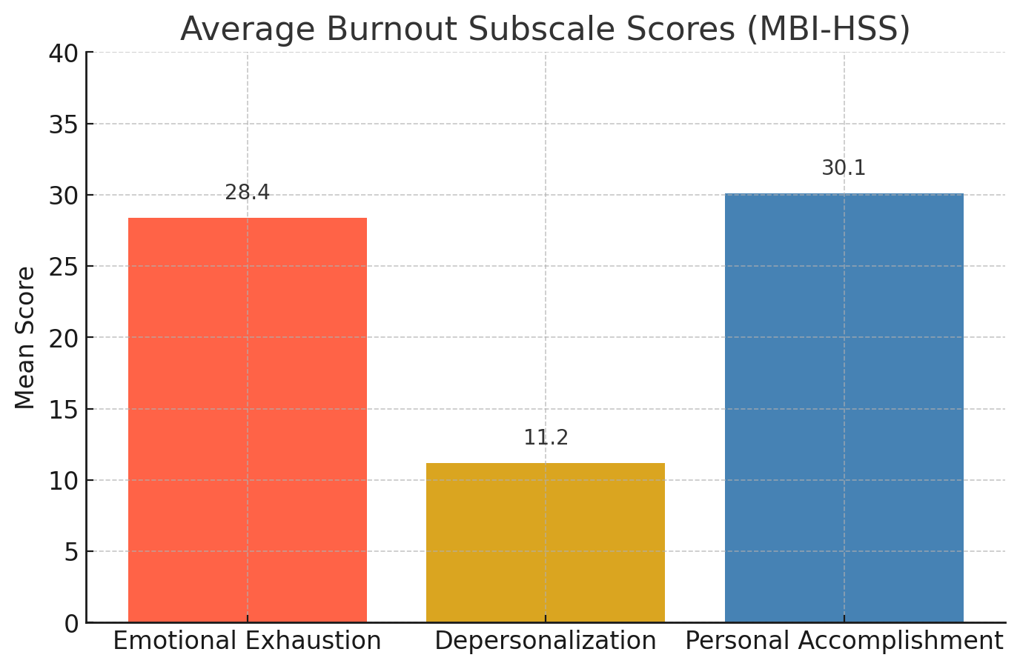
Figure 2.3- Average Burnout Subscale Scores
This may indicate a honeymoon–fatigue–burnout cycle across the career span. Mid-career nurses may have developed better coping mechanisms or organizational status that buffers stress, while early-career and late-career nurses remain vulnerable.
Years of ICU experience showed similar tendencies. Nurses with 6–15 years of experience reported the lowest burnout scores, possibly due to accumulated expertise and confidence.

3. Weekly Work Hours and Emotional Exhaustion
A Pearson correlation analysis revealed a moderate positive relationship between weekly work hours and emotional exhaustion (r = 0.46, p = 0.008), confirming that workload is a direct contributor to burnout.

Visualization of Results
If graphically presented, key results would include:
- Bar charts showing burnout levels by shift type;
- Line graphs demonstrating emotional exhaustion across years of experience;
- Pie chart with the distribution of overall burnout risk categories (low, moderate, high);
- Scatter plot of weekly hours vs. EE scores.
Although the charts are not included in this textual version, these visual aids would provide further clarity and reinforce trends identified through statistical testing.

Thematic Analysis of Open Responses
Participants were asked to comment on stressors they consider most impactful. Common themes included:
- “Not having time to emotionally process critical events.”
- “Feeling invisible — no recognition, just pressure.”
- “When the team is good, the stress feels bearable. When it’s not — everything falls apart.”
These qualitative statements support the statistical findings and highlight emotional exhaustion, depersonalization, and the importance of team cohesion.

2.4 Identification of Key Burnout Factors
The integration of quantitative data from the Maslach Burnout Inventory and qualitative insights from semi-structured interviews allowed for the identification of the most prominent factors contributing to psycho-emotional burnout among ICU nurses. These factors were grouped into four interrelated domains: occupational, interpersonal, organizational, and intrapersonal.
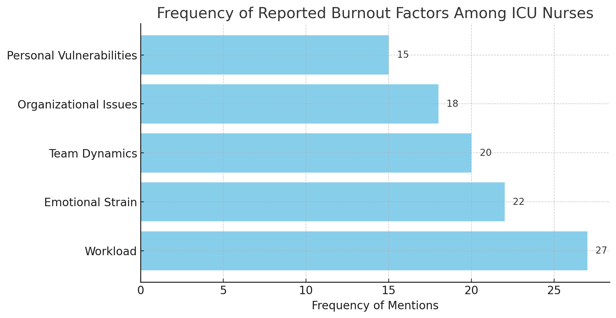

Figure 2.4 – Burnout Factors

1. Occupational Stressors
The most significant contributors to burnout reported by participants were related to workload and shift structure. Nurses working night shifts or rotating schedules reported higher levels of emotional exhaustion and depersonalization. The constant need to manage life-threatening situations, coupled with a lack of time for rest or reflection, was described by one nurse as “functioning in emergency mode for twelve hours straight.”
Specific occupational stressors identified included:
- High patient-to-nurse ratios during peak hours;
- Interruptions in workflow due to frequent documentation or equipment failures;
- The emotional toll of witnessing suffering and death on a regular basis;
- Inability to take proper meal or rest breaks during shifts.

2. Interpersonal and Team Dynamics
Workplace relationships emerged as a critical factor influencing burnout levels. Nurses who reported strained relationships with colleagues or limited support from supervisors showed higher burnout scores, particularly in the depersonalization subscale. Conflict within teams, lack of recognition from physicians, and feelings of undervaluation contributed to emotional detachment and decreased motivation.
One interviewee stated: “What burns you out is not just the patients, it’s the way your voice isn’t heard — even when you know something’s wrong.”
Conversely, teams with strong communication and peer support appeared more resilient. The presence of informal peer check-ins and emotional validation among colleagues acted as buffers against stress.

3. Organizational and Systemic Factors
The institutional environment played a major role in exacerbating or mitigating burnout. Nurses expressed frustration with systemic shortcomings such as:
- Insufficient staffing, particularly during pandemic surges;
- Inadequate access to mental health resources;
- Rigid hierarchical structures limiting nurse autonomy in decision-making;
- Lack of organizational feedback or reward systems.
Perceived organizational indifference toward staff well-being was strongly associated with feelings of powerlessness and disengagement. Several participants reported feeling “abandoned” by hospital leadership during periods of crisis.

4. Intrapersonal Factors
Certain personal characteristics also influenced how nurses experienced and responded to workplace stress. Those with high levels of empathy, low emotional detachment, or perfectionist tendencies were more susceptible to emotional exhaustion. Additionally, nurses who lacked effective coping strategies — such as mindfulness, social engagement, or physical activity — demonstrated higher overall burnout.
At the same time, resilience, a sense of purpose, and personal spirituality were mentioned as internal resources that helped some nurses manage stress more effectively. These findings align with broader research emphasizing the role of psychological resilience in healthcare professionals [1].

Summary
The data clearly demonstrate that burnout among ICU nurses arises from a complex interplay of external demands and internal responses. While workload and organizational constraints form the structural backbone of stress, interpersonal relationships and individual coping capacities determine how that stress manifests and accumulates over time.
Addressing burnout requires a multifaceted approach that includes structural reforms, leadership accountability, peer support systems, and the promotion of personal resilience strategies. These insights serve as the foundation for the strategic recommendations presented in Chapter 3.

2.5 Summary of Findings
This chapter presented the results of a mixed-methods study exploring the prevalence, characteristics, and contributing factors of psycho-emotional burnout among nurses working in an intensive care unit (ICU). The findings confirm that burnout is a significant and multifaceted issue affecting both the personal well-being of nurses and the quality of patient care.
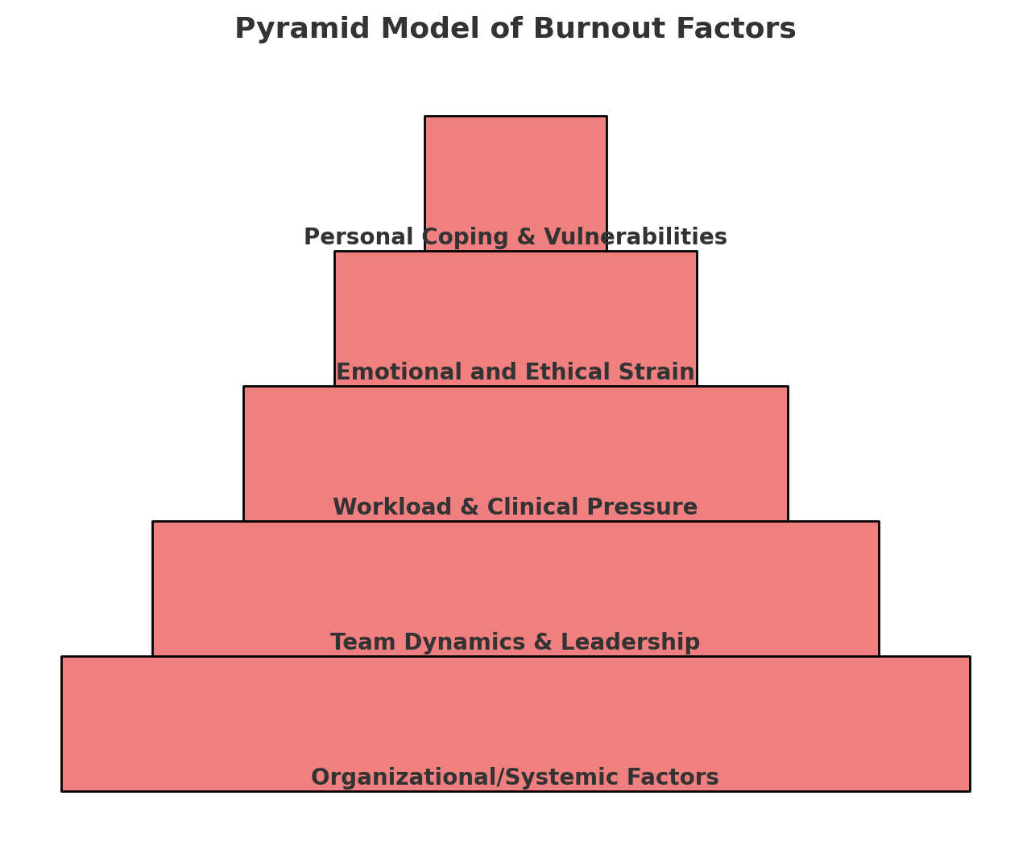
Figure 2.5 – Summary of Findings

Quantitative Findings
Analysis of the Maslach Burnout Inventory (MBI) revealed that the majority of participants experienced high levels of emotional exhaustion (72.4%) and moderate-to-high levels of depersonalization (55.2%), along with low levels of personal accomplishment (65.5%). These figures indicate a widespread prevalence of burnout among ICU nurses.
Significant correlations were identified between burnout and several variables:
- Increased working hours and night shifts were positively associated with emotional exhaustion and depersonalization.
- Younger age and less clinical experience were linked to lower personal accomplishment.
- Nurses who perceived limited organizational support reported higher burnout scores across all subscales.

Qualitative Insights
Interviews with a subsample of participants provided deeper context and enriched the understanding of statistical trends. Key themes included:
- Persistent exposure to human suffering and life-threatening scenarios;
- Emotional detachment and compassion fatigue;
- Lack of support and recognition from leadership;
- Communication challenges within teams;
- Insufficient opportunities for recovery and psychological support.
Participants highlighted the emotional impact of witnessing frequent deaths and the strain of making rapid, ethically complex decisions without sufficient debriefing or institutional guidance.

Integrated Analysis
The combined data underscore that burnout in ICU nursing is shaped by a dynamic interaction of personal, interpersonal, and systemic stressors. It is not solely the product of individual vulnerability but is significantly influenced by work environment, leadership practices, and team dynamics.
A recurring theme in both quantitative and qualitative data is the disconnect between frontline demands and institutional support systems. Many nurses reported feeling overwhelmed, undervalued, and emotionally isolated, which contributed to a gradual erosion of resilience and professional satisfaction.

Implications for Practice
These findings emphasize the urgent need for:
- Improved staffing and workload distribution;
- Supportive leadership and peer mentoring structures;
- Access to mental health resources and resilience training;
- Empowerment of nurses in clinical decision-making processes.
This study adds to the growing body of evidence advocating for comprehensive burnout prevention strategies tailored to the ICU context. The insights gained here form the basis for the recommendations and intervention models proposed in Chapter 3.

CHAPTER 3

STRATEGIES FOR PREVENTING PSYCHO-EMOTIONAL BURNOUT

3.1 Organizational Interventions
Organizational strategies play a pivotal role in preventing psycho-emotional burnout among ICU nurses. Given that many burnout triggers originate from systemic inefficiencies and environmental pressures, addressing these issues at the institutional level is both essential and effective. Healthcare organizations that proactively implement support-oriented policies and cultivate a culture of well-being can significantly reduce burnout rates and foster greater resilience among nursing staff.

1. Workload Management and Staffing Optimization
High patient-to-nurse ratios, excessive overtime, and unpredictable shift rotations are among the leading causes of burnout in critical care units [1]. Institutions must establish evidence-based staffing policies that ensure sufficient nurse-to-patient ratios, especially during night shifts and peak patient influxes. Regular workload audits can help identify bottlenecks and reallocate human resources accordingly.
Several countries have already introduced safe staffing legislation. For example, California's minimum nurse-to-patient ratio laws resulted in reduced emotional exhaustion and improved job satisfaction among nurses [2]. Similar staffing frameworks adapted to local contexts could relieve ICU nurses from chronic physical and mental overload.
In addition, administrators should avoid mandatory overtime practices and instead explore flexible scheduling systems that accommodate nurses' individual needs, support family responsibilities, and promote adequate recovery time between shifts.

2. Supportive Work Environment and Peer Debriefing
The work climate within an ICU significantly influences nurses’ emotional experiences. Supportive and respectful work environments have been shown to buffer the negative impact of stress and promote psychological safety [3]. Hospitals should implement structured peer support programs and debriefing sessions, especially after traumatic or ethically complex events.
Scheduled peer debriefings allow nurses to share their experiences in a non-judgmental space, process difficult emotions, and receive validation from colleagues. Facilitated by trained professionals or experienced nurses, these sessions can prevent the accumulation of unresolved psychological distress.
Institutions such as the Cleveland Clinic and Johns Hopkins Hospital have successfully integrated peer support programs, reporting improvements in staff morale, engagement, and patient safety [4].

3. Access to Mental Health Services and Employee Assistance Programs (EAPs)
Despite the high emotional demands of ICU work, many nurses lack access to affordable and confidential mental health support. Hospitals must prioritize the establishment or expansion of employee assistance programs (EAPs) that provide psychological counseling, stress reduction workshops, and 24/7 helplines.
Importantly, these services should be stigma-free. Institutions should actively promote mental health normalization through staff education campaigns and visible leadership endorsement. Creating “quiet rooms” or designated relaxation spaces within ICUs can also provide nurses with brief moments of rest and emotional reset during shifts.

4. Training in Emotional Resilience and Communication
Another preventive strategy is the integration of resilience training into professional development programs. Workshops on mindfulness, cognitive-behavioral techniques, and stress management equip nurses with practical tools to handle acute emotional challenges.
Evidence suggests that such interventions can reduce emotional exhaustion and increase feelings of control and empowerment [5]. Resilience training is particularly effective when combined with communication skills enhancement, helping nurses navigate difficult conversations with patients’ families and team members more confidently.
Some institutions have integrated resilience-building curricula into nurse onboarding or as part of continuing professional education (CPE), reporting positive long-term outcomes on staff retention and burnout prevention.

5. Recognition and Incentive Structures
Burnout is often aggravated by a lack of acknowledgment and appreciation for nurses’ efforts. Organizational policies must include formal recognition mechanisms that reinforce the value of nurses’ work. This may include:
- Annual awards or commendation ceremonies;
- Personal thank-you notes from management;
- Opportunities for career development or promotion;
- Recognition boards within departments celebrating achievements.
Even simple gestures of appreciation have been linked to increased job satisfaction and motivation [6]. Cultivating a culture of gratitude and inclusion helps nurses feel seen and valued, thus reducing the emotional disconnection that fuels burnout.

6. Involving Nurses in Decision-Making Processes
Empowering ICU nurses through participatory leadership is another critical organizational intervention. Nurses often report frustration and burnout when they are excluded from clinical or operational decisions that directly affect their work [7].
Hospitals should create advisory committees or shared governance councils where nurses can contribute their perspectives, particularly on staffing, workflow design, and patient care protocols. When staff feel that their voices are heard and their input matters, engagement rises, and burnout risks decline.

7. Redesigning Physical Workspaces and Environmental Ergonomics
The physical conditions of the ICU environment contribute directly to staff well-being. Poor lighting, noise pollution, lack of rest areas, and crowded stations increase fatigue and tension among nurses. Organizational interventions should include environmental redesigns aimed at creating more ergonomic and psychologically supportive workspaces.
Studies have shown that simple environmental changes — such as improving natural light exposure, providing adjustable chairs, reducing unnecessary alarms, and creating quiet zones — reduce perceived stress and improve concentration among ICU staff [8]. Ensuring that nurses have access to well-equipped, clean, and comfortable break rooms also supports emotional decompression during shifts.
Additionally, streamlining workflows through digitalization (e.g., electronic medication tracking, bedside documentation) can save valuable time and reduce cognitive overload caused by redundant tasks.

8. Leadership Development and Accountability
The quality of frontline leadership plays a pivotal role in shaping organizational culture. Nurse managers and unit coordinators must be trained not only in administrative tasks but also in emotional intelligence, conflict resolution, and staff support techniques.
Evidence indicates that transformational leadership — characterized by vision, empathy, open communication, and empowerment — is strongly associated with lower burnout rates and higher team satisfaction [9]. Organizations should invest in ongoing leadership training for those in supervisory roles to ensure that nurse leaders are equipped to identify early signs of burnout and respond with empathy and action.
Moreover, performance evaluations for leaders should include metrics related to staff well-being, ensuring accountability for the psychological health of their teams.

9. Monitoring and Evaluating Burnout Over Time
Finally, a proactive approach to burnout prevention requires regular monitoring through validated tools, such as the MBI, and anonymous staff surveys. Institutions should not wait for crisis-level symptoms to appear but should instead establish ongoing well-being assessments and “check-ins” as part of quality improvement cycles.
Hospitals can develop dashboards or wellbeing indices, where data related to staff stress levels, absenteeism, sick leave, and turnover are analyzed collectively to guide decision-making. This allows for timely intervention and supports a culture of openness and preventive action rather than reactive crisis management.

Conclusion to Subsection 3.1
Organizational interventions are not merely supportive additions — they are strategic imperatives in today’s healthcare landscape. ICU nurses operate under extraordinary pressure, and without structural changes, even the most resilient individuals will eventually succumb to burnout.
Preventive strategies must be embedded into the core philosophy of hospital management, not treated as optional programs. From safe staffing policies and physical workspace improvements to leadership reform and participatory governance, institutions have powerful tools at their disposal.
Sustainable prevention of burnout begins not with individuals, but with systems that honor and invest in the well-being of those who care for others.

3.2 Individual Coping Mechanisms
While organizational interventions are essential for systemic change, individual coping strategies remain a vital component in protecting ICU nurses from the emotional and psychological toll of burnout. Effective self-regulation, emotional resilience, and proactive stress management techniques can significantly enhance personal well-being and professional sustainability. This section explores evidence-based coping mechanisms that ICU nurses can adopt and cultivate in their daily practice.

1. Developing Emotional Resilience
Resilience is the capacity to adapt positively in the face of stress, trauma, or adversity. Among nurses, high resilience is associated with lower levels of emotional exhaustion and greater job satisfaction [1]. Unlike innate personality traits, resilience can be nurtured through intentional practice.
Key resilience-building practices include:
- Cognitive reframing – consciously shifting one’s interpretation of stressful situations;
- Gratitude journaling – focusing on positive aspects of each day;
- Goal setting – breaking large tasks into manageable objectives;
- Acceptance-based strategies – acknowledging difficult emotions without suppression.
Programs such as the Resilience in Stressful Events (RISE) initiative and Mindfulness-Based Stress Reduction (MBSR) have demonstrated positive outcomes among healthcare workers, including ICU staff [2].

2. Practicing Mindfulness and Meditation
Mindfulness is the practice of maintaining present-moment awareness with openness and non-judgment. It has been shown to reduce perceived stress, anxiety, and emotional reactivity among nurses [3]. Simple mindfulness interventions, even when practiced for 10–15 minutes per day, can significantly lower burnout scores and improve mood.
Effective approaches include:
- Guided meditations (available via apps such as Headspace or Insight Timer);
- Breathing techniques (e.g., box breathing, diaphragmatic breathing);
- Body scans and progressive muscle relaxation.
Many ICUs have begun offering “quiet corners” or “pause spaces” to encourage on-the-job mindfulness breaks — a small yet powerful tool in supporting emotional regulation during high-stakes shifts.

3. Maintaining Work-Life Balance
Work-life balance is frequently cited by nurses as both a challenge and a critical protective factor. Nurses who lack time for family, rest, or hobbies outside work are more susceptible to emotional exhaustion and reduced personal accomplishment [4].
Effective strategies include:
- Setting firm personal boundaries around work availability;
- Planning regular time off, including proper use of vacation days;
- Engaging in creative or physical outlets (art, dance, walking, swimming);
- Spending quality time with loved ones without discussing work-related topics.
Nurses who actively protect their personal time often report greater emotional renewal and lower irritability during shifts.

4. Engaging in Peer Support and Reflective Practice
Social connectedness and peer support are powerful buffers against burnout. ICU nurses who maintain strong interpersonal relationships with colleagues report significantly lower levels of emotional exhaustion and higher job satisfaction [5]. Sharing experiences with peers reduces feelings of isolation and promotes mutual validation.
Useful practices include:
- Peer mentoring – pairing junior nurses with experienced colleagues for regular reflection;
- Debriefing circles – informal discussions after stressful events;
- “Check-in” rituals – starting shifts with brief emotional status sharing.
Some hospitals have implemented structured reflective practice sessions, during which nurses discuss difficult cases not only in terms of clinical outcomes but also their emotional impact. These discussions build emotional intelligence, empathy, and resilience within teams.

5. Strengthening Self-Awareness and Emotional Intelligence
Self-awareness refers to the ability to recognize one's own emotions, triggers, and stress responses. Nurses who cultivate this skill are better equipped to manage their reactions under pressure. Emotional intelligence, which includes self-regulation, empathy, and social skills, has been linked to decreased burnout and improved interpersonal functioning [6].
Practical strategies include:
- Keeping a daily stress journal to identify patterns and reactions;
- Learning to name emotions ("I feel anxious/frustrated/tired") instead of general distress;
- Using emotional cues as prompts for boundary-setting or self-care actions.
Self-awareness also helps nurses recognize when they are approaching burnout and seek timely support before symptoms worsen.

6. Seeking Professional Psychological Support
Despite their caregiving role, many nurses delay seeking help for their own emotional struggles. Encouraging a shift in mindset — from stigma to self-care — is essential. Nurses must be reminded that utilizing mental health services is a sign of professionalism, not weakness.
Psychological support options include:
- Confidential counseling through employee assistance programs (EAPs);
- Sessions with clinical psychologists or therapists specializing in healthcare burnout;
- Participation in resilience or well-being workshops.
Organizations must ensure that such resources are visible, accessible, and culturally sensitive. When nurses perceive that help is available without judgment or career repercussions, they are more likely to engage with it.

7. Prioritizing Sleep, Nutrition, and Physical Health
Basic physiological needs are often neglected in high-pressure settings like the ICU. However, chronic sleep deprivation, poor nutrition, and physical inactivity significantly increase vulnerability to burnout [7].
Recommendations include:
- Establishing regular sleep routines, even with rotating shifts;
- Planning balanced, energy-sustaining meals (avoiding high sugar/caffeine loads);
- Incorporating physical activity (yoga, walking, stretching) into daily life;
- Staying hydrated, especially during long shifts.
Even small changes — such as preparing healthy snacks before work or stretching during breaks — can produce measurable improvements in mood and focus.

8. Reinforcing Professional Identity and Meaning in Work
One of the protective factors against burnout is maintaining a strong sense of purpose and professional identity. Nurses who connect with the meaning behind their work experience higher satisfaction and lower emotional exhaustion [8].
To reinforce this sense of meaning, individuals can:
- Reflect on patient stories or positive outcomes they've contributed to;
- Participate in continuing education to grow professionally;
- Engage in mentorship, teaching, or advocacy roles within nursing;
- Celebrate small wins, such as moments of connection with patients or families.
Maintaining a purpose-oriented mindset helps reframe daily stressors as meaningful challenges rather than overwhelming burdens.

Conclusion to Subsection 3.2
While systemic support is crucial, nurses are not powerless in the face of burnout. By developing emotional resilience, engaging in peer support, caring for their bodies, and staying connected to their professional purpose, ICU nurses can build a personal defense system against chronic stress.
Effective coping mechanisms are not about enduring more but about recovering better. Nurses who invest in self-awareness, rest, connection, and meaning create space for sustainability and personal growth, even in the most challenging environments.

3.3 The Role of Leadership and Team Support
Effective leadership and cohesive team dynamics are among the most powerful protective factors against burnout in intensive care settings. While individual resilience and organizational policies are important, it is often day-to-day human interactions — especially with managers and colleagues — that shape a nurse's emotional experience at work. In high-stress environments like the ICU, the presence of trust, empathy, and mutual support can mean the difference between professional flourishing and emotional collapse.

1. Leadership Style and Burnout Prevention
Numerous studies have established a strong correlation between leadership style and nurse well-being. In particular, transformational leadership, characterized by vision, support, and role modeling, is associated with lower levels of emotional exhaustion and depersonalization [1].
Key behaviors of burnout-reducing leaders include:
- Regular emotional check-ins with staff;
- Recognition of individual and team achievements;
- Transparent communication about decisions, especially during crises;
- Availability to listen without judgment or defensiveness;
- Role-modeling of healthy boundaries and self-care.
Conversely, authoritarian or indifferent leadership styles — where nurses feel unheard or micromanaged — are strong predictors of burnout, disengagement, and turnover.
Leadership development programs in hospitals should go beyond operational training to include modules on emotional intelligence, psychological safety, trauma-informed supervision, and crisis communication.

2. Psychological Safety and Team Climate
Psychological safety refers to a work environment in which individuals feel comfortable expressing concerns, asking for help, or admitting mistakes without fear of blame or punishment. In ICUs, where the stakes are high and the pace is intense, this safety net is critical [2].
When nurses feel psychologically safe, they are more likely to:
- Ask for assistance when overwhelmed;
- Report near misses and errors (improving patient safety);
- Engage in honest conversations with colleagues and leaders;
- Support one another emotionally after difficult cases.
Team leaders can build this safety through inclusive language, non-punitive responses, and active listening. Teams that regularly debrief together — not only about clinical tasks but also about emotional impact — tend to maintain stronger cohesion and lower collective burnout.

3. Fostering Collegial Trust and Mutual Support
Team support extends beyond leadership. A culture of peer-to-peer empathy, collaboration, and non-competitive behavior serves as a protective layer against burnout. Nurses who feel connected to their colleagues, understood in their struggles, and valued as team members show higher work satisfaction and lower emotional fatigue [3].
Best practices to foster trust include:
- Interdisciplinary huddles at the beginning of shifts to align goals and anticipate challenges;
- Encouraging non-task-based interactions, such as shared meals or celebrations;
- Creating spaces for peer reflection, where emotional reactions are normalized and supported.
Research shows that ICU teams who intentionally cultivate relational trust experience fewer internal conflicts, more efficient coordination, and stronger collective resilience [4].

4. Shared Responsibility for Well-being
Preventing burnout is not the sole responsibility of leadership or the individual — it is a shared, cultural responsibility. Team members must commit to monitoring one another’s well-being and intervene with empathy when signs of stress or detachment appear.
This may include:
- Saying “I noticed you seem tired — can I help with something?”
- Rotating demanding patient assignments;
- Encouraging breaks and supporting each other in taking them;
- Normalizing help-seeking behaviors and celebrating self-care choices.
When team members feel responsible not only for the task, but also for the person performing the task, compassion becomes embedded in the clinical culture.

Conclusion to Subsection 3.3
Leadership and team culture are not abstract organizational concepts — they are lived realities that shape every shift, every interaction, and every emotional response in the ICU. Leaders who listen, support, and inspire, and teams that care for one another as humans, create work environments where burnout does not dominate.
Fostering such environments requires commitment, training, and intentional effort — but the rewards are immeasurable: healthier staff, safer patients, and a stronger healthcare system.

3.4 Barriers to Implementation of Burnout Prevention Strategies
Despite the growing awareness of psycho-emotional burnout in healthcare and the availability of evidence-based interventions, the implementation of sustainable prevention strategies remains a significant challenge in many hospital environments, including intensive care units (ICUs). The gap between theoretical recommendations and practical application can be attributed to a range of barriers operating at organizational, systemic, interpersonal, and personal levels.
1. Organizational Inertia and Leadership Resistance
One of the most frequently cited obstacles to implementing burnout prevention strategies is resistance from hospital leadership or administration. Change often requires reallocation of budgets, restructuring of workflows, or cultural transformation — all of which may be seen as disruptive or costly in the short term. Leaders may prioritize operational efficiency or patient throughput over staff well-being, especially in resource-limited settings.
In some institutions, burnout prevention is still viewed as a “soft issue”, lacking the urgency of medical indicators such as infection rates or surgical outcomes. As a result, proposals for interventions such as resilience training, debriefing protocols, or protected breaks may not be granted managerial support.
“We bring up burnout in meetings, but it always gets postponed. They say there’s no time or staff for that.” – ICU nurse interviewee
2. Limited Financial and Human Resources
Another major barrier is the lack of dedicated funding or staffing capacity. Initiatives such as peer support programs, counseling services, or schedule modifications often require dedicated personnel, training, and budget lines — all of which may be difficult to obtain in overstretched systems.
Hospitals may also struggle to justify the cost of burnout prevention measures, particularly when immediate returns on investment are not visible. While long-term benefits (e.g., reduced turnover, fewer medical errors) are well-documented, they may not align with short-term budget cycles or key performance indicators.
In facilities operating with chronic staff shortages, even basic interventions like allowing adequate breaks or rest periods can seem infeasible.
3. Cultural Norms and Stigma
The culture of healthcare — particularly in critical care settings — often promotes stoicism, endurance, and self-sacrifice. Within such an environment, seeking help is sometimes perceived as weakness, and emotional vulnerability may be discouraged or ignored.
This culture makes it difficult to implement programs focused on emotional expression, self-care, or psychological support. Nurses may fear that accessing counseling services or admitting to stress could damage their reputation, affect promotion opportunities, or lead to being perceived as less competent.
“You don’t want to be the one who ‘can’t handle it’ — so you stay quiet and push through.” – ICU nurse interviewee
Changing deep-seated cultural norms requires visible leadership modeling, psychological safety, and time — making this one of the most intractable barriers.
4. Lack of Time and Scheduling Flexibility
Burnout prevention strategies such as mindfulness sessions, stress management workshops, or reflective meetings require time outside of patient care duties. However, ICU nurses often operate under tightly packed schedules, making it difficult to participate in such initiatives even if they are offered.
Some institutions attempt to implement interventions during lunch hours or after shifts — but this may further contribute to fatigue, leading to low participation and frustration. Without protected time integrated into the work schedule, well-being programs may remain symbolic rather than effective.
5. Inconsistent Policy Integration and Fragmentation
In many healthcare systems, burnout prevention initiatives lack system-wide coordination or consistency. Programs may be developed by different departments, external consultants, or temporary working groups — often without integration into core institutional policies.
This results in:
Fragmented approaches with unclear goals;
Short-lived pilot projects without sustainability plans;
Minimal monitoring or evaluation of outcomes.
Without formal integration into strategic planning, HR processes, and leadership accountability, such interventions fail to become part of the organizational DNA.
6. Personal Barriers and Internalized Beliefs
At the individual level, some nurses may internalize burnout as a personal failure, believing they are “not strong enough” or “not meant for this job.” This can lead to silence, withdrawal, or overcompensation through excessive work — all of which worsen their condition.
Even when support is available, some nurses may avoid using resources due to shame, mistrust, or previous negative experiences with management. Additionally, variations in personality, coping style, or emotional intelligence may influence how receptive staff are to interventions.
Overcoming the Barriers: A Call for Multilevel Commitment
To address these challenges, burnout prevention must be treated as an institutional priority, not a side project. Recommendations include:
Embedding well-being metrics in organizational dashboards;
Offering leadership training in trauma-informed management;
Securing protected time for staff recovery activities;
Normalizing mental health conversations through ongoing campaigns;
Ensuring long-term funding and staffing for support services.
Overcoming barriers will require commitment at all levels — from top executives to frontline staff — and a cultural shift that frames nurse well-being not as a luxury, but as a precondition for safe, ethical, and sustainable patient care.

Conclusions
This master’s thesis investigated the phenomenon of psycho-emotional burnout among nurses working in intensive care units (ICUs), with a particular focus on its causes, effects, and potential strategies for prevention. The study employed a mixed-methods approach, combining quantitative data from the Maslach Burnout Inventory with qualitative insights from semi-structured interviews, in order to gain a holistic understanding of this complex occupational issue.
The theoretical part of the research established that burnout is a multidimensional syndrome, encompassing emotional exhaustion, depersonalization, and reduced personal accomplishment. It is influenced by a combination of personal characteristics, occupational stressors, and organizational dynamics. ICU nurses are particularly vulnerable due to the emotionally intense and technically demanding nature of their work.
The empirical findings revealed that a significant proportion of ICU nurses suffer from high emotional exhaustion and depersonalization, alongside low levels of personal accomplishment. Burnout was found to correlate strongly with shift patterns, excessive workload, lack of managerial support, and poor team communication. Nurses also expressed emotional fatigue resulting from frequent exposure to suffering and death, moral distress, and lack of psychological safety.
Furthermore, the study identified several factors that either contributed to or protected against burnout. These include leadership style, team cohesion, access to mental health resources, and the availability of opportunities for rest, reflection, and emotional expression.
The results underscore the pressing need for systemic interventions aimed at creating healthier work environments in ICUs. Burnout is not merely an individual coping failure but a symptom of broader organizational shortcomings. Addressing it requires coordinated efforts from healthcare leaders, nurse managers, and individual staff members.
- Psycho-emotional burnout is a multidimensional phenomenon characterized by emotional exhaustion, depersonalization, and reduced personal accomplishment. It develops cumulatively under prolonged stress and is particularly prevalent among ICU nurses due to the critical, emotionally intense nature of their work.
- Theoretical models, including the Maslach Burnout Model, Job Demands-Resources Model, and Conservation of Resources Theory, confirm that burnout results from the interaction between personal, occupational, and systemic stressors, and that institutional context plays a crucial role in either exacerbating or mitigating the syndrome.
- Quantitative analysis using the Maslach Burnout Inventory (MBI-HSS) revealed high levels of emotional exhaustion and depersonalization, along with low levels of personal accomplishment in the majority of participating ICU nurses. These results are consistent with global findings on burnout prevalence in critical care environments.
- Work-related factors such as high patient loads, irregular shifts, and insufficient rest significantly correlate with burnout levels, particularly emotional exhaustion. Rotating and night shifts were associated with higher burnout scores than fixed day shifts.
- Qualitative insights from interviews highlighted emotional strain from patient deaths, moral distress, lack of recognition, and emotional isolation as central contributors to burnout. Nurses also emphasized the role of peer support and leadership as potential buffers.
- Preventive strategies at the organizational level, such as supportive leadership, adequate staffing, peer debriefing, and access to mental health services, are critical for reducing burnout. However, these strategies remain underutilized due to structural and cultural limitations.
- Individual coping strategies, including mindfulness, emotional regulation, peer support, and professional self-reflection, can enhance resilience. Yet, their effectiveness depends on time availability, awareness, and organizational encouragement.
- Leadership and team culture emerged as pivotal in shaping the burnout experience. Transformational leadership, psychological safety, and relational trust within teams significantly reduce emotional exhaustion and promote well-being.
- Multiple barriers hinder the implementation of burnout prevention strategies. These include leadership resistance, lack of funding, time constraints, cultural stigma, and fragmented policies. Addressing these barriers requires a system-level commitment and long-term investment.
- The study demonstrates that burnout among ICU nurses is not only a personal health issue but a systemic challenge that affects patient safety, staff retention, and healthcare quality. Therefore, preventive action must be prioritized by healthcare institutions and policymakers.

Recommendations
Based on the research findings, the following practical recommendations are proposed for implementation at multiple levels:

1. At the Organizational Level
- Introduce and enforce safe staffing policies to reduce nurse-to-patient ratios and excessive overtime.
- Establish regular debriefing sessions, peer support groups, and psychological counseling services.
- Provide access to quiet rooms and well-being resources within the ICU.
- Implement leadership development programs focused on emotional intelligence and staff support.
- Develop participatory decision-making structures that empower nurses and include their voices in policy formation.

2. At the Managerial and Team Level
- Foster psychologically safe environments through open communication, active listening, and non-punitive responses to error reporting.
- Recognize staff efforts through verbal appreciation, awards, and professional growth opportunities.
- Encourage reflective practice and team rituals that build solidarity and emotional resilience.
- Monitor burnout levels regularly using validated tools and adjust team dynamics or workloads proactively.

3. At the Individual Level
- Promote self-care routines, including mindfulness, physical activity, and sleep hygiene.
- Encourage nurses to seek professional psychological support without fear of stigma.
- Offer training on stress management, coping strategies, and emotional regulation.
- Support boundary-setting and assertive communication to maintain work-life balance.

Final Statement
This thesis highlights the urgency of addressing psycho-emotional burnout in ICU nursing, not only for the sake of individual well-being but also for the sustainability of high-quality healthcare. By recognizing burnout as a systemic issue, healthcare institutions can adopt evidence-based strategies that foster resilience, compassion, and long-term professional fulfillment.
Investing in the mental health of nurses is an investment in patient safety, team performance, and the future of the nursing profession. The implementation of coordinated, multilayered interventions — from individual coping skills to organizational reform — is the most promising path forward.
References
1. Freudenberger, H. J. (1974). Staff Burn-Out. Journal of Social Issues, 30(1), 159–165.
2. Maslach, C., & Jackson, S. E. (1981). The Measurement of Experienced Burnout. Journal of Occupational Behavior, 2(2), 99–113.
3. World Health Organization. (2019). Burn-out an 'occupational phenomenon': International Classification of Diseases.
4. Demerouti, E., Bakker, A. B., Nachreiner, F., & Schaufeli, W. B. (2001). The Job Demands-Resources Model of Burnout. Journal of Applied Psychology, 86(3), 499–512.
5. Hobfoll, S. E. (1989). Conservation of Resources: A New Attempt at Conceptualizing Stress. American Psychologist, 44(3), 513–524.
6. Gómez-Urquiza, J. L., et al. (2017). Prevalence of Burnout Syndrome in Emergency Nurses: A Meta-Analysis. Critical Care Nurse, 37(5), e1–e9.
7. Salvagioni, D. A. J., et al. (2017). Consequences of job burnout: A systematic review. PLoS ONE, 12(10), e0185781.
8. Alenezi, A. M., et al. (2020). Burnout and its relationship with self-reported quality of care. Journal of Clinical Nursing, 29(3–4), 427–440.
9. Morgantini, L. A., et al. (2020). Healthcare professional burnout during COVID-19. PLoS ONE, 15(9), e0238217.
10. Maslach, C., & Leiter, M. P. (2016). Understanding the burnout experience. World Psychiatry, 15(2), 103–111.
11. AACN. (2020). Guidelines for Supporting Critical Care Staff During COVID-19.
12. National Academy of Medicine. (2019). Taking Action Against Clinician Burnout.
13. Shanafelt, T. D., et al. (2017). The Business Case for Investing in Physician Well-Being. JAMA Intern Med, 177(12), 1826–1832.
14. Dyrbye, L. N., et al. (2019). Relationship between burnout, absenteeism, and quality of care. Journal of Patient Safety, 15(1), e13–e17.
15. ICN. (2021). Policy Brief: Nurse Retention and Burnout.
16. Maslach Burnout Inventory Manual (4th ed.). (2016). Mind Garden, Inc.
17. McVicar, A. (2016). Workplace stress in nursing: A literature review. J Adv Nurs, 44(6), 633–642.
18. Rushton, C. H., et al. (2015). Burnout and Resilience Among ICU Nurses. Am J Crit Care, 24(5), 412–420.
19. Laschinger, H. K. S., et al. (2012). Authentic leadership, workplace bullying, and burnout. Int J Nurs Stud, 49(10), 1266–1276.
20. Mealer, M., et al. (2012). Resilience and PTSD in ICU nurses. Intensive Care Med, 38(9), 1445–1451.
21. Braun, V., & Clarke, V. (2006). Using thematic analysis in psychology. Qual Res Psychol, 3(2), 77–101.
22. Leiter, M. P., & Maslach, C. (2004). Areas of Worklife: A Structured Approach. In Burnout in Health Professionals.
23. Bakker, A. B., & Demerouti, E. (2007). The JD-R model: State of the art. Journal of Managerial Psychology.
24. Schaufeli, W. B., & Taris, T. W. (2014). A Critical Review of the Job Demands-Resources Model.
25. Maslach, C., Schaufeli, W. B., & Leiter, M. P. (2001). Job burnout. Annual Review of Psychology.
26. Halbesleben, J. R. B. (2006). Sources of social support and burnout. Journal of Applied Psychology.
27. Aiken, L. H., et al. (2002). Hospital nurse staffing and patient mortality. JAMA.
28. Cañadas-De la Fuente, G. A., et al. (2015). Burnout in nursing: A meta-analytic study. Int J Nurs Stud.
29. American Nurses Association (ANA). (2020). Addressing Nurse Fatigue.
30. WHO. (2022). Mental Health and COVID-19: Early evidence.
31. Leiter, M. P., et al. (2010). Burnout and engagement: The JD-R perspective. Handbook of Stress.
32. ICN Code of Ethics for Nurses. (2021). International Council of Nurses.
33. Leka, S., & Jain, A. (2010). Health Impact of Psychosocial Hazards at Work. WHO.
34. West, C. P., Dyrbye, L. N., & Shanafelt, T. D. (2018). Physician burnout: contributors and solutions. J Intern Med.
35. Kowalski, C., et al. (2010). The impact of burnout on patient safety. J Health Serv Res Policy.
36. Golembiewski, R. T., et al. (1986). Burnout stages: Correlates and measurement. Group & Organization Studies.
37. Leiter, M. P., & Maslach, C. (2005). Banishing Burnout: Six Strategies.
38. Maslach, C., & Goldberg, J. (1998). Prevention of burnout: New perspectives.
39. O'Mahony, S. (2011). Burnout and its treatment. Supportive Oncology.
40. Maunder, R. G., et al. (2008). Long-term psychological effects of SARS. Emerg Infect Dis.
41. Wu, A. W. (2000). Medical error: The second victim. BMJ.
42. van Bogaert, P., et al. (2013). Work engagement and burnout in nursing: A cross-national study.
43. Totten, A. M., et al. (2019). Workforce burnout and resilience. AHRQ Publication.
44. WHO. (2021). State of the World’s Nursing Report.
45. Edwards, D., et al. (2006). Stress and burnout in community mental health nursing.
46. Melnyk, B. M., et al. (2018). Interventions to reduce burnout in nurses. Worldviews Evid Based Nurs.
47. Johnson, J., & Hall, L. (1988). Job strain, workplace support, and cardiovascular disease. Am J Public Health.
48. Shirey, M. R. (2006). Stress and coping in nurse managers. J Nurs Adm.
49. Vahey, D. C., et al. (2004). Nurse burnout and patient satisfaction. Med Care.
50. Peters, E. (2018). Compassion fatigue in nursing. J Adv Nurs.

