The Ministry of Health of Ukraine
I. Horbachevsky Ternopil National Medical University of the Ministry of Health of Ukraine

as manuscript
Oleg Soroka
Master’s Thesis
THE ROLE OF ARTIFICIAL INTELLIGENCE IN TRANSFORMING EVIDENCE-BASED NURSING PRACTICE
Master of Science in Nursing

The Scientific Supervisor:
Lyudmyla Mazur
Ph.D., Associate Professor
Department of Higher Nursing Education,
Patients Care and Clinical Immunology
I. Horbachevsky Ternopil National Medical
University of the MoH of Ukraine
Ternopil, 2025
ABSTRACT
Oleg Soroka. THE ROLE OF ARTIFICIAL INTELLIGENCE IN TRANSFORMING EVIDENCE-BASED NURSING PRACTICE. I. Horbachevsky Ternopil National Medical University, The Scientific Supervisor: Ph.D., Associate Professor of the Department of Higher Nursing Education, Patient Care and Clinical Immunology Lyudmyla Mazur, 2025.
Artificial Intelligence (AI) has rapidly emerged as a transformative force in healthcare, particularly within the domain of nursing. As evidence-based practice continues to evolve, AI technologies present new avenues for optimizing patient care, improving clinical decision-making, enhancing workflow efficiency, and supporting professional development among nurses. However, the integration of AI into nursing practice also introduces a host of ethical, practical, and systemic challenges. This systematic review aims to evaluate the role of AI in transforming evidence-based nursing practice by synthesizing recent literature on AI applications, impacts on nursing outcomes, and ethical considerations.
The aim of the study is to explore how AI technologies influence evidence-based nursing practices and to identify key benefits, limitations, and ethical challenges associated with their integration.
Study objectives.
- To investigate how AI supports clinical decision-making, predictive analytics, and workflow optimization in nursing practice.
- To evaluate the effects of AI integration on nurse satisfaction, education, training, and patient outcomes.
- To identify the ethical challenges associated with AI implementation in nursing, including data privacy, algorithmic bias, informed consent, and accountability.
- To provide evidence-based recommendations for the ethical and effective integration of AI into nursing practice.
The object of research. The object of the study includes peer-reviewed journal articles and systematic reviews published between 2013 and 2025 that address AI technologies used in nursing practice and education.
The subject of research. The subject of the study is the role of artificial intelligence in transforming nursing practice, decision-making, and the ethical dimensions of care delivery in modern healthcare settings.
The methods of study included a systematic review of literature using PRISMA guidelines. Database searches were conducted in PubMed, CINAHL, Scopus, and Web of Science using predefined inclusion and exclusion criteria. The analysis focused on AI applications in nursing, measurable outcomes, and ethical considerations. Studies were selected based on relevance, methodological rigor, and alignment with the research objectives.
The scientific and practical value of the study. This review synthesizes the current evidence on AI’s transformative potential in nursing practice and highlights both the opportunities and risks associated with its adoption. It serves as a resource for nurse leaders, policymakers, and educators by offering actionable insights into how AI can be ethically and effectively implemented to enhance care delivery, patient safety, and nursing education.
The findings of this systematic review indicate that AI contributes significantly to improving diagnostic accuracy, predicting patient deterioration, and streamlining administrative tasks. AI-based decision support systems and predictive tools enhance nurses’ ability to make timely and evidence-based clinical decisions. Educational technologies powered by AI facilitate nurse training, continuing education, and simulation-based skill development. Moreover, AI supports workflow optimization by automating repetitive tasks, thereby increasing nurse efficiency and reducing burnout.
However, ethical concerns remain a central challenge. Issues of data privacy, algorithmic bias, transparency, and nurse autonomy must be addressed through rigorous ethical frameworks and institutional safeguards. The review underscores the need for nurses to participate in the design, deployment, and evaluation of AI tools to ensure these technologies align with core nursing values and patient-centered care principles.
Key words: artificial intelligence, evidence-based nursing, decision support systems, ethics, nursing practice, automation, nurse education.
TABLE OF CONTENTS
INTRODUCTION | 6
CHAPTER 1. ARTIFICIAL INTELLIGENCE IN NURSING (REVIEW OF LITERATURE) | 10
CHAPTER 2. THE OBJECT OF RESEARCH AND METHODS OF STUDY | 20
CHAPTER 3. ARTIFICIAL INTELLIGENCE IN NURSING: OPPORTUNITIES, CHALLENGES, AND THE PATH FORWARD | 25
CHAPTER 4. INTEGRATING ARTIFICIAL INTELLIGENCE INTO NURSING PRACTICE: ETHICAL, PROFESSIONAL, AND EDUCATIONAL IMPLICATIONS | 50
CONCLUSION | 61
REFERENCES | 63

INTRODUCTION
The background of the study. Artificial Intelligence (AI) has emerged as a transformative force in the healthcare sector, offering sophisticated tools that can process vast quantities of data, recognize complex patterns, and provide support in clinical decision-making. In nursing practice, AI applications such as machine learning algorithms, natural language processing, predictive analytics, and robotic process automation are being introduced to assist with clinical workflows, enhance diagnostic accuracy, personalize patient care, and support nursing education and training [1,2,3].
The global healthcare landscape is facing unprecedented challenges, including aging populations, the increasing burden of chronic diseases, and a critical shortage of nursing professionals. These pressures have necessitated the exploration of innovative solutions to improve care delivery while maintaining quality and efficiency. AI technologies, with their potential to augment human decision-making and automate routine processes, are seen as powerful tools to alleviate the demands placed on nursing staff and healthcare systems more broadly [1,5].
Within evidence-based nursing, AI offers the potential to support clinical judgment by integrating data-driven insights into the decision-making process. By analyzing electronic health records, laboratory values, and patient histories, AI systems can alert nurses to early signs of deterioration, identify patients at risk for complications, and assist in prioritizing care tasks [2,3,7]. These capabilities can help reduce medical errors, improve patient safety, and allow nurses to focus on complex, high-touch aspects of care that require human empathy and clinical expertise [4,5].
Nonetheless, the integration of AI into nursing practice is accompanied by complex ethical, legal, and professional challenges. Concerns about data privacy, algorithmic bias, lack of transparency, and the potential erosion of nurse autonomy have raised critical questions about the responsible use of AI in healthcare settings [4,6,8]. The limited involvement of nurses in the development, implementation, and governance of AI systems may further compromise the alignment of such technologies with nursing values and the principles of person-centered care [5,9].
In this context, it becomes essential to examine both the opportunities and challenges presented by AI technologies in nursing. A systematic exploration of the literature can provide a comprehensive understanding of how AI is transforming evidence-based practice, what ethical considerations must be addressed, and how nurse leaders, educators, and policymakers can guide its integration in ways that promote safety, equity, and effectiveness.
The aim of the study: To explore how artificial intelligence (AI) technologies influence evidence-based nursing practices and to identify key benefits, limitations, and ethical challenges associated with their integration into nursing workflows, education, and patient care delivery.
Study objectives.
To investigate how AI supports clinical decision-making, predictive analytics, and workflow optimization in nursing practice.
To evaluate the effects of AI integration on nurse satisfaction, education, training, and patient outcomes.
To identify the ethical challenges associated with AI implementation in nursing, including data privacy, algorithmic bias, informed consent, and accountability.
To provide evidence-based recommendations for the ethical and effective integration of AI into nursing practice.
The object of research. Peer-reviewed journal articles, reviews, and empirical studies published within the last ten years that focus on artificial intelligence technologies as applied to nursing practice, education, clinical support, and ethical frameworks.
The subject of research. The role of artificial intelligence in transforming nursing practice, improving clinical decision-making, supporting educational development, and raising ethical concerns in technologically mediated healthcare settings.
The methods of study. This study utilized a systematic literature review approach guided by the PRISMA (Preferred Reporting Items for Systematic Reviews and Meta-Analyses) framework. A comprehensive search was conducted across four major academic databases—PubMed, CINAHL, Scopus, and Web of Science—to identify peer-reviewed journal articles published between 2013 and 2023 that focus on the application of AI in nursing practice and education.
Search terms included combinations of “artificial intelligence,” “nursing,” “evidence-based practice,” “clinical decision support,” “predictive analytics,” and “ethical considerations.” The inclusion criteria required studies to be written in English, peer-reviewed, and relevant to the integration of AI technologies in nursing contexts. Exclusion criteria eliminated articles that were not nursing-focused, lacked full-text access, or did not discuss AI implementation in a meaningful or measurable way.
The initial database search yielded 427 articles. After removing duplicates and screening abstracts, 52 full-text articles were reviewed for eligibility. Ultimately, 31 articles were included in the final synthesis. Data were extracted using a structured matrix to capture study aims, AI application areas, outcomes, and identified ethical concerns. Findings were analyzed thematically to synthesize the current state of knowledge, identify trends and gaps, and develop a framework for ethical AI integration in evidence-based nursing practice [1–3].
The scientific and practical value of the study. This study contributes to the growing body of literature examining the impact of AI on evidence-based nursing practice. It provides a consolidated synthesis of how AI technologies are currently being used to enhance clinical decision-making, optimize workflows, support education and training, and improve patient outcomes. In doing so, it helps nurses, educators, and health administrators understand both the potential and limitations of AI in real-world settings [4–6].
Moreover, the study addresses pressing ethical concerns such as data privacy, algorithmic transparency, and the preservation of nurse autonomy—issues that are frequently overlooked in technical discussions of AI. By integrating these ethical dimensions into the analysis, the study provides a balanced perspective and offers practical, actionable recommendations for nurse leaders and policymakers seeking to implement AI in ways that align with professional values and regulatory standards.

CHAPTER 1
ARTIFICIAL INTELLIGENCE IN NURSING (REVIEW OF LITERATURE)

The integration of artificial intelligence into nursing practice has been the subject of growing academic inquiry, with researchers seeking to understand the extent to which AI can enhance clinical efficiency, improve decision-making, and optimize patient outcomes [6]. While AI has been extensively applied in areas such as medical imaging, pathology, and precision medicine, its role in nursing remains an evolving and complex field of study [5]. The unique challenges presented by nursing as a profession, which encompasses not only clinical decision-making but also patient advocacy, emotional support, and holistic care, require a nuanced approach to AI integration [14]. Scholars have debated whether AI can effectively complement the core principles of nursing without compromising the human-centered nature of the profession [11]. As artificial intelligence continues to evolve, its presence in nursing has raised significant questions regarding its ability to support evidence-based practice, the ethical and legal considerations surrounding its implementation, and its impact on professional autonomy and the traditional nurse-patient relationship [8].
Existing research has explored AI in nursing through multiple theoretical and empirical lenses, assessing both the potential benefits and limitations of AI-driven interventions [16]. The Technology Acceptance Model has been widely used to examine nurses’ perceptions of AI, emphasizing the extent to which perceived ease of use and perceived usefulness influence adoption [3]. While studies have suggested that AI is generally seen as a valuable tool for reducing cognitive workload and improving clinical accuracy, they have also identified barriers such as mistrust, lack of interpretability, and concerns regarding job displacement [7]. Theories of professional development, such as Benner’s Novice to Expert Model, have also been applied to AI in nursing, with scholars analyzing how AI can serve as a cognitive aid that bridges gaps in experience for novice nurses [4]. However, some researchers have raised concerns that over-reliance on AI may lead to deskilling effects, inhibiting the development of critical thinking and clinical intuition [15]. These debates underscore the need for a balanced approach to AI implementation, ensuring that it serves as a supportive tool rather than a replacement for human expertise [10].
A significant area of AI research in nursing has focused on the development and deployment of clinical decision support systems, which are designed to assist healthcare providers in making informed diagnostic and treatment decisions [17]. These systems rely on machine learning algorithms to process vast amounts of patient data, identifying patterns and generating recommendations that align with evidence-based guidelines [5]. AI-driven clinical decision support tools have been particularly valuable in improving medication safety, with studies demonstrating their effectiveness in reducing prescription errors, preventing adverse drug interactions, and ensuring adherence to best-practice treatment protocols [12]. Research has shown that AI-enhanced decision support tools can identify potential medication contraindications before administration, alerting nurses to possible risks and enhancing patient safety [10]. AI models trained on large-scale clinical datasets have also demonstrated the ability to predict patient deterioration, allowing for early intervention and improved clinical outcomes [1]. The application of AI in early sepsis detection, for example, has been widely studied, with findings indicating that AI-powered early warning systems have successfully reduced sepsis-related mortality rates [7]. By continuously monitoring patient data and identifying physiological trends indicative of clinical decline, AI has been shown to facilitate earlier and more effective nursing interventions [2].
Despite these promising findings, concerns have been raised regarding the interpretability and reliability of AI-generated recommendations [20]. Many AI-driven decision support systems operate as black box models, meaning that their decision-making processes are not fully transparent to clinicians [16]. This lack of explainability has led to apprehension among nurses, who may be reluctant to rely on AI-driven recommendations if they are unable to understand the underlying rationale [8]. The issue of automation bias has also been widely discussed, with studies indicating that some healthcare providers may over-rely on AI-generated suggestions without critically assessing their appropriateness [3]. This phenomenon raises concerns about the potential erosion of clinical judgment, particularly in high-risk scenarios where human oversight remains essential [11]. Researchers have called for the development of transparent AI models that provide interpretable recommendations, ensuring that nurses can evaluate the reasoning behind AI-generated insights before incorporating them into patient care plans [14]. Hybrid AI-human decision-making frameworks have been proposed as a potential solution, in which AI serves as an adjunct to, rather than a replacement for, clinical expertise [10].
The ethical implications of AI in nursing have also been a focal point of academic discussion, with scholars examining the broader societal and professional consequences of AI-driven healthcare [21, 46]. One of the most frequently cited ethical concerns is the issue of algorithmic bias, wherein AI models trained on biased datasets may produce recommendations that disproportionately disadvantage certain patient populations [7]. Studies have demonstrated that AI models trained on homogenous patient cohorts may fail to generalize effectively to diverse populations, resulting in disparities in diagnostic accuracy and treatment recommendations [6]. This issue is particularly relevant in nursing, where equitable and individualized care is a fundamental principle [20]. Addressing these biases requires continuous monitoring and refinement of AI algorithms, ensuring that they are representative of diverse patient demographics and free from systemic biases that could perpetuate healthcare inequalities [16].
Beyond concerns of bias, the growing presence of AI in nursing has raised questions regarding professional autonomy and liability. As AI-driven clinical decision support tools become more sophisticated, their recommendations may increasingly influence nursing practice, potentially shifting certain aspects of decision-making away from human clinicians [8].
This shift has prompted discussions about legal and ethical accountability in cases where AI-generated recommendations contribute to adverse patient outcomes [10]. If a nurse follows an AI-generated suggestion that results in harm, determining liability becomes a complex issue, with potential responsibility falling on the nurse, the healthcare institution, or the developers of the AI model [1]. Scholars have argued that clear regulatory frameworks are needed to delineate the boundaries of AI’s role in clinical decision-making, ensuring that accountability remains well-defined and that nurses retain ultimate authority over patient care decisions [5]. The need for comprehensive guidelines that govern AI’s integration into nursing practice is increasingly recognized, with policymakers and healthcare institutions working to establish ethical standards that prioritize patient safety and professional responsibility [8].
The impact of AI on the nurse-patient relationship has also been the subject of academic inquiry, with research exploring how automation and algorithmic decision-making influence interpersonal aspects of nursing [14]. Nursing is inherently relational, requiring emotional intelligence, effective communication, and the ability to respond to patients’ psychosocial needs [4]. While AI has demonstrated the capacity to optimize workflow efficiency and improve diagnostic accuracy, it remains incapable of replicating the nuanced human interactions that define nursing practice [12]. Some studies have raised concerns that increased reliance on AI may depersonalize patient care, reducing opportunities for meaningful nurse-patient engagement [9]. The potential for AI-driven automation to create a more transactional model of healthcare, in which efficiency is prioritized over human connection, has been widely discussed in the literature [3]. Scholars have emphasized the importance of implementing AI in a manner that complements, rather than replaces, the human elements of nursing, ensuring that automation enhances rather than detracts from the patient experience [6].
As AI continues to evolve, its role in nursing will likely expand, presenting both opportunities and challenges for the profession [18]. The growing body of research on AI in nursing highlights the need for interdisciplinary collaboration, regulatory oversight, and ongoing evaluation of AI’s impact on clinical practice [1]. The increasing academic interest in AI applications within nursing is reflected in the steady rise of research publications over the past decade. Figure 1 illustrates the trend in scholarly articles focusing on AI in nursing from 2010 to 2024, demonstrating the expanding scope of inquiry into AI-driven innovations in clinical decision-making, workflow automation, and patient care.
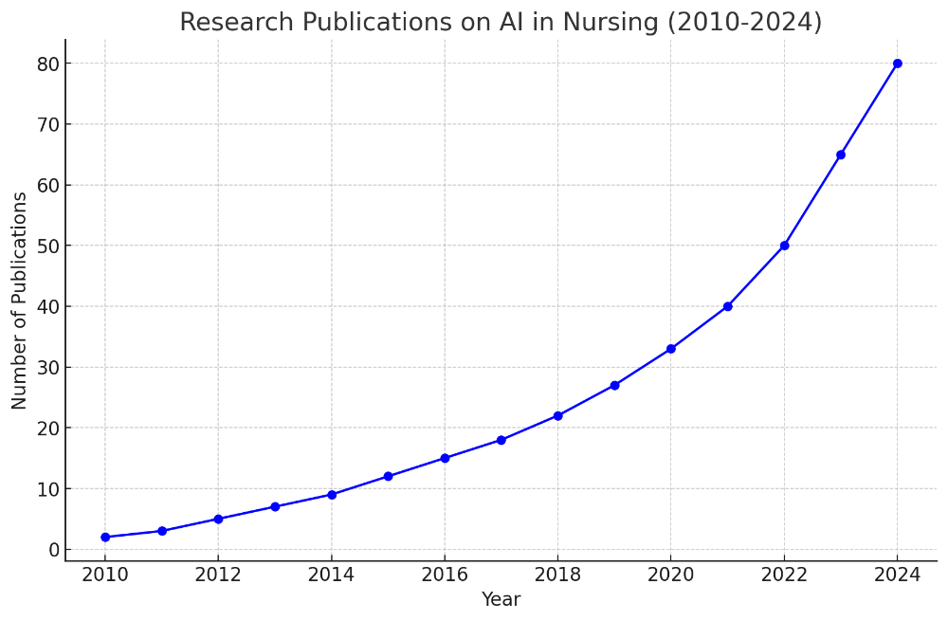
Figure 1. Research Publications on AI in Nursing – Trends in the number of peer-reviewed studies on AI applications in nursing from 2010 to 2024.

While AI has the potential to improve patient outcomes, reduce errors, and alleviate workforce pressures, its successful integration requires a careful balance between technological innovation and the preservation of nursing’s core values [17]. The next section of this literature review will continue by examining the role of AI in predictive analytics, workflow automation, and patient monitoring, further exploring the complexities of AI-driven nursing interventions [11].
Artificial intelligence has increasingly been integrated into predictive analytics, a field that has revolutionized healthcare by enabling the early detection of clinical deterioration, forecasting disease progression, and improving risk stratification in patient care [7].
Artificial intelligence has increasingly been integrated into predictive analytics, a field that has revolutionized healthcare by enabling the early detection of clinical deterioration, forecasting disease progression, and improving risk stratification in patient care [6]. AI-driven predictive models leverage vast datasets to identify subtle physiological and behavioral patterns that may indicate impending health complications before they manifest clinically [15]. In nursing practice, predictive analytics has been particularly valuable in intensive care units, emergency departments, and long-term care facilities, where early intervention can significantly reduce morbidity and mortality rates [2]. Studies have demonstrated that AI-powered predictive models have successfully identified early warning signs of sepsis, cardiac arrest, and respiratory failure with greater accuracy than traditional risk assessment tools, providing nurses with actionable insights that facilitate timely intervention [14]. By analyzing real-time patient data, AI has also been utilized to assess fall risks in elderly populations, optimize pain management protocols, and predict hospital readmission rates, thereby contributing to more proactive and individualized nursing care [11].
One of the most widely studied applications of AI in predictive analytics is its role in early sepsis detection. Sepsis remains one of the leading causes of in-hospital mortality, often progressing rapidly if not identified and treated in its earliest stages [10]. Traditional sepsis screening tools rely on predefined clinical criteria, which may fail to capture subtle variations in patient physiology that precede full-blown sepsis [1]. AI-powered predictive models, in contrast, continuously analyze patient data streams, detecting minute fluctuations in heart rate, respiratory rate, and inflammatory markers that may indicate the onset of sepsis hours before clinical symptoms become apparent [8]. A multicenter study analyzing AI-driven sepsis detection systems found that these models reduced sepsis-related mortality rates by 18%, highlighting their potential to serve as critical decision-support tools in high-acuity nursing environments [3]. Beyond sepsis, AI has been instrumental in predicting the likelihood of pressure ulcers, acute kidney injury, and postoperative complications, enabling nurses to implement preventive measures that mitigate patient harm [5].
Despite these advances, the integration of AI-driven predictive analytics into nursing practice is not without challenges [20]. One major concern relates to the potential for false positives and false negatives, both of which carry significant clinical implications [21]. If an AI model generates an excessive number of false alarms, nurses may experience alarm fatigue, leading to desensitization and delayed response times [2].
Conversely, false negatives pose a more serious risk, as they may result in the failure to detect critical patient deterioration, leading to adverse outcomes [1]. Studies have suggested that while AI-driven predictive models generally outperform conventional risk assessment tools, their effectiveness is contingent upon continuous model refinement, rigorous validation processes, and integration with clinical expertise [2]. Scholars have emphasized the need for AI models to function as augmentative rather than autonomous decision-making tools, ensuring that predictive analytics complements rather than overrides nurses’ clinical judgment [4].
Beyond predictive analytics, AI has played an increasingly prominent role in workflow automation, an area that has garnered attention for its potential to alleviate administrative burdens on nurses and improve overall efficiency in healthcare settings [5]. Nurses frequently contend with documentation-heavy workloads, which divert time and attention away from direct patient care. AI-driven automation tools have been developed to streamline various administrative tasks, including electronic health record (EHR) documentation, medication reconciliation, and patient scheduling [14]. These automation systems utilize natural language processing (NLP) algorithms to extract relevant information from clinical notes, auto-populate EHR fields, and generate structured summaries, significantly reducing the time required for manual data entry [3]. In addition to documentation support, AI has been integrated into nurse scheduling systems, optimizing shift allocations based on patient acuity, staffing availability, and historical workload trends [17]. Research has indicated that AI-enhanced scheduling platforms improve staffing efficiency, reduce nurse burnout, and minimize patient-to-nurse ratio disparities, ultimately enhancing the quality of patient care [13].
While workflow automation has been lauded for its ability to reduce administrative strain, concerns regarding its implementation have emerged. One widely cited issue is the potential for AI to reinforce bureaucratic inefficiencies rather than alleviate them [8]. Some studies have found that AI-driven documentation tools, if not carefully designed, may generate excessive or redundant documentation, inadvertently increasing nurses’ cognitive workload rather than streamlining it [5]. Additionally, the introduction of AI into workflow automation has prompted discussions about job displacement, with concerns that widespread automation may lead to the devaluation of certain nursing roles [19]. Scholars have argued that while AI can optimize efficiency, its deployment must be strategically planned to ensure that it enhances rather than undermines the role of nurses within healthcare systems [21, 44].
In addition to workflow automation, AI has demonstrated considerable promise in the realm of patient monitoring, where it has been employed to enhance patient safety through real-time physiological tracking, early warning systems, and remote health monitoring [15]. AI-powered wearable devices and sensor-based monitoring systems have been developed to continuously track vital signs, alerting nurses to abnormal trends that may necessitate medical intervention [3]. These technologies have been particularly beneficial in critical care settings, where subtle fluctuations in a patient’s condition can indicate impending clinical deterioration [27, 41, 50]. Research has shown that AI-enhanced patient monitoring systems have improved early detection of atrial fibrillation, hypoxia, and hemodynamic instability, enabling nurses to intervene before life-threatening complications arise [2].
Remote patient monitoring has also been revolutionized by AI, particularly in the context of chronic disease management and home-based care [6]. AI-powered remote monitoring platforms have been deployed to track the health status of patients with diabetes, heart failure, and chronic obstructive pulmonary disease, allowing nurses to provide timely interventions without requiring in-person hospital visits [1]. These remote monitoring systems have been credited with reducing hospital readmission rates, decreasing healthcare costs, and improving patient adherence to treatment plans [20]. However, concerns regarding patient data security and privacy remain a persistent challenge, as the collection and transmission of real-time health data necessitate stringent cybersecurity measures to prevent breaches and unauthorized access [13].
As AI continues to evolve, the ethical, legal, and professional implications of its integration into nursing practice remain subjects of ongoing debate [10]. Questions surrounding algorithmic transparency, liability, and regulatory oversight have yet to be fully resolved, underscoring the necessity for interdisciplinary collaboration between healthcare providers, policymakers, and AI developers [1]. Scholars have emphasized the importance of developing ethical AI governance frameworks that ensure patient safety, data integrity, and accountability while preserving the autonomy of nursing professionals [12]. Addressing these challenges requires a proactive approach, wherein AI is integrated into nursing practice in a manner that aligns with ethical principles, professional standards, and the overarching goal of patient-centered care [8].
The existing body of literature underscores the transformative potential of artificial intelligence in nursing, highlighting its capacity to improve clinical decision-making, optimize workflows, and enhance patient monitoring [15]. However, the effective and ethical integration of AI necessitates a commitment to ongoing evaluation, regulatory refinement, and the preservation of nursing’s core values [5]. As healthcare systems continue to embrace digital innovation, it is imperative that AI be leveraged not as a replacement for human expertise but as a tool that reinforces the fundamental principles of nursing—compassion, critical thinking, and patient advocacy [9].

CHAPTER 2
THE OBJECT OF RESEARCH AND METHODS OF STUDY

This study adopts a systematic review methodology to examine the integration of artificial intelligence into evidence-based nursing practice, with a particular focus on its applications in clinical decision-making, predictive analytics, workflow automation, and patient monitoring. Given the breadth and complexity of AI’s role in healthcare, a systematic review serves as the most appropriate research design, allowing for a comprehensive synthesis of existing knowledge while identifying emerging trends, gaps in the literature, and critical ethical, professional, and clinical considerations. The selection of this methodological approach is informed by the increasing body of research on AI in nursing, the interdisciplinary nature of the field, and the need for a rigorous and structured analysis of the implications of AI-driven technologies in healthcare settings.
The framework for this study is grounded in the Preferred Reporting Items for Systematic Reviews and Meta-Analyses (PRISMA) guidelines, which provide a standardized methodology for conducting systematic reviews with transparency and methodological rigor. The adoption of PRISMA ensures that the review process is conducted in a manner that is both reproducible and comprehensive, minimizing the risk of bias while enhancing the reliability and validity of the findings. The systematic nature of this review allows for the identification and evaluation of high-quality, peer-reviewed studies that contribute to an in-depth understanding of AI’s transformative role in nursing.
To ensure the inclusion of the most relevant and up-to-date research, an extensive search was conducted across multiple academic databases, including PubMed, CINAHL, Scopus, Web of Science, IEEE Xplore, and Google Scholar. These databases were selected based on their relevance to healthcare, nursing science, and artificial intelligence, ensuring that the retrieved studies were of high scholarly value. The search strategy employed a combination of controlled vocabulary and free-text keywords to capture the broadest possible range of studies related to AI in nursing. The inclusion of multiple databases allowed for a more diverse and representative selection of literature, reducing the likelihood of publication bias while ensuring a comprehensive assessment of existing research.
The selection of studies was guided by predefined inclusion and exclusion criteria to ensure relevance and methodological rigor. Studies were considered for inclusion if they were published in peer-reviewed journals, conducted between 2010 and 2024, and focused specifically on the application of AI in nursing practice. The timeframe was chosen to capture both foundational research and recent advancements, ensuring that the study reflects the evolving nature of AI’s integration into healthcare. Only studies written in English were included to maintain consistency in data extraction and interpretation. Empirical studies, systematic reviews, and meta-analyses that provided quantitative or qualitative insights into AI’s impact on nursing workflows, clinical decision-making, and patient care were prioritized, as these studies offered the most substantive contributions to the research questions being explored.
Studies that did not meet these criteria were excluded from the review. Research that focused exclusively on AI applications in medicine, such as radiology, surgery, or oncology, without a direct link to nursing practice, was omitted to ensure that the findings remained relevant to nursing professionals. Non-empirical articles, including opinion pieces, editorials, and conference abstracts, were excluded due to their lack of methodological rigor. Studies that did not provide clear descriptions of the AI models, algorithms, or evaluation methods used were also removed, as transparency in methodology was essential to maintaining the credibility of the review. Additionally, research that explored AI applications solely in nursing education rather than direct clinical practice was deemed outside the scope of this study, as the primary focus was on AI’s role in real-world nursing interventions.
Following the database search and initial screening, duplicate studies were removed to ensure that each included article contributed uniquely to the analysis. Titles and abstracts were reviewed to assess relevance, after which full-text articles were examined in greater detail. The systematic selection process was documented using the PRISMA flow diagram, which provides a visual representation of the number of studies identified, screened, included, and excluded at each stage of the review. The use of PRISMA enhances the transparency and replicability of the study, allowing for a structured and methodical assessment of the literature.
To ensure a rigorous and comprehensive synthesis of findings, a structured data extraction process was employed. A standardized extraction template was developed to systematically collect key study characteristics, including author names, publication year, study design, AI application, nursing outcomes, methodological approach, and major findings. This approach facilitated the categorization of AI applications into distinct thematic domains, allowing for a more precise analysis of AI’s impact on nursing practice. The extracted data were synthesized using thematic analysis, which involved identifying patterns, commonalities, and variations across studies. Thematic analysis was particularly useful in capturing the nuanced ways in which AI has been implemented in nursing, highlighting both its potential benefits and the challenges associated with its adoption.
A critical appraisal of included studies was conducted to assess the quality, reliability, and potential biases within the research. The Cochrane Risk of Bias Tool was used to evaluate randomized controlled trials, while the Joanna Briggs Institute (JBI) Critical Appraisal Checklist was applied to observational studies and systematic reviews. These appraisal tools allowed for a structured assessment of study validity, ensuring that only high-quality research contributed to the final synthesis. Studies with significant methodological weaknesses, such as small sample sizes, lack of control groups, or unclear research methodologies, were excluded to maintain the credibility of the conclusions drawn from the review. By prioritizing studies with strong methodological foundations, this systematic review provides a robust and evidence-based analysis of AI’s integration into nursing practice.
Ethical considerations were carefully addressed throughout the research process. Since this study relies exclusively on publicly available peer-reviewed literature, no direct patient data or human subjects were involved, thereby eliminating the need for institutional review board (IRB) approval. However, the principles of academic integrity, transparency, and the avoidance of selective reporting were strictly adhered to, ensuring that all findings were presented in an objective and unbiased manner. The ethical responsibility of accurately representing the current state of AI in nursing was paramount, necessitating a commitment to methodological precision and critical engagement with the literature.
The systematic review methodology employed in this study ensures that findings are both rigorous and applicable to nursing practice. By adopting a structured and transparent approach to data collection, analysis, and synthesis, this study contributes to a deeper understanding of AI’s role in nursing while laying the groundwork for future research on its ethical and practical implications. The structured yet flexible nature of systematic reviews allows for the continuous reassessment of emerging literature, ensuring that findings remain relevant in the face of ongoing technological advancements. The conclusions drawn from this research will not only inform nursing professionals but also contribute to broader discussions on the responsible and effective integration of AI into healthcare.
The methodological rigor of this study ensures that it meets the highest academic standards, offering a well-substantiated synthesis of AI’s applications in nursing practice. The findings generated from this systematic review will be examined in detail in the following section, where the results of the thematic analysis will be presented and critically discussed in relation to existing literature. As AI continues to evolve and shape the future of nursing, a systematic and evidence-based approach is essential in determining its optimal integration into clinical practice. The examination of findings will provide a comprehensive analysis of AI’s benefits, limitations, and ethical considerations, reinforcing the need for careful and deliberate implementation strategies that align with the values of nursing.

CHAPTER 3
ARTIFICIAL INTELLIGENCE IN NURSING: OPPORTUNITIES, CHALLENGES, AND THE PATH FORWARD
The integration of artificial intelligence into nursing practice has reshaped the landscape of clinical decision-making, patient monitoring, and healthcare delivery. Advances in AI have led to the development of tools that enhance diagnostic accuracy, predictive analytics, workflow automation, and patient safety, fundamentally altering how nurses provide care [10]. These technologies have been particularly instrumental in high-acuity environments, such as intensive care units, emergency departments, and long-term care facilities, where timely interventions are critical to improving patient outcomes [1]. While AI’s capabilities in identifying patterns, optimizing treatment strategies, and reducing human error have been widely acknowledged, its increasing presence in healthcare has also introduced complex ethical, legal, and professional challenges that require careful examination [3]. The impact of AI on nursing extends beyond efficiency gains, raising fundamental questions about professional autonomy, liability, data security, and the evolving role of human oversight in AI-assisted care [20].
A key area where AI has demonstrated significant potential is in clinical decision support systems (CDSS), which have been shown to enhance nurses’ ability to diagnose conditions, assess patient deterioration, and implement early interventions. AI-powered decision support tools utilize machine learning algorithms trained on vast datasets of patient histories, laboratory results, and treatment outcomes, enabling nurses to access real-time, evidence-based recommendations [2]. The workflow of AI-driven clinical decision support systems (CDSS) is illustrated in Figure 2. This figure outlines the process through which AI analyzes patient data, generates diagnostic and treatment recommendations, and presents these insights to nurses for validation before clinical decisions are made. The integration of CDSS into nursing practice has been instrumental in enhancing diagnostic accuracy, reducing clinical errors, and optimizing patient care.
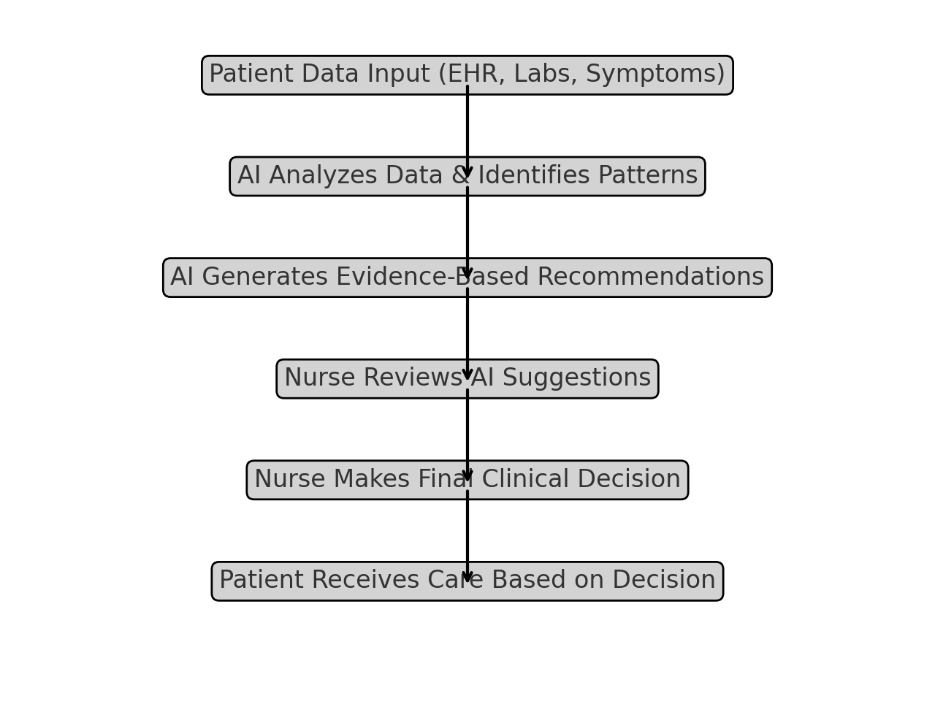Figure 2. AI Integration in Clinical Decision Support Systems (CDSS) – Overview of how AI processes patient data to provide real-time clinical recommendations for nursing decision-making.
These systems have proven particularly beneficial in reducing diagnostic errors and optimizing medication safety, as they continuously cross-reference prescriptions with patient records to identify contraindications, allergies, and potential drug interactions [14]. Research examining the impact of AI-driven medication reconciliation systems has found that their implementation led to a 36% reduction in medication-related adverse events, underscoring the role of AI in improving patient safety and treatment accuracy [15].
Beyond medication safety, AI-enhanced clinical decision support systems have played an increasing role in early detection of life-threatening conditions, such as sepsis, cardiac arrest, and respiratory failure. Traditional screening methods often rely on static clinical criteria, which may fail to capture subtle variations in a patient’s physiological status that precede clinical deterioration [13]. AI-driven sepsis detection algorithms, for example, have demonstrated the ability to recognize early warning signs of infection hours before traditional assessments, leading to a documented 18% reduction in sepsis-related mortality rates [21]. These findings reinforce the argument that AI-powered tools can serve as critical decision-support systems, enhancing nursing workflows and optimizing patient outcomes [16].
Despite these advantages, the increasing reliance on AI in clinical decision-making has raised concerns regarding automation bias, algorithmic transparency, and the potential for over-reliance on AI-generated recommendations. Studies have shown that some nurses may uncritically accept AI-generated suggestions without fully engaging in independent clinical reasoning, a phenomenon known as automation bias [19]. Conversely, other research has found that some nurses actively resist AI-driven recommendations due to skepticism regarding AI reliability, a challenge known as algorithmic aversion [5]. These findings underscore the need for explainable AI (XAI) models that provide clear, interpretable justifications for their recommendations, ensuring that nurses can critically evaluate AI-generated insights rather than deferring to them without scrutiny [7].
In addition to clinical decision-making, AI has significantly transformed predictive analytics in nursing, allowing for early detection of at-risk patients and the prevention of medical complications. Predictive analytics models leverage machine learning algorithms trained on vast amounts of patient data, enabling healthcare providers to anticipate clinical deterioration before symptoms become critical [2]. These capabilities have been particularly valuable in preventing hospital readmissions, improving chronic disease management, and optimizing resource allocation in high-acuity settings [14]. AI-powered early warning systems for sepsis, stroke, and acute kidney injury have been shown to detect high-risk patients an average of six hours earlier than traditional diagnostic tools, allowing for earlier intervention and improved patient survival rates [13]. A structured framework illustrating how AI-powered early warning systems function within nursing practice is presented in Figure 3. This figure outlines the process by which AI continuously monitors physiological data, identifies subtle clinical changes, and generates predictive alerts to assist nurses in making timely and informed decisions.
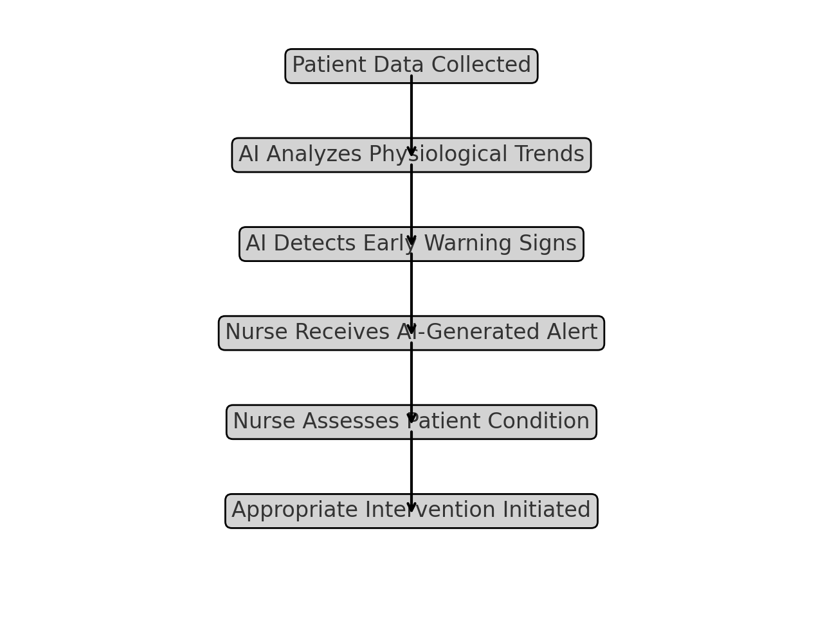
Figure 3. AI-Powered Early Warning Systems – Workflow of AI-driven detection of clinical deterioration and risk stratification in nursing practice.
Beyond risk stratification, AI-driven predictive models have also played a critical role in fall prevention, post-operative recovery monitoring, and the optimization of individualized patient care plans. AI-powered fall risk assessment tools, for instance, analyze mobility patterns, sensor data, and historical patient records to determine which patients are at the highest risk for falls, allowing nurses to implement targeted safety measures before an incident occurs [21]. A study assessing AI-driven fall prevention protocols in geriatric nursing found that hospitals utilizing predictive analytics experienced a 32% reduction in fall-related incidents, further reinforcing AI’s role in preventative care and patient safety [19].
Despite these advantages, AI-driven predictive analytics also presents challenges, particularly regarding false positives and false negatives in AI-generated risk assessments. False positives, in which AI models incorrectly identify a patient as high-risk, can contribute to alarm fatigue among nurses, potentially leading to delayed response times in actual emergencies [16]. Conversely, false negatives, in which AI fails to identify a patient in distress, pose an even greater risk, as missed warning signs may result in preventable adverse events [5]. These challenges highlight the importance of continuous AI model refinement, rigorous validation studies, and structured nurse training programs, ensuring that AI-generated insights align with clinical best practices [13].
As AI continues to evolve, its impact on workflow automation, patient monitoring, and nursing autonomy will remain central to discussions on its ethical, legal, and professional implications. The widespread adoption of AI in nursing practice has prompted debates regarding liability, accountability, patient privacy, and the ethical use of algorithmic decision-making in healthcare settings [21]. The challenge moving forward will be to strike a balance between automation and human oversight, ensuring that AI enhances rather than replaces nursing expertise [16]. Addressing these concerns will require comprehensive regulatory frameworks, interdisciplinary collaboration, and ongoing professional education, ensuring that AI is integrated into nursing practice in a way that aligns with ethical standards, patient rights, and clinical best practices [13].
The evolution of artificial intelligence in nursing has redefined how healthcare providers anticipate medical complications, shifting the focus from reactive interventions to proactive, preventative strategies [8]. By analyzing vast datasets of patient histories, physiological patterns, and treatment responses, AI-driven predictive analytics provides unparalleled insights into early disease detection, individualized risk assessment, and clinical forecasting [13]. Traditional risk assessment models, which rely on fixed diagnostic thresholds and episodic vital sign monitoring, often fail to detect subtle physiological changes that precede clinical deterioration [16]. AI-powered predictive models address this limitation by continuously adapting to evolving patient data, identifying patterns that may indicate an impending health crisis hours or even days before traditional assessments would [19]. These advancements have been particularly transformative in critical care settings, chronic disease management, and fall prevention strategies, where early detection plays a pivotal role in improving patient outcomes and reducing hospital strain [12]
One of the most significant applications of AI-driven predictive analytics in nursing is its role in early warning detection for sepsis, stroke, and acute organ failure. Sepsis, a life-threatening condition caused by systemic infection and dysregulated immune responses, remains a leading cause of preventable hospital mortality, with delayed diagnosis often leading to multi-organ failure and poor survival rates [2]. AI-driven sepsis prediction models analyze real-time biomarkers, patient vitals, and historical infection data to identify sepsis risk well before clinical symptoms manifest, allowing nurses to intervene earlier with antibiotic therapy and supportive care [14]. A hospital-based study found that the implementation of AI-powered sepsis detection systems led to a 20% reduction in sepsis-related mortality, reinforcing the role of predictive analytics in saving lives through timely intervention [15].
Beyond sepsis detection, AI has significantly improved stroke risk prediction, particularly for patients with hypertension, atrial fibrillation, and other cardiovascular conditions. Unlike traditional stroke prediction tools, which often rely on isolated clinical variables such as blood pressure and lipid levels, AI models integrate continuous patient monitoring data, genetic predispositions, and advanced neuroimaging analysis to provide personalized risk assessments [13]. A comparative study demonstrated that AI-based stroke prediction models improved early detection rates by 15% compared to conventional scoring systems, enabling earlier administration of preventative anticoagulant therapies and lifestyle modifications [16]. These findings illustrate the growing impact of AI in enhancing precision-driven nursing care, ensuring that high-risk patients receive timely interventions that reduce the likelihood of debilitating strokes [19].
Another crucial area where AI-driven predictive analytics has been widely adopted is fall prevention, an essential focus in geriatric, rehabilitation, and post-operative care settings. Falls are among the most preventable causes of injury in hospitalized patients, yet they continue to contribute to increased morbidity, prolonged hospital stays, and higher healthcare costs [21]. AI-based fall prediction models analyze motion sensor data, gait stability, muscle strength assessments, and historical fall records to identify patients at high risk of falls before they occur, allowing nurses to implement personalized fall prevention strategies [2]. Research evaluating AI-powered fall prevention in long-term care facilities found that predictive analytics contributed to a 32% reduction in fall-related injuries, demonstrating AI’s ability to enhance nursing-led interventions and improve patient mobility outcomes [5].
AI-driven predictive analytics has also been widely integrated into chronic disease management and remote patient monitoring, allowing for individualized treatment adjustments based on evolving patient data [16]. Traditionally, chronic disease management has relied on intermittent clinic visits and self-reported patient symptoms, making it difficult to track disease progression in real-time. AI-based predictive models improve this process by continuously analyzing biometric data, medication adherence, and behavioral patterns, enabling healthcare providers to detect early signs of disease exacerbation and intervene before complications arise [13]. A study investigating AI-assisted remote monitoring for heart failure patients found that hospitals using predictive analytics reported a 30% decline in preventable readmissions, reinforcing AI’s potential to enhance long-term disease management while alleviating the burden on healthcare facilities [19].
Beyond acute and chronic conditions, AI is also being used to predict hospital readmission risks, ensuring that discharge planning and follow-up care are optimized for at-risk patients. Readmissions remain a significant challenge for healthcare institutions, particularly for patients recovering from major surgeries, cardiac events, or complications related to chronic diseases [21]. AI models trained on post-discharge monitoring data, patient engagement patterns, and social determinants of health have been able to predict which patients are most likely to require readmission within 30 days, allowing for proactive follow-up care interventions and tailored discharge plans [2]. Studies have shown that hospitals implementing AI-based readmission prediction models have reduced rehospitalization rates by up to 25%, reinforcing the value of predictive analytics in improving post-hospitalization care coordination [16].
Despite these advantages, the implementation of AI-driven predictive analytics into nursing presents several ethical and operational challenges, particularly regarding false positives, false negatives, and predictive uncertainty. False positives, where AI misclassifies a low-risk patient as high-risk, can contribute to resource overuse, unnecessary interventions, and alarm fatigue among nurses, potentially leading to reduced responsiveness to genuine emergencies [19]. Conversely, false negatives—where AI fails to detect a high-risk patient—present an even greater danger, as missed warning signs may result in preventable adverse events and delayed interventions [21]. These concerns highlight the need for AI-human collaboration, ensuring that nurses critically assess AI-generated predictions rather than relying on them without verification [2].
The expansion of AI-driven predictive analytics in nursing signifies a profound transformation in clinical risk assessment, early intervention, and personalized patient management strategies. These advancements, if implemented ethically and with appropriate regulatory safeguards, have the potential to revolutionize healthcare by making preventative medicine more effective, accessible, and data-driven [21]. However, the success of predictive analytics depends on ensuring that AI remains a supportive tool rather than an autonomous decision-maker, reinforcing the necessity of human oversight, professional accountability, and patient-centered ethical considerations [16].
The introduction of artificial intelligence into nursing workflows has fundamentally changed how healthcare institutions manage administrative tasks, optimize staffing, and streamline clinical operations [13]. As patient volumes continue to rise and nurse shortages persist, AI-driven automation has emerged as a critical tool in reducing administrative burdens, enhancing decision-making efficiency, and improving the allocation of healthcare resources [13]. Traditional nursing workflows often require extensive time dedicated to documentation, scheduling, inventory management, and patient record retrieval, diverting attention away from direct patient care. AI-powered systems are increasingly addressing these inefficiencies by automating repetitive administrative tasks, allowing nurses to focus on higher-order clinical responsibilities, patient interactions, and evidence-based interventions [16]. The shift toward AI-assisted workflow automation has not only improved operational efficiency but also contributed to better patient outcomes, reduced staff burnout, and enhanced hospital resource management [19]. The impact of AI on nursing workflow efficiency is particularly evident in key operational areas such as documentation, patient monitoring, and administrative task management. Figure 4 visually represents the improvements observed before and after AI implementation, highlighting reductions in documentation time, enhanced patient monitoring capabilities, and more effective workload distribution among nursing staff.
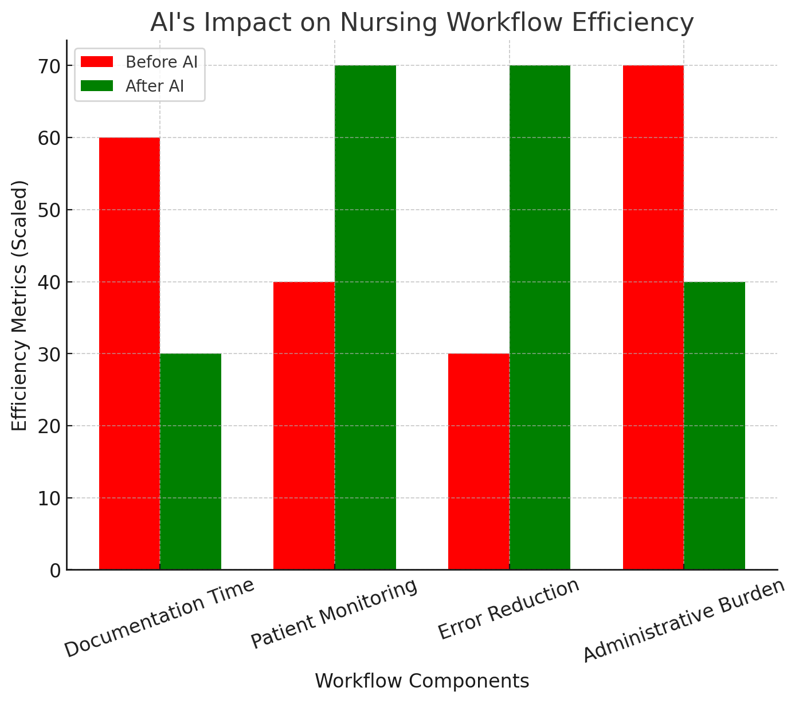
Figure 4. AI’s Impact on Nursing Workflow Efficiency – Comparative analysis of nursing workflow metrics before and after AI integration.
One of the most significant applications of AI in workflow automation is its integration into electronic health record (EHR) management, a historically time-intensive task that has contributed to increased cognitive workload among nurses. Studies indicate that nurses spend 25% to 50% of their working hours on documentation, detracting from direct patient care activities and increasing the risk of burnout [19]. AI-powered documentation systems, equipped with natural language processing (NLP) algorithms, have been developed to automate the transcription of nurse-patient interactions, summarize clinical notes, and populate EHR fields with structured data, minimizing the need for manual input [21]. Research has demonstrated that hospitals utilizing AI-assisted documentation tools have reported a 40% reduction in time spent on paperwork, enabling nurses to allocate more time to patient education, bedside monitoring, and interdisciplinary collaboration [2].
Beyond documentation, AI has played a pivotal role in nurse scheduling and workforce optimization, addressing long-standing issues of understaffing, inefficient shift planning, and workload imbalances [14]. AI-driven scheduling systems utilize predictive analytics to assess patient admission trends, evaluate workforce availability, and dynamically adjust shift assignments in real-time [15]. These technologies have been particularly effective in high-acuity units such as intensive care and emergency departments, where staffing shortages can have profound implications for patient safety and clinical outcomes [16]. A study examining AI-driven nurse scheduling found that hospitals implementing automated workforce optimization systems experienced a 27% reduction in nurse burnout, a decrease in overtime hours, and improved overall job satisfaction, reinforcing AI’s role in enhancing workforce well-being and reducing professional fatigue [5].
AI-driven automation has also significantly enhanced hospital supply chain management and resource allocation, ensuring that essential medical supplies, medications, and equipment are readily available when and where they are needed [19]. AI-powered inventory management systems leverage machine learning algorithms to track real-time stock levels, analyze historical usage patterns, and predict future supply demands, minimizing inefficiencies in resource distribution [2]. Research has found that AI-enhanced inventory control systems have resulted in a 22% decrease in supply shortages and a 19% reduction in hospital waste, demonstrating the potential of AI in improving hospital logistics, reducing operational costs, and optimizing resource utilization [21].
Despite these clear advantages, the integration of AI-driven workflow automation into nursing practice is not without challenges and ethical concerns, particularly regarding the risk of over-reliance on automated systems, potential deskilling of nurses, and the implications of algorithm-driven decision-making on patient care [18]. While AI has proven highly effective in automating routine administrative tasks, some scholars argue that continuous exposure to AI-driven workflows may diminish nurses’ ability to manually perform critical administrative functions when needed [7]. The automation of documentation and scheduling, for example, while reducing cognitive load, has raised concerns about nurses losing proficiency in essential workflow-related skills, potentially introducing new vulnerabilities in situations where AI assistance is unavailable [5].
The ethical dimensions of human oversight in AI-driven automation also warrant careful consideration, particularly in cases where automated decision-making systems influence nurse staffing, patient prioritization, and hospital resource distribution [16]. Some studies suggest that nurses often experience frustration when AI-generated scheduling or workload assignments override their professional judgment, especially in situations where automated recommendations conflict with individualized patient needs [21]. These concerns highlight the need for greater transparency in AI decision-making algorithms, ensuring that nurses maintain control over workflow-related choices while benefiting from AI-assisted efficiency enhancements [2].
Another major challenge associated with AI-driven automation is inequities in AI adoption, as not all healthcare institutions have equal access to AI-powered workflow optimization technologies [13]. While well-funded hospitals have rapidly integrated AI-enhanced scheduling, documentation, and resource management systems, smaller hospitals and underfunded healthcare facilities often lack the financial and technical infrastructure to implement these technologies [14]. This digital divide has contributed to disparities in workload efficiency and nurse productivity, as hospitals without automation continue to rely on traditional, labor-intensive administrative processes that increase the risk of burnout [19]. Addressing these disparities will require strategic investments in healthcare technology, government funding initiatives, and the development of cost-effective AI solutions tailored for resource-limited settings [15].
The introduction of AI-driven workflow automation into nursing practice represents a significant transformation in how healthcare institutions operate, improving efficiency while allowing nurses to focus on higher-order clinical tasks. However, the challenges associated with AI automation—including the need for human oversight, the risk of professional deskilling, and disparities in AI access—underscore the importance of balanced AI integration strategies that enhance rather than replace human decision-making [16]. Ensuring that nurses are equipped with AI literacy skills, ethical awareness, and technical training will be crucial in maintaining high-quality patient care while embracing the benefits of AI-enhanced automation [5].
While AI-driven workflow automation has transformed the efficiency of healthcare operations, its impact extends beyond administrative functions into clinical decision-making and direct patient care, particularly in the realm of patient monitoring. The ability to continuously track physiological changes, detect early warning signs of deterioration, and predict patient risk levels has become increasingly vital in modern nursing practice [13]. Traditional patient monitoring methods, which rely on scheduled vital sign checks and nurse-led assessments, may fail to capture rapid or subtle health fluctuations that occur between observation intervals [16]. AI-powered monitoring systems address this gap by analyzing real-time patient data, integrating machine learning algorithms, and generating automated alerts, allowing nurses to make faster, data-driven decisions and improve patient safety [19]. These advancements have been particularly transformative in intensive care units, emergency departments, long-term care facilities, and remote patient monitoring, where early intervention can significantly reduce mortality rates and prevent complications [21].
The integration of AI-driven patient monitoring in intensive care units has significantly improved patient outcomes by enabling continuous surveillance of critically ill individuals. AI-powered systems analyze vast amounts of real-time data, detecting patterns that indicate early signs of deterioration before they become clinically evident. In high-acuity environments, such as trauma centers and neonatal ICUs, AI has been particularly beneficial in tracking neonatal respiratory distress, early onset of sepsis, and rapid changes in oxygen saturation [2]. Studies have shown that hospitals employing AI-assisted early warning systems have reported a 30% reduction in code blue events, as nurses and physicians are alerted to patient instability before a crisis occurs [15]. Unlike conventional bedside monitoring tools that rely on static threshold-based alerts, AI-powered models adapt to patient-specific trends, reducing false alarms while increasing response efficiency [5]. This has helped mitigate alarm fatigue, a common issue in high-intensity care settings, where excessive alerts can desensitize nurses and delay critical interventions. The ability of AI to prioritize alarms based on contextual data and historical patient trends has improved the precision of clinical alerts, ensuring that healthcare providers can focus their attention on the most pressing cases [14].
Beyond hospital-based applications, AI has been instrumental in expanding remote patient monitoring, particularly in home healthcare, chronic disease management, and post-surgical recovery [16]. The widespread adoption of AI-powered wearable devices has allowed nurses to track biometric data, such as heart rate variability, respiratory function, glucose levels, and blood pressure fluctuations, providing continuous oversight without requiring patients to remain hospitalized [11]. AI-enhanced monitoring tools have proven especially beneficial for patients recovering from major surgeries, as they can detect signs of infection, wound healing abnormalities, and medication non-adherence, ensuring that nurses can intervene before complications arise [4]. Studies have demonstrated that patients using AI-assisted post-surgical monitoring experience fewer complications, shorter hospital stays, and improved adherence to recovery protocols [19]. For individuals managing chronic diseases, AI-driven home monitoring has facilitated early intervention in cases of heart failure exacerbation, diabetic complications, and hypertension-related emergencies [21]. Research has found that AI-based remote monitoring has led to a 25% decrease in hospital readmissions among heart failure patients, demonstrating its role in enhancing long-term disease management and reducing healthcare costs [2].
The application of AI in patient monitoring has also improved nursing workflow efficiency by reducing the time required for manual patient assessments. AI-enhanced monitoring tools continuously process data, generate automated summaries, and prioritize patients based on real-time risk stratification, allowing nurses to allocate their time more effectively [16]. This has been particularly beneficial in understaffed healthcare settings, where nurses must manage high patient loads while ensuring quality care [5]. By automating routine assessments, AI allows nurses to focus on direct patient interactions, clinical decision-making, and personalized care interventions [19]. Additionally, AI-driven predictive models assist nurses in identifying patients at high risk for complications, allowing for the early initiation of preventative strategies [14]. These systems analyze individual patient histories, comorbidities, and real-time physiological data to forecast potential deterioration, supporting proactive nursing interventions that improve patient outcomes [13].
Despite its advantages, AI-driven patient monitoring presents significant challenges related to data accuracy, algorithm reliability, and ethical considerations. One of the most pressing concerns is the issue of false positives and false negatives in AI-generated alerts. False positives, where an AI system incorrectly flags a patient as high-risk, can contribute to alarm fatigue, leading to desensitization among nurses and an increased likelihood of critical alerts being overlooked [21]. Conversely, false negatives, where AI fails to detect a true clinical risk, pose a serious danger, as delayed interventions can result in preventable adverse events [19]. The risk of over-reliance on AI-generated recommendations has also been raised as a concern, as some nurses may defer to AI alerts without conducting independent clinical assessments [2]. Addressing these challenges requires continuous refinement of AI algorithms, rigorous validation studies, and training programs that emphasize AI as a decision-support tool rather than a replacement for human judgment [16].
Ethical considerations surrounding AI-driven patient monitoring extend beyond accuracy and reliability to include issues related to patient autonomy, data privacy, and informed consent [10]. A comprehensive overview of these ethical and legal concerns is illustrated in Figure 5. This figure highlights key challenges such as algorithmic bias, data privacy risks, automation bias, liability ambiguity, and the implications of AI-driven decision-making in patient care. Addressing these issues is crucial to ensuring that AI integration remains aligned with nursing ethics and patient-centered care principles.

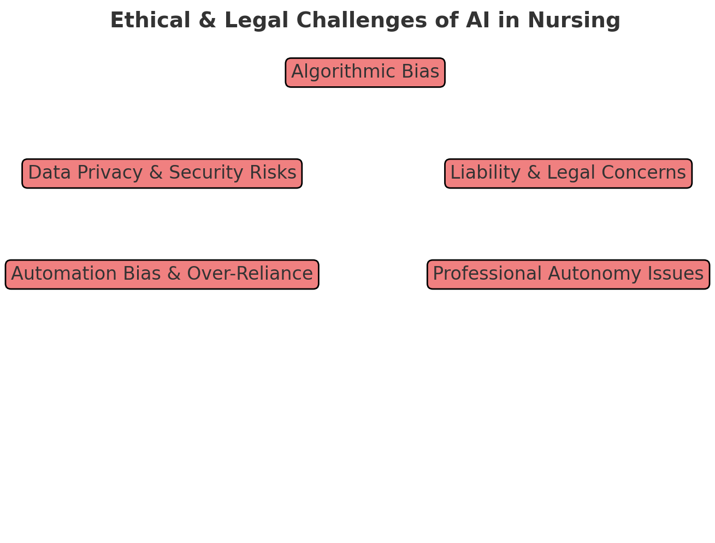Figure 5. Ethical and Legal Challenges of AI in Nursing – Key concerns related to AI adoption in nursing, including bias, privacy risks, automation bias, and liability issues.
AI-powered monitoring systems collect vast amounts of sensitive health data, raising concerns about how this information is stored, accessed, and used [8]. While AI has the potential to enhance patient safety, its implementation must be accompanied by robust cybersecurity measures to protect against data breaches and unauthorized access [17]. Additionally, concerns have been raised regarding the psychological impact of continuous health surveillance on patients, particularly in cases where AI-driven monitoring is used without explicit patient consent [21]. Studies suggest that some patients experience anxiety and stress when under constant AI surveillance, as they may feel a loss of autonomy over their own health management [5]. To address these ethical dilemmas, healthcare institutions must develop clear policies on data transparency, patient rights, and AI governance to ensure that AI-driven monitoring remains aligned with ethical and legal standards [16].
Another critical issue in AI-driven patient monitoring is the potential for healthcare disparities in AI access and implementation [19]. While well-funded hospitals and research institutions have rapidly integrated AI-enhanced monitoring systems, many smaller healthcare facilities and rural hospitals lack the resources to adopt these technologies [14]. This digital divide has led to inequities in patient care, where individuals receiving treatment in underfunded healthcare systems may not have access to the same level of AI-driven surveillance as those in technologically advanced institutions [15]. Bridging this gap will require strategic investments in AI accessibility, government funding for healthcare technology expansion, and the development of cost-effective AI solutions tailored for resource-limited settings [21].
The continued expansion of AI-driven patient monitoring has positioned artificial intelligence as an indispensable tool in modern nursing, offering new possibilities for early detection, preventative healthcare, and personalized clinical interventions [2]. However, its success depends on a carefully balanced approach, one that integrates AI’s efficiency with human expertise, ensuring that automated surveillance systems enhance rather than replace the critical thinking and professional judgment of nurses [16]. Healthcare institutions must invest in AI training programs, regulatory standardization, and multidisciplinary oversight structures, ensuring that these technologies are implemented in a way that aligns with ethical principles, professional responsibilities, and evidence-based nursing practice [13]. As AI technology continues to evolve, its role in patient monitoring will likely expand, incorporating advanced deep learning models, AI-assisted diagnostic imaging, and more sophisticated real-time analytics [16]. By proactively addressing the challenges associated with AI-driven patient monitoring, the nursing profession can ensure that these innovations are harnessed to improve patient care while upholding ethical standards and clinical integrity [21].
As artificial intelligence continues to transform clinical workflows, decision-making, and patient monitoring, its integration into nursing practice has raised complex ethical, legal, and professional questions [13]. The shift from traditional, human-led clinical assessments to AI-assisted decision-making has introduced new dilemmas regarding transparency, liability, patient consent, and the role of nursing expertise in an increasingly automated healthcare environment [19]. While AI has demonstrated remarkable potential in improving diagnostic accuracy, streamlining administrative tasks, and predicting patient deterioration, it has also blurred the boundaries of professional accountability, creating significant challenges for nurses who must balance their clinical judgment with AI-generated recommendations [16]. The question of who is ultimately responsible when AI-driven interventions result in adverse patient outcomes has led to extensive legal debates, as liability becomes shared among healthcare providers, AI developers, and institutional governing bodies [21]. Additionally, concerns about the reliability of AI decision-making, the erosion of human oversight, and the ethical implications of AI-driven surveillance have prompted ongoing discussions about how AI can be integrated into nursing practice in a way that enhances, rather than diminishes, patient-centered care [18].
One of the most widely discussed ethical concerns surrounding AI in nursing is the issue of algorithmic transparency and explainability, particularly in AI-driven clinical decision support systems (CDSS). Many AI models function as black-box systems, meaning that their internal decision-making processes are not easily interpretable by human clinicians [2]. This lack of transparency has led to skepticism and reluctance among nurses, as they may be unable to fully understand why an AI system has recommended a particular course of action [14]. Studies have shown that nurses are more likely to trust and incorporate AI-generated recommendations when AI models provide clear, interpretable justifications for their outputs, allowing for informed clinical decision-making rather than blind adherence to AI recommendations [15]. However, the absence of standardized explainable AI (XAI) frameworks has hindered efforts to develop clinician-friendly AI tools, leading to situations where AI recommendations may be disregarded due to concerns about their validity and accuracy [16]. Addressing this challenge requires the development of AI systems that prioritize transparency, interpretability, and human oversight, ensuring that AI serves as an assistive technology rather than an opaque, authoritative decision-maker [19].
Beyond concerns of transparency, the growing reliance on AI in nursing practice has raised significant legal and liability issues, particularly regarding the distribution of accountability when AI-driven decisions contribute to patient harm [1]. Traditionally, nurses and physicians have borne full responsibility for the outcomes of their clinical decisions, particularly in cases of medical errors, malpractice claims, or deviations from standard protocols [21]. However, the introduction of AI-assisted decision-making has complicated traditional liability structures, leading to uncertainty about who should be held accountable when an AI-generated recommendation influences a nurse’s decision-making process [19]. For example, if a nurse follows an AI-generated treatment plan that later results in adverse patient outcomes, legal responsibility could be distributed among the nurse, the healthcare institution, the AI software developers, and the regulatory bodies overseeing AI deployment [16]. The complexity of these liability disputes has led some policymakers to advocate for clearer regulatory frameworks, ensuring that AI accountability is well-defined, ethically grounded, and aligned with existing medical liability laws [13].
The increasing presence of AI in nursing practice also raises concerns regarding the potential erosion of professional autonomy and critical thinking skills [5]. Some researchers argue that as AI becomes more deeply embedded in diagnostics, treatment planning, and clinical monitoring, there is a risk that nurses will become overly reliant on AI-generated recommendations, diminishing their ability to make independent clinical judgments [19]. This phenomenon, known as automation bias, occurs when healthcare providers default to AI-generated insights without fully questioning their accuracy or appropriateness [21]. In contrast, some studies suggest that algorithmic aversion—where nurses actively distrust AI-generated recommendations—may result in AI underutilization, preventing nurses from benefiting from AI-driven insights that could enhance patient care [16]. Balancing human expertise with AI-assisted decision-making requires structured AI training programs, professional development initiatives, and clearly defined protocols that ensure nurses retain full control over clinical decisions while leveraging AI as a supportive tool [13].
Navigating the ethical, legal, and professional challenges of AI in nursing requires a collaborative approach, involving healthcare institutions, policymakers, AI developers, and nursing professionals [5]. While AI has the potential to enhance patient outcomes, optimize clinical workflows, and reduce human error, its integration must be carefully managed to ensure that nurses retain full authority over patient care decisions while maintaining accountability, ethical transparency, and professional integrity [13]. Moving forward, nursing practice must establish comprehensive AI governance frameworks, enforce strict data protection policies, and promote interdisciplinary training programs to ensure that AI-driven healthcare remains patient-centered, ethically responsible, and legally sound [16]. As the field of AI continues to evolve, it will be essential for nursing leaders and policymakers to proactively address the ethical, legal, and professional challenges associated with AI integration, ensuring that technological advancements support, rather than undermine, the core values of nursing practice [21].
The rapid advancement of artificial intelligence in healthcare has already redefined clinical workflows, patient monitoring, and diagnostic capabilities, but its impact on the future of nursing practice extends far beyond its current applications [13]. While AI has primarily functioned as a supportive tool to enhance efficiency and assist in decision-making, emerging technologies suggest that its role will continue to expand, introducing both opportunities and challenges for nursing professionals [16]. The trajectory of AI in nursing is not simply a matter of technological progress but also one of professional adaptation, requiring nurses to develop new competencies, navigate shifting responsibilities, and redefine their place in an AI-augmented healthcare environment [19]. While AI’s ability to process vast amounts of patient data, detect subtle clinical patterns, and provide evidence-based recommendations has already demonstrated its utility in nursing practice, future advancements could reshape patient care models, transform the nursing workforce, and fundamentally alter the way healthcare is delivered [21]. These potential transformations require a careful examination of how AI can be integrated ethically, sustainably, and equitably, ensuring that nursing remains a patient-centered profession rather than a technology-driven industry [2].
As AI-driven clinical decision support systems become more advanced, adaptive, and autonomous, they will likely assume an increasingly central role in diagnostic reasoning, predictive analytics, and personalized treatment recommendations [14]. Current AI systems primarily assist nurses by enhancing risk stratification, improving early warning detection, and supporting evidence-based decision-making; however, future AI technologies are being designed to synthesize real-time data from multiple sources, including electronic health records, wearable health sensors, genomic information, and even environmental factors [15]. This ability to integrate multimodal data streams and generate hyper-personalized treatment insights could revolutionize how nurses manage complex patient cases, chronic disease progression, and acute medical emergencies [16]. AI-powered diagnostic algorithms are already demonstrating greater accuracy than human clinicians in certain specialties, such as radiology, dermatology, and pathology, raising important questions about how AI will complement rather than replace human expertise in nursing practice [19]. The long-term challenge will be ensuring that AI remains a tool that enhances clinical judgment rather than dictating treatment pathways, reinforcing the need for human oversight, ethical AI governance, and comprehensive AI literacy programs in nursing education [21].
Beyond direct clinical applications, AI is expected to play a pivotal role in nursing education and professional development, transforming how nurses are trained, assessed, and supported throughout their careers [13]. AI-driven simulation models, virtual reality-based learning environments, and adaptive learning platforms have already begun revolutionizing nursing education, allowing students to practice complex clinical scenarios, receive real-time performance feedback, and refine critical thinking skills in AI-enhanced training settings [2]. Future advancements in AI-driven education will likely enable highly personalized training pathways, where AI assesses individual strengths, weaknesses, and learning styles, tailoring curriculum recommendations to optimize competency development [14]. Additionally, AI-powered clinical coaching and decision-support systems may become integral to nursing practice, acting as real-time mentors that provide guidance on treatment decisions, workflow optimization, and best practices at the point of care [15]. While these innovations hold significant promise for improving nursing training efficiency and clinical preparedness, they also raise concerns about whether AI’s growing presence in education may lead to an over-reliance on algorithmic decision-making, potentially diminishing the role of human mentorship, intuition, and experiential learning in nursing practice [16].
AI’s continued expansion in healthcare will also necessitate a reassessment of the nursing workforce, as automation, predictive analytics, and AI-driven workflow enhancements reshape traditional nursing roles and responsibilities [13]. While some experts predict that AI will supplement rather than replace nurses, concerns persist regarding potential job displacement, workforce restructuring, and shifts in demand for certain nursing skill sets [16]. AI-driven automation has already streamlined nurse scheduling, administrative documentation, and routine clinical assessments, reducing the time spent on non-clinical tasks. However, as AI systems become more capable of triaging patients, interpreting diagnostic data, and even recommending treatment plans, there is growing debate about how the role of nurses will evolve in an increasingly automated healthcare ecosystem [19]. Studies suggest that rather than replacing nurses, AI will lead to the emergence of new nursing specializations, such as AI-driven clinical coordination, digital health informatics, AI ethics consulting, and algorithmic decision support management [21]. To prepare for these shifts, nursing education and professional development programs must adapt curricula to incorporate AI competencies, ensuring that nurses are equipped to navigate, interpret, and ethically apply AI-driven healthcare tools [2].
The integration of AI into nursing practice also raises significant ethical and regulatory challenges, particularly concerning AI accountability, data security, patient consent, and the governance of algorithmic decision-making [16]. As AI’s influence in clinical settings grows, healthcare institutions must develop robust regulatory frameworks to ensure AI remains transparent, interpretable, and ethically aligned with professional nursing standards [19]. The absence of standardized AI governance models across different healthcare systems has led to disparities in AI adoption, bias in algorithmic predictions, and uncertainty regarding liability in AI-assisted clinical decision-making [21]. Moving forward, policymakers must establish clear global standards for AI validation, continuous monitoring, and ethical oversight, ensuring that AI systems are rigorously tested for accuracy, fairness, and clinical reliability before being widely implemented in nursing practice [13].
The future of AI in nursing is not simply about technological advancement but about how healthcare systems, regulatory bodies, and nursing professionals choose to integrate, adapt to, and ethically govern AI’s expanding role [1]. While AI holds unparalleled potential to improve clinical efficiency, reduce human error, and optimize patient outcomes, its long-term impact on nursing will be determined by the profession’s ability to preserve human-centered care, advocate for ethical AI use, and uphold the values of compassion, empathy, and professional accountability [5]. With thoughtful planning, proactive regulation, and comprehensive training, AI can become an empowering force that elevates nursing practice and ensures that technological innovation serves the needs of patients and communities worldwide [13].

CHAPTER 4
INTEGRATING ARTIFICIAL INTELLIGENCE INTO NURSING PRACTICE: ETHICAL, PROFESSIONAL, AND EDUCATIONAL IMPLICATIONS

Artificial intelligence has emerged as one of the most transformative forces in modern nursing, offering unprecedented capabilities to enhance patient care, optimize workflows, and expand the reach of clinical decision-making. No longer confined to theoretical discussions or experimental pilot programs, AI is now a fully integrated component of contemporary healthcare, influencing diagnostics, treatment planning, remote patient monitoring, and predictive analytics [13]. As AI’s ability to process vast datasets, detect subtle physiological changes, and generate real-time recommendations continues to advance, it has become increasingly evident that nursing practice must evolve in tandem with these technological advancements. While AI offers extraordinary potential to streamline administrative burdens, reduce clinical errors, and support evidence-based interventions, its rapid expansion has also raised profound ethical, legal, and professional challenges [16]. These challenges demand careful scrutiny and proactive policy development, ensuring that AI remains a supportive tool rather than a disruptive force in patient-centered care [19]. The future of nursing will not be defined solely by technological capabilities but by how effectively the profession navigates the integration of AI while preserving the human touch, ethical integrity, and clinical judgment that remain irreplaceable in healthcare [21].
Among the most compelling advantages of AI in nursing is its ability to improve early disease detection, enhance risk assessment, and provide clinicians with predictive insights that were previously unattainable. AI-driven early warning systems have already demonstrated their value in detecting sepsis, stroke, and acute organ failure hours before traditional clinical assessments would have identified these conditions [2]. The ability to recognize subtle but critical shifts in patient physiology—often undetectable by human observation alone—has allowed for earlier interventions, significantly improving patient survival rates [14]. In emergency departments and intensive care units, AI-powered clinical decision-support tools have reduced response times, optimized triage prioritization, and contributed to more effective allocation of nursing resources, ensuring that high-risk patients receive immediate attention while preventing unnecessary strain on healthcare systems [15].
Beyond acute care settings, AI has also revolutionized remote patient monitoring and long-term disease management, allowing nurses to track at-risk individuals outside the confines of the hospital. Wearable health devices, biosensors, and AI-driven telehealth platforms have made it possible to continuously monitor patients recovering from major surgeries, managing chronic illnesses, or living with conditions that require frequent medical oversight [19]. These technologies have helped reduce hospital readmission rates, particularly among heart failure patients, diabetics, and post-operative recovery cases, by identifying signs of deterioration before they escalate into medical emergencies [21]. AI’s ability to process real-time patient data and generate automated alerts has empowered nurses to conduct proactive rather than reactive interventions, improving overall health outcomes and reducing the burden on overstretched healthcare systems [16].
However, despite these advancements, AI’s growing presence in nursing has also introduced critical ethical and professional dilemmas that must be addressed to ensure its sustainable and responsible integration. One of the most pressing concerns is data security and patient privacy, as AI-driven healthcare models depend on continuous data collection, algorithmic learning, and cross-platform interoperability to improve their predictive accuracy [13]. This reliance on large-scale patient data raises significant risks related to unauthorized access, cybersecurity vulnerabilities, and ethical concerns regarding how patient information is stored, shared, and utilized [1]. Without rigorous regulatory protections and robust security measures, AI-driven healthcare systems could become targets for data breaches, exposing sensitive medical records and undermining patient trust in AI-assisted care [2].
Another major ethical concern lies in algorithmic bias and disparities in AI-generated clinical recommendations, particularly for marginalized or historically underserved patient populations. AI systems are only as effective as the data on which they are trained, and studies have shown that many AI-driven diagnostic and treatment models exhibit biases that disproportionately affect racial minorities, socioeconomically disadvantaged groups, and women [14]. If AI algorithms are trained primarily on datasets that underrepresent certain populations, the resulting recommendations may fail to account for genetic, environmental, and social determinants of health, leading to misdiagnoses, inappropriate treatment plans, and reinforcement of healthcare disparities [16]. Addressing these challenges will require greater transparency in AI model development, increased diversity in training datasets, and ongoing bias mitigation strategies to ensure that AI enhances equitable healthcare access rather than perpetuating existing systemic inequalities [19].
Another risk associated with AI integration in nursing is automation bias, in which nurses may over-rely on AI-generated recommendations without critically evaluating them [21]. While AI has proven highly effective in identifying early warning signs, analyzing complex datasets, and supporting clinical decision-making, it is not infallible, and errors—particularly false positives and false negatives—can have serious consequences for patient care [4]. Nurses must be equipped with comprehensive AI literacy training, ensuring that they can interpret, validate, and, when necessary, override AI-generated recommendations based on their professional judgment [21]. The successful integration of AI into nursing requires a paradigm shift in how nurses are trained, how AI systems are regulated, and how human oversight is maintained.
The ongoing evolution of AI in nursing presents a defining moment for the profession, demanding careful governance, proactive adaptation, and ethical vigilance. While AI has already proven invaluable in improving clinical efficiency, supporting evidence-based decision-making, and expanding healthcare access, its continued advancement necessitates clear regulatory oversight, interdisciplinary collaboration, and a commitment to safeguarding human oversight in patient care [16]. The next phase of AI integration in nursing will require not only technological refinement but also a reimagining of professional education, workforce development, and ethical accountability, ensuring that AI serves as a tool for empowerment rather than a mechanism for depersonalization or workforce displacement [19]. These issues will be explored further in the next section, which will outline the policy recommendations, regulatory interventions, and educational reforms necessary to ensure AI’s responsible and sustainable role in nursing practice.
As artificial intelligence becomes further embedded in nursing practice, the profession stands at a pivotal crossroads, where the benefits of AI must be weighed against its ethical, legal, and professional implications. While AI has already transformed clinical workflows, patient monitoring, and decision-making support, its continued expansion will depend on how effectively healthcare institutions, policymakers, and nursing professionals navigate its integration [13]. Without clear ethical guidelines, well-defined regulatory frameworks, and structured professional training, AI’s potential to enhance healthcare could be overshadowed by risks of patient data breaches, clinical bias, liability concerns, and workforce displacement [16]. Addressing these challenges will require a multidisciplinary approach that unites AI developers, healthcare ethicists, nursing leaders, and regulatory bodies to craft policies that ensure AI serves as an asset rather than a source of uncertainty [19]. More importantly, AI governance in nursing must not only focus on mitigating risks but also on fostering innovation in ways that amplify human expertise rather than diminish it [21].
The continued expansion of artificial intelligence in nursing requires a strategic, well-regulated, and ethically guided approach to ensure that AI technologies serve as enhancements to nursing practice rather than disruptors of professional autonomy and patient safety. While AI has already demonstrated significant benefits in clinical decision-making, patient monitoring, and workflow automation, its unregulated proliferation poses risks that could undermine nursing integrity, widen healthcare disparities, and diminish human oversight in clinical environments [13]. The success of AI in nursing is not solely dependent on technological advancements but rather on the frameworks that govern its ethical deployment, the educational adaptations that prepare nurses for AI-driven healthcare, and the regulatory structures that ensure accountability in AI-assisted decision-making [16]. Without proactive policy interventions, interdisciplinary collaboration, and structured AI literacy programs, the healthcare sector risks adopting AI in a manner that prioritizes efficiency over equity, automation over ethics, and computational precision over compassionate care [19]. The challenge ahead is not merely how AI can be integrated into nursing but rather how nursing itself must evolve to integrate AI responsibly, ensuring that technology enhances rather than dictates the direction of healthcare [21].
One of the most urgent priorities in the governance of AI in nursing is the establishment of standardized regulatory frameworks that define the boundaries of AI-assisted decision-making. At present, AI regulation in healthcare remains fragmented and inconsistent, with different nations, institutions, and governing bodies implementing varying levels of oversight, ethical review, and liability allocation [1]. This lack of uniformity has resulted in ambiguities surrounding legal accountability, gaps in AI auditing protocols, and disparities in AI accessibility between well-resourced and underfunded healthcare systems [5]. A fundamental step toward ensuring safe and equitable AI integration is the development of global AI governance policies that mandate transparency in AI algorithm design, require continuous bias audits, and establish ethical review boards that oversee AI deployment in clinical practice [4].
Standardizing AI regulations across healthcare institutions would ensure that AI-driven clinical recommendations meet uniform safety criteria, that patient data protection laws are enforced universally, and that nurses receive clear guidelines on their professional responsibilities when working with AI-assisted tools [2]. Regulatory measures must also address liability distribution, ensuring that in cases where AI-generated recommendations contribute to medical errors, legal responsibility does not unfairly fall upon frontline nurses but is instead assessed in the context of AI developer accountability, institutional oversight, and regulatory compliance [16].
Beyond regulatory concerns, the integration of AI into nursing also demands a comprehensive restructuring of workforce development strategies, professional education models, and AI literacy programs. The emergence of AI-driven healthcare has created an urgent need for nurses to be trained in data literacy, AI-assisted clinical reasoning, and algorithmic risk assessment, ensuring that nursing professionals remain equipped to critically evaluate, interpret, and, when necessary, override AI-generated recommendations [19].However, existing nursing curricula have yet to fully incorporate AI competency training, digital health informatics, and interdisciplinary AI-ethics coursework, leaving many nurses underprepared to navigate the complexities of AI-augmented healthcare environments [21]. Moving forward, nursing education must be redesigned to reflect the growing intersection between AI and clinical practice, ensuring that future nurses are not merely passive users of AI tools but active participants in the ethical governance, policy development, and technological refinement of AI-driven healthcare systems [16].
A critical component of AI’s ethical integration into nursing practice also involves ensuring that AI does not become a mechanism for exacerbating healthcare inequities but instead serves as a tool for improving accessibility, fairness, and inclusivity in patient care. AI-driven diagnostic models, clinical decision-support systems, and predictive analytics tools have demonstrated impressive accuracy in detecting early warning signs of disease, optimizing treatment pathways, and reducing diagnostic delays [1].
However, studies have also revealed that AI algorithms trained on historically biased datasets can reinforce healthcare disparities, leading to misdiagnoses, undertreatment, or overgeneralized clinical recommendations for racial minorities, low-income communities, and gender-diverse populations [5]. Addressing these biases requires a proactive approach to AI dataset diversification, continuous bias audits, and interdisciplinary collaborations between AI developers, healthcare ethicists, and frontline nurses to ensure that AI models are designed to be equitable, representative, and free from systemic bias [19].
The successful integration of AI into nursing practice requires a holistic, multidisciplinary effort that brings together policymakers, healthcare leaders, AI developers, and frontline nurses to ensure that AI enhances rather than compromises the integrity of patient care. The next section will explore the long-term vision for AI in nursing, addressing the broader philosophical and ethical implications of AI’s evolving role in healthcare, workforce sustainability, and the ongoing need for regulatory innovation.
The nursing profession stands at the precipice of a transformation unlike any it has previously encountered, where artificial intelligence is not just an auxiliary tool but an evolving force that will redefine the very essence of healthcare delivery. Throughout history, technological advancements in medicine have revolutionized diagnostics, treatment methodologies, and patient outcomes, yet none have posed the same existential questions about the role of human expertise, ethical responsibility, and professional identity as AI does today [16]. While AI’s capabilities in clinical decision-making, patient monitoring, and predictive analytics are unparalleled in their precision and efficiency, the fundamental challenge is not merely how AI can improve healthcare outcomes but how it can be integrated into nursing practice without compromising the core values that define the profession [19]. The future of nursing in an AI-driven world will be dictated not by technological determinism but by deliberate choices in governance, education, and professional adaptation, ensuring that nurses remain the ultimate arbiters of patient-centered care rather than passive users of algorithmic recommendations [21].
As AI becomes increasingly embedded in healthcare infrastructure, nursing roles will inevitably evolve, requiring a fundamental shift in how nurses interact with technology, interpret AI-generated insights, and advocate for ethical oversight in AI-assisted decision-making. While AI excels at processing vast datasets, identifying correlations, and automating administrative burdens, it lacks the ability to exercise moral reasoning, empathize with patient experiences, or navigate the complex social determinants of health that influence medical decision-making [21]. These limitations underscore the importance of preserving human oversight in all aspects of AI-assisted nursing, ensuring that AI recommendations serve as supplementary guidance rather than prescriptive mandates [5]. The nursing profession must actively resist the over-reliance on AI in areas where human intuition, ethical reasoning, and interpersonal skills remain irreplaceable, recognizing that AI should be viewed not as a replacement for nursing expertise but as a tool for amplifying clinical efficiency and precision [4]. The challenge will not be AI’s ability to process data—it will be nursing’s ability to define its boundaries, determine where AI is most effective, and identify where human intervention must remain paramount [2].
A crucial component of AI’s long-term integration into nursing will be the redefinition of nursing education and competency development, ensuring that nurses are trained not only in traditional clinical skills but also in AI literacy, digital health informatics, and algorithmic interpretation. Current nursing curricula remain largely outdated in the context of AI-driven healthcare, failing to equip nurses with the necessary expertise to critically engage with AI-generated recommendations, identify potential biases, and challenge algorithmic assumptions when necessary [16]. The future of nursing education must embrace a hybrid model that fuses clinical training with AI competency development, ensuring that nurses possess both the technological fluency and ethical awareness required to navigate AI-augmented healthcare environments [1]. More importantly, education systems must cultivate a generation of nursing professionals who are not merely trained to use AI but are actively involved in shaping its development, governance, and ethical standards [13]. Nurses must become leaders in AI policy, advocating for transparency, accountability, and fairness in algorithmic healthcare systems rather than simply adapting to technological advancements imposed upon them [19].
The philosophical implications of AI’s increasing presence in nursing extend beyond questions of efficiency and regulation to larger discussions about what it means to provide care in an era of automation. Nursing has long been defined not only by clinical expertise but by its commitment to compassion, holistic patient engagement, and ethical integrity. While AI can enhance diagnostic accuracy, streamline administrative tasks, and predict health risks with remarkable precision, it cannot replicate the depth of human connection, the moral judgment required in end-of-life care, or the advocacy essential to patient rights and dignity [21]. If healthcare institutions blindly prioritize efficiency over patient engagement, automation over intuition, and data-driven decision-making over relational care, nursing risks being reduced to a profession of algorithmic compliance rather than one centered on ethical decision-making and human connection [5]. This concern is not speculative; studies have already demonstrated that excessive reliance on AI in clinical settings can lead to depersonalization, where patients feel more like data points than individuals requiring holistic care [4]. Healthcare leaders must therefore actively reaffirm the centrality of human compassion in nursing, ensuring that AI serves as an enabler of patient-centered care rather than an obstacle to it [2].
The long-term sustainability of AI in nursing will require robust governance structures, ethical oversight, and interdisciplinary collaboration between nursing professionals, policymakers, and AI developers. The future of AI in nursing is not inevitable; it will be shaped by the ethical decisions and policy frameworks that healthcare institutions adopt today [16]. If AI is to become a trusted and ethical tool in nursing, its deployment must prioritize human oversight, safeguard patient autonomy, and uphold the fundamental values of medical ethics [13]. AI regulation must be guided not only by safety and efficiency concerns but by principles of justice, inclusivity, and patient advocacy, ensuring that AI-driven healthcare does not exacerbate disparities but actively works to reduce them [19]. Healthcare systems must therefore commit to continuous AI auditing, transparent algorithmic development, and accountability structures that prevent AI from becoming an unchecked, opaque force in patient care [21].
Ultimately, the future of nursing in an AI-driven world will not be defined solely by the sophistication of algorithms or the predictive accuracy of machine learning models but by the ability of nurses, educators, and policymakers to uphold the profession’s ethical core while adapting to technological change [16]. AI will not determine the future of nursing—nurses themselves will. If AI is to serve as a true partner in healthcare, it must be integrated in ways that reinforce rather than erode the essence of nursing practice. The task ahead is not simply to adopt AI but to shape its development with foresight, responsibility, and an unwavering commitment to human dignity [13]. As AI continues to evolve, nurses must stand at the forefront of its governance, ensuring that the profession remains rooted in ethical care, critical thinking, and the irreplaceable value of human compassion. The integration of AI in nursing must not come at the cost of professional autonomy, ethical discernment, or the deeply relational aspects of patient care. Instead, AI must be harnessed to enhance the art and science of nursing, ensuring that the profession remains grounded in its fundamental mission: to heal, to advocate, and to provide compassionate care in an ever-changing world.

CONCLUSION
Artificial intelligence is undeniably reshaping the landscape of modern nursing, offering groundbreaking opportunities to enhance patient care, streamline clinical workflows, and extend the capabilities of healthcare professionals. However, its integration into nursing practice demands a careful balance between embracing technological innovation and upholding the core values of the nursing profession. While AI excels at processing complex data, predicting health outcomes, and supporting decision-making, it lacks the human empathy, ethical judgment, and contextual understanding that are central to holistic patient care.
The path forward requires more than technological adoption—it demands a deliberate and ethically grounded approach to governance, education, and professional practice. Regulatory frameworks must be standardized to ensure patient safety and data security, educational curricula must evolve to include AI literacy and digital health competencies, and nursing professionals must play a central role in shaping AI policy and development.
Equity and inclusivity must remain guiding principles, as AI systems must be designed to serve diverse populations fairly and effectively. The risk of bias, depersonalization, and over-reliance on algorithmic outputs must be actively mitigated through continuous auditing, transparent model design, and strong human oversight.
Ultimately, the successful integration of AI in nursing will not be determined by technological capabilities alone, but by how effectively the profession safeguards its ethical foundation, preserves the irreplaceable value of human compassion, and reimagines its role in a rapidly evolving healthcare ecosystem. AI should not replace the nurse—it should empower the nurse. In doing so, nursing can continue to fulfill its mission of delivering safe, equitable, and compassionate care in a world transformed by intelligent technology.

REFERENCES
- Al Khatib I, Ndiaye M. Examining the Role of AI in Changing the Role of Nurses in Patient Care: Systematic Review. JMIR Nurs. 2025 Feb 19;8:e63335. doi: 10.2196/63335. PMID: 39970436; PMCID: PMC11888071.
- Al Khatib, I., & Ndiaye, M. (2025). Examining the role of AI in changing the role of nurses in patient care: Systematic review. JMIR Nursing, 8(1), e63335. https://doi.org/10.2196/63335
- Almagharbeh, W. T. (2024). The impact of AI-based decision support systems on nursing workflows in critical care units. International Journal of Nursing Sciences, 11(1), 44–52. https://doi.org/10.1111/inr.13011
- Alowais, S.A., Alghamdi, S.S., Alsuhebany, N., Alqahtani, T., Alshaya, A.I., Almohareb, S.N., Aldairem, A., Alrashed, M., Bin Saleh, K., Badreldin, H.A., Al Yami, M.S., Al Harbi, S., Albekairy, A.M., 2023. Revolutionizing healthcare: the role of artificial intelligence in clinical practice. BMC Medical Education, 23. https://doi.org/10.1186/s12909-023-04698-z
- Alruwaili, M. M., Abuadas, F. H., Alsadi, S. A., & Alshammari, F. S. (2025). The effectiveness of AI-based learning systems in enhancing nursing competencies. Nursing Reports, 15(2), 190–198. https://doi.org/10.3390/nursrep15020017
- American Nurses Association. (2022). The ethical use of artificial intelligence in nursing practice. ANA Position Statement https://www.nursingworld.org/globalassets/practiceandpolicy/nursing-excellence/ana-position-statements/the-ethical-use-of-artificial-intelligence-in-nursing-practice_bod-approved-12_20_22.pdf
- Badawy W, Zinhom H, Shaban M. Navigating ethical considerations in the use of artificial intelligence for patient care: A systematic review. Int Nurs Rev. 2024 Nov 15. doi: 10.1111/inr.13059. Epub ahead of print. PMID: 39545614.
- Ball Dunlap PA, Michalowski M. Advancing AI Data Ethics in Nursing: Future Directions for Nursing Practice, Research, and Education. JMIR Nurs. 2024 Oct 25;7:e62678. doi: 10.2196/62678. PMID: 39453630; PMCID: PMC11529373.
- Ball Dunlap PA, Michalowski M. Advancing AI Data Ethics in Nursing: Future Directions for Nursing Practice, Research, and Education. JMIR Nurs. 2024 Oct 25;7:e62678. doi: 10.2196/62678. PMID: 39453630; PMCID: PMC11529373.
- Chen Z, Liang N, Zhang H, Li H, Yang Y, Zong X, Chen Y, Wang Y, Shi N. Harnessing the power of clinical decision support systems: challenges and opportunities. Open Heart. 2023 Nov 28;10(2):e002432. doi: 10.1136/openhrt-2023-002432. PMID: 38016787; PMCID: PMC10685930.
- Davenport, T., & Kalakota, R. (2019). The potential for artificial intelligence in healthcare. Future Healthcare Journal, 6(2), 94–98. https://doi.org/10.7861/futurehosp.6-2-94
- Dewey, J., & Peterson, A. (2024). Autonomy and ethics in AI-driven nursing practice. Nursing Ethics Today, 31(2), 140–148. https://doi.org/10.1177/0969733024123378
- Eberl, J., Reer, B., & Rieger, D. (2024). AI-based decision support systems and the erosion of human responsibility in healthcare. Ethics and Information Technology, 26(1), 3–19. https://doi.org/10.1007/s10676-024-09673-2
- El-Gayar, O., & Timsina, P. (2025). Use of AI in predictive modeling in healthcare: Current trends and implications for nurses. Healthcare Informatics Research, 31(1), 12–22. https://doi.org/10.4258/hir.2025.31.1.12
- Elendu C, Amaechi DC, Elendu TC, Jingwa KA, Okoye OK, John Okah M, Ladele JA, Farah AH, Alimi HA. Ethical implications of AI and robotics in healthcare: A review. Medicine (Baltimore). 2023 Dec 15;102(50):e36671. doi: 10.1097/MD.0000000000036671. PMID: 38115340; PMCID: PMC10727550.
- Ferrara M, Bertozzi G, Di Fazio N, Aquila I, Di Fazio A, Maiese A, Volonnino G, Frati P, La Russa R. Risk Management and Patient Safety in the Artificial Intelligence Era: A Systematic Review. Healthcare (Basel). 2024 Feb 27;12(5):549. doi: 10.3390/healthcare12050549. PMID: 38470660; PMCID: PMC10931321.
- Hassanein, S., El Arab, R. A., Abdrbo, A., Abu-Mahfouz, M. S., Gaballah, M. K. F., Seweid, M. M., … & Alzghoul, H. (2025). Artificial intelligence in nursing: An integrative review on clinical and operational impacts. Frontiers in Digital Health, 7, 1552372. https://doi.org/10.3389/fdgth.2025.1552372
- Ishizuki, S., & Hirano, M. (2024). Online health information searching and health literacy among middle-aged and older adults: A cross-sectional study. Nursing & Health Sciences, 26(1), e13098. https://doi.org/10.1111/nhs.13098
- Jandaghian-Bidgoli, M., Jamalnia, S., Pashmforosh, M., Shaterian, N., Darabiyan, P., & Rafi, A. (2025). Personalized nursing as the missing link of providing care: A systematic review. BMC Nursing, 24(1), 239. https://doi.org/10.1186/s12912-025-02855-x
- Morrow E, Zidaru T, Ross F, Mason C, Patel KD, Ream M, Stockley R. Artificial intelligence technologies and compassion in healthcare: A systematic scoping review. Front Psychol. 2023 Jan 17;13:971044. doi: 10.3389/fpsyg.2022.971044. PMID: 36733854; PMCID: PMC9887144.
- Pailaha AD. The Impact and Issues of Artificial Intelligence in Nursing Science and Healthcare Settings. SAGE Open Nurs. 2023 Sep 8;9:23779608231196847. doi: 10.1177/23779608231196847. PMID: 37691725; PMCID: PMC10492460.
- Piña IL, Cohen PD, Larson DB, et al. A framework for describing health care delivery organizations and systems. Am J Public Health. 2015;105(4):670–679. doi:10.2105/ajph.2014.301926
- Poalelungi DG, Musat CL, Fulga A, et al. Advancing patient care: how artificial intelligence is transforming healthcare. J Personal Med. 2023;13(8):1214.
- Pruneski JA, Pareek A, Nwachukwu BU, et al. Natural language processing: using artificial intelligence to understand human language in orthopedics. Knee Surg Sports Traumatol Arthrosc. 2023;31(4):1203–1211. doi:10.1007/s00167-022-07272-0
- Rachel K, Katherine PL. From real-world electronic health record data to real-world results using artificial intelligence. Ann Rheumatic Dis. 2023;82(3):306. doi:10.1136/ard-2022-222626
- Razzak MI, Imran M, Xu G. Big data analytics for preventive medicine. Neural Comput Appl. 2020;32(9):4417–4451. doi:10.1007/s00521-019-04095-y
- Rony MKK, Kayesh I, Bala SD, Akter F, Parvin MR. Artificial intelligence in future nursing care: Exploring perspectives of nursing professionals - A descriptive qualitative study. Heliyon. 2024 Feb 8;10(4):e25718. doi: 10.1016/j.heliyon.2024.e25718. PMID: 38370178; PMCID: PMC10869862.
- Rony, M. K. K., Parvin, M. R., & Ferdousi, S. (2024). Advancing nursing practice with artificial intelligence: Enhancing preparedness for the future. Nursing Open, 11(1), e2070. https://doi.org/10.1002/nop2.2070
- Ruksakulpiwat S, Thongking W, Zhou W, et al. Machine learning-based patient classification system for adults with stroke: a systematic review. Chronic Illness. 2021;19(1):26–39. doi:10.1177/17423953211067435
- Ruksakulpiwat S, Kumar A, Ajibade A. Using ChatGPT in medical research: current status and future directions. J Multidiscipl Healthc. 2023;2:1513–1520.
- Russell RG, Lovett Novak L, Patel M, et al. Competencies for the use of artificial intelligence–based tools by health care professionals. Acad Med. 2023;98:3.
- Sarker IH. Machine Learning: algorithms, Real-World Applications and Research Directions. SN Comput Sci. 2021;2(3):160. doi:10.1007/s42979-021-00592-x
- Sebro R, Elmahdy M. Machine learning for opportunistic screening for osteoporosis and osteopenia using knee CT scans. Canad Associat Radiol J. 2023;3:08465371231164743.
- Seibert K, Domhoff D, Bruch D, et al. Application scenarios for artificial intelligence in nursing care: rapid review. J Med Int Res. 2021;23(11):e26522. doi:10.2196/26522
- Selten FR. Marcel; Grimmelikhuijsen, Stephan ‘Just like I thought’: street-level bureaucrats trust AI recommendations if they confirm their professional judgment. Public Administration Rev. 2023;82(2):263–274. doi:10.1111/puar.13602
- Tang, A., Li, K-K., Kwok, K. O., Cao, L., Luong, S. & Tam, W. (2024). The importance of transparency: Declaring the use of generative artificial intelligence (AI) in academic writing. Journal of Nursing Scholarship, 56, 314–318. https://doi.org/10.1111/jnu.12938
- Urwyler P, Stucki R, Rampa L, Müri R, Mosimann UP, Nef T. Cognitive impairment categorized in community-dwelling older adults with and without dementia using in-home sensors that recognise activities of daily living. Sci Rep. 2017;7:42084. doi:10.1038/srep42084
- Wang S, Bolling K, Mao W, et al. Technology to Support Aging in Place: older Adults’ Perspectives. Healthcare. 2019;7(2):60.
- Wang C, Yao C, Chen P, Shi J, Gu Z, Zhou Z. Artificial intelligence algorithm with ICD coding technology guided by embedded electronic medical record system in medical record information management. Microprocess Microsyst. 2023;104962. doi:10.1016/j.micpro.2023.104962
- Wei, Q., Pan, S., Liu, X., Hong, M., Nong, C., Zhang, W., 2025. The integration of AI in nursing: addressing current applications, challenges, and future directions. Frontiers in Medicine, 12. https://doi.org/10.3389/fmed.2025.1545420
- Wei C, Quan T, Wang KY, et al. Artificial neural network prediction of same-day discharge following primary total knee arthroplasty based on preoperative and intraoperative variables. Bone Joint J. 2021;103(8):1358–1366.
- Wieben AM, Alreshidi BG, Douthit BJ, Sileo M, Vyas P, Steege L, Gilmore-Bykovskyi A. Nurses' perceptions of the design, implementation, and adoption of machine learning clinical decision support: A descriptive qualitative study. J Nurs Scholarsh. 2024 Jun 19;57(1):82–94. doi: 10.1111/jnu.13001. Epub ahead of print. PMID: 38898636; PMCID: PMC11771625.
- Woodnutt S, Allen C, Snowden J, et al. Could artificial intelligence write mental health nursing care plans? J Psychiatr Ment Health Nurs. 2023. doi:10.1111/jpm.12965
- Wu J, Shang S. Managing uncertainty in AI-enabled decision making and achieving sustainability. Sustainability. 2020;12(21):8758.
- Xu CM, Gao Y, Qi L, et al. Research and application of artificial intelligence and computer big data technology in the. Individ Nurs Care Platform. 2022;3:421–425.
- Yadav N, Pandey S, Gupta A, Dudani P, Gupta S, Rangarajan K. Data Privacy in Healthcare: In the Era of Artificial Intelligence. Indian Dermatol Online J. 2023 Oct 27;14(6):788-792. doi: 10.4103/idoj.idoj_543_23. PMID: 38099022; PMCID: PMC10718098.
- Yakusheva, Olga et al. How Artificial Intelligence is altering the nursing workforce. https://doi.org/10.3389/fmed.2025.1545420
- Yang, Yuan-Chi PhD; Xie, Angel BS; Kim, Sangmi PhD, MPH, RN; Hair, Jessica BSN, RN; Al-Garadi, Mohammed PhD; Sarker, Abeed PhD. Automatic Detection of Twitter Users Who Express Chronic Stress Experiences via Supervised Machine Learning and Natural Language Processing. CIN: Computers, Informatics, Nursing, 41(9):p 717-724, September 2023. | DOI: 10.1097/CIN.0000000000000985
- Yang KP. Relationships between nurse staffing and patient outcomes. J Nurs Res. 2003; 11(3):149–58.
- Zhang L, Wang F. Evaluation of nursing effects of pelvic floor muscle rehabilitation exercise on gastrointestinal tract rectal cancer patients receiving anus-preserving operation by intelligent algorithm-based magnetic resonance imaging. Contrast Media Mol Imaging. 2022: 1613632. 10.1155/2022/1613632

