MINISTRY OF HEALTH OF UKRAINE
I. HORBACHEVSKY TERNOPIL NATIONAL MEDICAL UNIVERSITY

International Students’ Faculty
Department of General Chemistry

APPROVED BY
Head of the Department of General Chemistry Department
Assoc. Prof. Hryhoriy ZAGRYCHUK
________________________
«___» __________ 2025

UDC 615.214:574.5]-092.4:004.94

QUALIFYING WORK
on the title:
«Impacts of psychotropic pharmaceuticals on aquatic ecosystems: a biochemical assessment of chlorpromazine effects in single and combined exposures on a model organism using in silico and in vitro approaches»

Prepared by student of 5th course

Specialty 226 PHARMACY, INDUSTRIAL PHARMACY
____________________ Agbortoko Etaka Ojong

Scientific supervisor:
Ph.D, Associate Professor of Higher Education Institution
of General Chemistry Department _______________Lesya GNATYSHYNA

TERNOPIL 2025
CONTENTS
LIST OF CONDITIONAL DESIGNATIONS 3
INTRODUCTION 4
CHAPTER I. LITERATURE REVIEW 8
1.1. The emerging concern of psychotropic pharmaceuticals in aquatic environments. 8
1.2. Biochemical targets of psychotropic pharmaceuticals: oxidative stress, biotransformation, and metabolic status 14
CHAPTER II. MATERIALS AND EXPERIMENTAL METHODS 17
2.1. Sampling and designing the experiment 17
2.2. Assays for thiol compounds: metallothionein and glutathione 19
2.3. Assays for biochemical parameters of oxidative stress, biotransformation and sign of toxicity. 20
2.4. Statistical evaluation of data 23
CHAPTER ІІІ. RESULTS AND DISCUSSION 25
3.1. Toxicological and environmental impact of chlorpromazine: in silico approaches to assess ecological risks of pharmaceutical pollutants 25
3.2. Concentration of cellular soluble thiols and redox-potential in the model organism of U.tumidus exposed to chlorpromazine and modulated by the effect of glyphosate 35
3.3. Indexes of prooxidant–antioxidant balance and biotransformation system in the model organism of U.tumidus exposed to chlorpromazine and modulated by the effect of glyphosate 38
3.4. Generalization and discussion of research results 43
CONCLUSIONS 50
REFERENCES 52

LIST OF CONDITIONAL DESIGNATIONS
Cz |  | Chlorpromazine+18ºC
Glp | – | Glyphosate+18ºC
Mix | – | Glyphosate + chlorpromazine +18ºC
MTs | – | Metallothioneins
Zn-MT |  | Zinc concentration within metallothioneins
Zn-t |  | Zinc levels in digestive gland tissue
NRR | – | Neutral Red Retention assay
LMS | – | Lysosomal membrane stability
GSH |  | Reduced glutathione
GSSG |  | Oxidized glutathione
ROS |  | Reactive oxygen species
CYP450 |  | Cytochrome P450
EROD |  | Ethoxyresorufin-O-deethylase
GST |  | Glutathione S-transferase
ABTS |  | 2,2’-Azino-di-[3-ethylbenzthiazoline sulphonate]
PC |  | Protein carbonyls
LPO |  | Lipid peroxidation products
ChE |  | Cholinesterase
Cas-3 | – | Caspase-3
IBR |  | Integrated Biomarker Response
PCA | – | Principal component analysis
BBB |  | Blood-Brain Barrier
CNS |  | Central nervous system
BCF |  | Bioconcentration factor

INTRODUCTION
Relevance of the study. Chlorpromazine (Cz), a first-generation antipsychotic drug with a long history of clinical use, remains a cornerstone in the treatment of various psychiatric disorders. While its therapeutic efficacy is well-established, the environmental fate and ecological consequences of its increasing detection in aquatic ecosystems are raising significant concerns. The widespread occurrence of pharmaceutical compounds, including Cz, in water sources – attributed to factors such as improper disposal, wastewater effluent, and environmental persistence – necessitates a comprehensive understanding of their behavior and impact within these sensitive environments [53].
Indeed, a diverse array of pharmaceuticals is now recognized as ubiquitous aquatic contaminants, with frequent reports of their presence in rivers and surface waters [53, 63]. Among these substances, Cz stands out as a particular concern due to its well-documented ecotoxicity [63] and its designation as one of the 15 most hazardous compounds in hospital wastewater, with hazard quotients surpassing 1000 [17]. Introduced into clinical practice in the mid-20th century, Cz remains a widely utilized and cost-effective psychotropic drug [25]. Recent findings regarding its antiviral activity, including potential against coronavirus infections [47, 54], may further contribute to its environmental load. Measured concentrations of Cz in sewage treatment plant effluents (up to 11.3 ng/L) [5] and psychiatric hospital wastewater (5-364 ng/L) [63] highlight its presence in wastewater streams, a primary entry point into aquatic ecosystems. Notably, Cz has demonstrated toxicological effects across a range of aquatic organisms, including protozoa [42], micro- and macroinvertebrates, particularly, macrophytes and fish [2, 20, 34].
The present investigation into chlorpromazine's impact is specifically motivated by its suspected involvement in metal uptake and metabolism, processes known to be crucial for aquatic organism physiology. The biological effects of chlorpromazine have been linked to disruptions in calcium homeostasis [61] and potentiation of manganese toxicity [43]. Its designation as one of the most hazardous chemicals in hospital wastewater, that found at high concentrations (mg L⁻¹) [17] along with its documented persistence in river water and strong affinity for sediment adsorption [25], highlights the urgent need for comprehensive environmental risk assessment.
Bivalve molluscs are established as sensitive bioindicators of chemical pollution and climate change in surface waters [35], and their physiological responses to abiotic stressors have been extensively characterized using integrative biomarker approaches. However, the specific responses of molluscs to individual xenobiotics, particularly at low, environmentally realistic concentrations and in the context of combined exposures, remain poorly understood [19]. The call for "evidence-based ecotoxicology" [41] emphasizes the urgent need to develop environmentally relevant risk assessment models that examine organismal responses to complex contaminant mixtures at ecologically plausible concentrations. Elucidating the specific reactions to individual compounds within these combined exposure scenarios is crucial for accurate ecological risk prediction.
To address this need, this study investigates the effects of chlorpromazine (Cz) and the widely used herbicide Roundup (with its active ingredient glyphosate) – both common aquatic pollutants – on the freshwater bivalve Unio tumidus. Glyphosate, one of the most globally applied herbicides for weed control [38], reaches significant levels in freshwater environments (up to hundreds of µg L⁻¹ [37, 52]. Its potential toxicity to non-target organisms, including bivalve molluscs, even at low concentrations (0.1–100 µg L⁻¹), has been reported across various biological levels (biochemical, histological, physiological) in in vitro, ex vivo, acute, and sub-chronic exposure studies [12, 27, 28, 38], with its chelating properties towards divalent metal ions suggested as a potential mechanism of toxicity [39].
The aim of the qualifying work is to assess the biochemical stress response in a model organism U. tumidus exposed to psychotropic pharmaceuticals chlorpromazine at environmentally relevant concentration and to investigate how this response is altered by the presence of a glyphosate-based herbicide using in silico and in vitro approaches.
Task of the research:
1. Assess toxicological and environmental impact of chlorpromazine using in silico approach.
2. Assess the cellular soluble thiols and redox-potential in the tissue of the model organism of U.tumidus exposed to chlorpromazine and modulated by the effect of glyphosate.
3. Assess the indexes of prooxidant–antioxidant balance in the model organism of U.tumidus exposed to chlorpromazine and modulated by the effect of glyphosate.
4. Assess the indexes of biotransformation system in the model organism of U.tumidus exposed to chlorpromazine and modulated by the effect of glyphosate.
5. Asses the indexes of cytotoxicity and metabolic status in the model organism of U.tumidus exposed to chlorpromazine and modulated by the effect of glyphosate
6. Determine, using statistical methods, the key biochemical parameters that serve as reliable indicators of a model organism's response to stress caused by environmental stressors.
The object of research – biochemical response in a model organism U. tumidus under single and combined exposures to pharmaceutical and herbicides.
The subject of research – concentration of cellular soluble thiols, biochemical parameters of oxidative stress, biotransformation system, cytotoxicity, and metabolic status in the model organism of U.tumidus exposed to chlorpromazine and modulated by the effect of glyphosate.
Research methods: spectrophotometric (determination of enzyme activity: 7-ethoxyresorufin-O-deethylase, glutathione S-transferase, caspase-3, cholinesterase, total antioxidant activity; protein carbonyls production and lipid peroxidation content; glutathione and metallothionein concentration; Zn content and lysosomal stability), computational methods (SwissTargetPrediction, BioTransformer 3.0, Molsoft, ADMET lab 3.0, and AdmetSAR 3.0 web server), statistical analysis.
Scientific novelty of the research. Initially, effects of chlorpromazine and glyphosate exposure on bivalve mollusks (U. tumidus) were investigated. Combined exposure to chlorpromazine and glyphosate led to significant changes in biochemical parameters, particularly oxidative stress markers, glutathione, metallothioneins (Zn-MT), and phase I biotransformation enzymes like ethoxyresorufin-O-deethylase. Interestingly, single chlorpromazine exposure improved lysosomal stability, an unusual finding that may be related to calcium-dependent mechanisms. Chlorpromazine action provoked Zn depletion in tissue and its accumulation in metallothioneins that was positively correlated with total antioxidant activity and redox state of glutathione.
Practical significance of the research. The study demonstrated that the combined effects of chlorpromazine and glyphosate are complex and could produce both synergistic and antagonistic impacts on zinc uptake and antioxidant responses in mollusks. The results suggest that pharmaceuticals at low concentration can influence metal homeostasis and enzyme activity in aquatic organisms, with implications for their ecological and human health risks. This study underscores the environmental and toxicological concerns surrounding pharmaceuticals, particularly chlorpromazine, and highlights the significance of in silico approaches to understand their behavior in aquatic ecosystems. Exposure to chlorpromazine and its combination with glyphosate resulted in the most substantial biochemical effects, with Zn- metallothioneins level nd ethoxyresorufin-O-deethylase activity being key contributors.
The structure of the work. The qualification thesis consists of 59 pages, including an introduction, chapter 1 (literature review), chapter 2 (materials and experimental methods), chapter 3 (results and discussion), conclusions and a list literature cited. The qualifying work contains 10 figures and 9 tables. The references consist of 65 sources.
Personal contribution of the master's student. The author of scientific work independently conducted the literature review, formal analysis, validation procedures, and data visualization. The biochemical analysis and the application of the proposed statistical methods to the research findings were carried out with the guidance and participation of the supervisor.
CHAPTER I. LITERATURE REVIEW
1.1. The emerging concern of psychotropic pharmaceuticals in aquatic environments
Since the late 1970s, the detection of a diverse array of pharmaceuticals in aquatic environments has become a well-documented phenomenon. The continuous refinement of modern chemical analysis techniques has facilitated the identification of an ever-increasing number of these compounds across various environmental compartments, underscoring the widespread nature of pharmaceutical contamination [56]. Despite this growing body of evidence regarding their occurrence, a comprehensive understanding of the fate, transport, and ultimately, the ecological ramifications of these substances within aquatic ecosystems remains significantly limited.
Aquatic environments are typically characterized by the presence of pharmaceuticals at low concentrations, generally ranging from nanograms to micrograms per liter. While discerning direct toxic effects at these environmentally relevant levels presents a considerable challenge, necessitating ideally long-term studies employing sensitive biological indicators, short-term acute toxicity assays retain their value in assessing the impact of severe, episodic pollution events [46]. Furthermore, the potential for subtle yet significant harmful effects to manifest across multiple generations of invertebrate organisms highlights the critical need for multigenerational studies to fully elucidate the long-term ecological risks associated with these contaminants.
The inherent biological activity of pharmaceuticals, their varying persistence within environmental matrices, and their diverse impacts on non-target aquatic fauna have collectively driven an intensified focus on their presence in aquatic environments. Considering the broad spectrum of detected concentrations, spanning several orders of magnitude from nanograms to milligrams per liter, and the often-unique mechanisms by which these compounds exert their effects on biological systems [45], the examination of biochemical responses in exposed aquatic life offers crucial insights into their potential ecological consequences.
Despite the often-low concentrations of pharmaceuticals in water bodies, their intentional design to elicit biological responses even at trace levels [17] suggests a potential for significant, albeit subtle, alterations in aquatic organisms. Notably, while the pharmacological mechanisms of many drugs involve the regulation of vital metal homeostasis within organisms, the cascading effects of this interaction within the complex biogeochemical cycles of aquatic environments remain largely unexplored.
Among the diverse classes of pharmaceuticals, aquatic products represent a significant food category, placing associated food safety concerns at the forefront of human health considerations. In aquaculture practices, medications, including the neuroleptic chlorpromazine (Cz), alongside other sedatives and anesthetics like azaperone and diazepam, are frequently employed to mitigate injury during transportation [23, 47]. However, the injudicious overuse or misuse of these substances can lead to direct water pollution and the accumulation of drug residues within aquatic organisms, potentially compromising both fish health and the overall quality of aquatic ecosystems. Moreover, studies have documented the direct negative impacts of anesthetic and sedative chemicals present in ambient waters on fish physiology. Within the dynamic aquatic environment, these pharmaceuticals undergo biotic and abiotic transformations, resulting in a complex mixture of degradation products, some of which may retain or even exhibit enhanced toxicity, often with poorly understood toxicological profiles. The risk of these drug residues accumulating in the food chain presents a serious threat to human health, leading many countries and international regulatory agencies to impose strict limits on their use in fish intended for consumption. The broader ecological consequences of pharmaceutical misuse and the presence of their residues in natural waterways on diverse aquatic communities remain a critical area of investigation.
Chlorpromazine hydrochloride, a common phenothiazine antipsychotic, serves as a model compound for understanding the broader environmental implications of psychoactive pharmaceuticals. Its chemical synthesis involves a well-characterized alkylation reaction of 2-chloro-10H-phenothiazine with 3-dimethylaminopropylchloride, facilitated by a strong base (sodium amide), as detailed in the accompanying scheme:
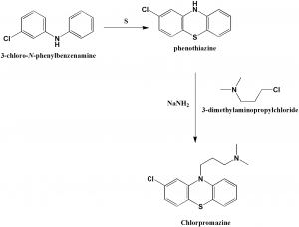

Fig. 1.1. Method of chlorpromazine synthesis by Krstić et al., 2016 [32]
Chlorpromazine, characterized by its physicochemical properties (pKa 9.3, log Pow 5.35), holds historical significance as the first modern antipsychotic drug. Beyond its primary clinical application in managing schizophrenia and other mental disorders, emerging research has highlighted its potential in neuroprotection and as a supporting agent in cancer treatment, as well as its intrinsic antibiotic properties [54]. Cz exerts its diverse pharmacological effects through complex interactions with various neurotransmitter receptors in the central nervous system, including dopamine, serotonin, histamine, and adrenergic receptors [2]. Its extensive metabolism in the human body involves a series of oxygenation and conjugation reactions, resulting in numerous metabolites with potentially distinct pharmacological activities. While mammalian metabolism has been relatively well-studied, the biotransformation pathways of chlorpromazine in aquatic organisms remain largely unknown [10]. Furthermore, chlorpromazine undergoes abiotic transformation in the environment, particularly through photolysis, yielding a variety of photoproducts with potentially unknown and hazardous properties [25]. The persistence of its phenothiazine core and its demonstrated toxicity to various non-target aquatic organisms, even at low concentrations, underscore the need for a comprehensive assessment of its ecological risks [15].
After nearly six decades of extensive clinical application and over fifteen years of dedicated research into the environmental fate and effects of pharmaceuticals, a surprisingly limited body of knowledge exists specifically concerning the environmental behavior and ecological ramifications of chlorpromazine. This stark disparity underscores a significant knowledge gap regarding the environmental impact of this widely prescribed antipsychotic drug once it enters aquatic systems. While the scientific literature contains several studies detailing the metabolic pathways of chlorpromazine, these investigations are predominantly early research focused on mammalian models, primarily humans and laboratory animals such as rats, with a notable scarcity of data on its transformation and effects within aquatic organisms.
Particularly, in a study of Alkimin et al., 2020 it was indicated that chlorpromazine can have harmful effects on various non-target organisms, such as macroliths, invertebrates, and fish [2]. Specifically, laboratory studies [34] found that the LC50 of Cz for fish Carassius auratus was 1.11 mg/L after 24 hours of exposure and decreased to 0.32 mg/L after 96 hours, indicating increased toxicity over time. For instance, it inhibited the growth of the duckweed Lemna minor, with a concentration causing a 50% reduction (EC50) after 148 hours being 0.92 mg/L [1]. Furthermore, both chlorpromazine and its breakdown products when exposed to light were highly toxic to the protozoan Spirostomum ambiguum, resulting in a 50% mortality (LC50) at concentrations around 0.5 mg/L after just 24 hours [56].
The toxic effects of chlorpromazine have been observed in various aquatic organisms. A high toxic potential for chlorpromazine was indicated by a fish plasma model at a concentration of 36 ng/L [41]. In aquatic invertebrates, chlorpromazine has demonstrated acute and chronic toxicity to the water flea Daphnia magna, causing immobility with a 48-hour EC50 value of 1.81 mg/L (or 5.7 µM) and negatively impacting population growth [45]. Additionally, Cz at a concentration of 1.6 µM has been reported to suppress larval transformation in the Mediterranean mussel Mytilus galloprovincialis [62]. However, despite these effects on survival and development, acute exposure to chlorpromazine at concentrations of 0.01, 1.00, or 250 µg/L did not significantly alter biochemical indicators in D. magna [45]. Similarly, a concentration of 10 µg/L of chlorpromazine did not induce changes in reproduction and certain physiological parameters in this crustacean species [2].
Bivalve mollusks have been identified as bioindicators of climate change and chemical contamination in surface waters. The health state of these species impacted by abiotic stressors has been characterized using a variety of integrative biomarkers [35]. Molluscs' particular reactions to some xenobiotics, however, are poorly understood and were primarily studied in exposures to single compounds at high concentrations [19]. These substances are rarely expected in the environment unless there is an unintentional release of contaminants. Developing ecologically realistic models for risk assessment, which involves testing reactions to combined exposures at low environmental concentrations, is part of the call for "evidence-based ecotoxicology" [41]. The bivalve molluscs' hormetic-like mobilization of antioxidant and metabolic responses was demonstrated by the applied modest subchronic exposures to common aquatic contaminants, with some specificity in the groups treated to glyphosate and chlorpromazine. This specificity was eliminated by complex exposures, and heating increased the toxicity of glyphosate to mollusks at nearly ineffective concentrations [3, 27].
Psychoactive pharmaceuticals, including antipsychotics like chlorpromazine, have been consistently detected in various environmental matrices beyond wastewater treatment facilities, including drinking water sources, sewage sludge, and surface waters [56]. The primary point source for the introduction of these substances into aquatic environments is the effluent discharge from wastewater treatment plants [17]. Incompletely metabolized drugs, either as their parent compounds or as transformation products, are released into receiving waters via these discharge points [5]. Although psychoactive medications are typically found at lower concentrations in aquatic settings compared to other pollutants, the accumulating evidence suggests that even their trace presence can exert harmful effects on aquatic organisms and potentially pose risks to human health [16, 25, 26, 27]. Notably, chlorpromazine exhibits a relatively high persistence in aquatic environments, with a reported half-life of up to four weeks [25)], and has been detected in various water bodies at concentrations ranging from 1 to 364 ng/L [2].
Consequently, governmental bodies, environmental regulatory agencies, and the broader public have increasingly focused their attention on monitoring the levels of these medications in aquatic environments and within aquatic biota. Understanding the potential hazardous consequences of psychoactive drugs is paramount, given the direct exposure of aquatic organisms, vital components of aquatic ecosystems, to these contaminants [15]. Existing research indicates that psychoactive pharmaceuticals can induce a range of detrimental impacts on aquatic organisms, affecting their behavior, development, reproduction, nerve function, and other critical physiological systems.
Antipsychotic drugs, including chlorpromazine, are primarily introduced into wastewater treatment facilities following their excretion by patients via urine and feces. However, the inherent limitations of conventional wastewater treatment technologies, which are not specifically designed for the removal of pharmaceuticals and their metabolites, result in a variable percentage of the administered dose ultimately reaching the environment. These compounds have been detected in virtually every environmental matrix, including drinking water, rivers, lakes, hospital effluents, and municipal wastewater. The reported environmental concentrations of antipsychotics are often sufficiently high to potentially exert significant impacts on aquatic life. Furthermore, emerging research suggests that antipsychotics, among other pharmaceutical classes, are likely undergoing bioaccumulation within aquatic food webs [14].
The inherent physicochemical properties of psychoactive medications and their bioactive metabolites often contribute to their persistence in aquatic environments, further complicating their removal by conventional wastewater treatment processes. As a result, these compounds and their transformation products are regularly identified in both aquatic environments and within aquatic species. Even at low concentrations, these medications have demonstrated harmful effects on non-target organisms, such as bivalves (freshwater mussels and clams) and bony fish (zebrafish and fathead minnows). However, the precise mechanisms underlying the toxicity of antipsychotics to aquatic animals and their potential implications for human health remain largely unclear [65].
In natural aquatic environments, pollutants rarely occur in isolation; instead, they are typically present as complex mixtures [38]. The combined toxic effects of these multi-contaminant exposures can deviate significantly from the effects observed with single pollutants due to synergistic or antagonistic interactions among the various substances, altering their overall impact on living organisms [16, 26, 27].
Given their widespread therapeutic application and the growing evidence of their presence and potential impact in aquatic environments, psychoactive drugs represent a significant class of pharmaceuticals requiring in-depth investigation. Their capacity to interfere with fundamental physiological processes, particularly those involving the neuroendocrine system and metal homeostasis, underscores the urgency of elucidating their ecological risks [14].

1.2. Biochemical targets of psychotropic pharmaceuticals: oxidative stress, biotransformation, and metabolic status
Antipsychotic pharmaceuticals, including chlorpromazine, can induce a range of toxic effects in aquatic organisms, often initiated by the generation of reactive oxygen species (ROS), leading to oxidative stress [34, 57]. The severity of these effects is modulated by factors such as the concentration of the pharmaceutical, the organism's uptake rate, and the duration of exposure [25, 27, 63]. Documented toxicological impacts of chlorpromazine and other antipsychotics on aquatic life encompass several key areas:
1) Neurotoxicity. A significant concern is the neurotoxic potential of these drugs in non-target organisms, often manifesting as aberrant behavioral changes [4, 14, 56]. Zebrafish (Danio rerio) serve as a widely utilized model organism in ecotoxicological studies to assess the neurobehavioral impacts of psychiatric medications across various developmental stages [55]. Studies have demonstrated neurotoxic effects in zebrafish and other fish species, including goldfish (Carassius auratus), crucian carp, and fathead minnows, as well as in crustaceans like the blood cockle (Tegillarca granosa) and the marbled crayfish (Procambarus virginalis). Behavioral alterations are considered a primary indicator of an organism's immediate response to environmental stressors and are directly linked to the survival challenges faced by individuals and populations [65].
2) Embryonic Developmental and Reproductive Toxicity. The continuous exposure of aquatic organisms to exogenous chemicals across multiple generations, due to their confinement in the aquatic environment, can result in significant toxicity to embryonic development. This includes abnormal hatching rates, increased lethality, and the occurrence of teratogenic effects [61]. Such developmental toxicity can ultimately lead to irreversible long-term damage to the reproductive capacity and overall fitness of aquatic populations.
3) Oxidative Stress and Immunotoxicity: Acute exposure studies have indicated that psychoactive pharmaceuticals can induce reductive-oxidative responses in various aquatic organisms, including bony fish and mollusks [34]. This often results in oxidative stress characterized by the overproduction ROS and other peroxides [57]. Excessive ROS accumulation can overwhelm cellular antioxidant defense mechanisms, leading to oxidative damage to organelles, biomacromolecules, and mitochondrial function, ultimately triggering apoptosis [23]. Furthermore, sublethal concentrations of antipsychotics, such as sertraline in juvenile zebrafish, have been shown to induce notable modifications in immune responses and circadian rhythms, highlighting potential immunotoxic effects [62].
4) Other Toxicities: Beyond neurotoxicity, developmental, reproductive, and oxidative stress, psychoactive drugs have been associated with genetic toxicity, endocrine disruption, lethality, and bioaccumulation in aquatic organisms. The potential for sublethal effects of antipsychotics to increase mortality rates in aquatic creatures underscores the complexity of their ecological impact.
Research has specifically investigated chlorpromazine's role in inducing oxidative stress in aquatic organisms. For instance, Oliveira et al. (2015) reported catalase activation in Daphnia magna exposed to 1 µg/L of chlorpromazine [45]. Research on the freshwater bivalve Unio tumidus has revealed a strong correlation between metallothionein-associated thiols and glutathione concentration, both of which play key roles in maintaining redox homeostasis and zinc binding during chlorpromazine exposure [28]. Long-term exposure to chlorpromazine in goldfish (Carassius auratus) has been shown to significantly alter oxidative stress markers, specifically catalase (CAT) and superoxide dismutase (SOD), indicating a clear increase in oxidative stress [34]. Similarly, Daphnia magna exposed to chlorpromazine exhibited significant changes in CAT activity, further suggesting the induction of oxidative stress [45]. Moreover, Atama et al. (2020) found elevated levels of lipid peroxidation products in African catfish (Clarias gariepinus) exposed to chlorpromazine, signifying damage to cell membranes due to ROS production, alongside the activation of glutathione peroxidase to counteract increased hydrogen peroxide levels resulting from reduced catalase activity [4].
The presented study aims to further elucidate the ecological risks of chlorpromazine by examining its effects on the freshwater bivalve Unio tumidus at environmentally relevant concentrations, focusing on a set of biochemical parameters associated with oxidative stress, biotransformation system, and metabolic state. Additionally, the study will investigate the combined effects of chlorpromazine and glyphosate to better reflect the complex reality of multi-pollutant exposure in aquatic environments.

CHAPTER II. MATERIALS AND EXPERIMENTAL METHODS
2.1. Sampling and designing the experiment
As a model organism for bivalve mollusks of the Unionidae family, Unio tumidus (Philipson, 1788) was chosen for the experimental study of the effects of pharmaceuticals in both single and combined exposures. Adult mollusks, aged 3-4 years, with a length of 7-8 cm and body weight of 50-60 g, were collected from a reference site suggested to be conditionally clean (a tributary of the Dniester River) [20]. All the essential conditions for transportation and pre-acclimatization have been fulfilled (Table 2.1.)
Table. 2.1. Laboratory conditions during the pre-acclimatization period following the transportation of mollusk individuals
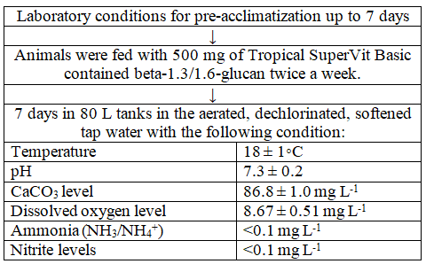
In our experiment, we used nanomolar concentrations of the psychoactive drug chlorpromazine and the organophosphonate pesticide Roundup, which contains the active ingredient glyphosate, known for its metal-chelating properties. These were administered in both single and combined exposures.
Drawing upon our previous research [27, 28] and with the goal of simulating environmentally relevant impact levels, we selected a low concentration of Roundup at 17 µg/L, which equates to 36 nM. This concentration is approximately 0.2 times the Predicted No Effect Concentration (PNEC), an estimated threshold derived from long-term exposure data across multiple species [38]. For chlorpromazine, we chose a concentration of 18 µg/L or 57 nM, a level previously shown to induce only minor physiological alterations in aquatic organisms [45].
To achieve this, we divided the specimens into four groups. The exposure period of 14 days and tested temperature (18°C) were informed by our prior work [21]. This temperature is also considered typical of water temperatures in Europe, particularly in Ukraine, ranging from 17°C to 28°C during the sampling period [60].
Table 2.2. Experimental design: modeling the subchronic effects of chlorpromazine and glyphosate
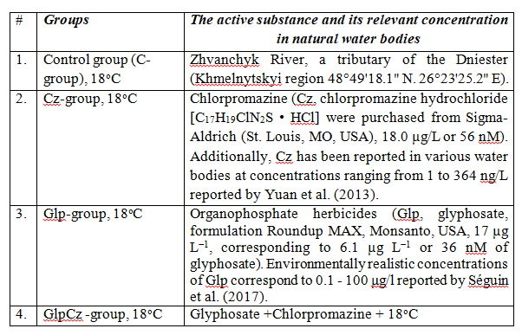
The experimental water and chemicals were changed every two days, and no species mortality during the exposures. For most biochemical analyses, digestive glands from molluscs (n=8) per group were prepared separately. However, for metal analysis tissues from specimens (n=5) in each exposed groups were pooled. Following collection, the mollusc specimens were dissected on ice and subsequently rapidly frozen to a temperature range of -35 to -40°C until the time of analysis. We received frozen digestive gland samples and pooled eluates of extracted metalloproteins after gel-exclusion chromatography for each group from Prof. Stolyar O.B.'s lab at Ternopil Volodymyr Hnatiuk National Pedagogical University for our biochemical experiment.

2.2. Assays for thiol compounds: metallothionein and glutathione
The total concentration of metallothioneins (MTs) was estimated by measuring thiol levels using the 2-nitrobenzoic acid derivates (DTNB) reduction method, as described by Viarengo et al. (1997) [58]. The level of MT is calculated assuming the relationship: 1 mol MTs = 20 mol GSH and expressed as μg of MTs per g of wet tissue mass according to the protocol:
- Digestive gland (300 mg) was ground in cold homogenizing buffer (1:3 v/v) with β-mercaptoethanol and phenylmethylsulfonyl fluoride.
- After centrifuging at 16,000 g for 60 min, the supernatant was mixed with ethanol/chloroform mixture and centrifuged again at 6,000 g for 12 minutes.
- Ethanol (3 ml) was added to the supernatant, and samples were frozen for 1 hour. Then 0.2 M phosphate buffer, рН 8.0 was added to the test tubes and centrifuged at 6,000 g for 12 minutes.
- Washing buffer (at –20°C).was made and stored at –20°C.
- The pellet was washed twice with washing buffer containing chloroform, tris-sucrose solution with absolute ethanol. Centrifugation occurred at 6,000 g for 12 minutes.
- Each pellet was dissolved in Tris-EDTA buffer and 0.43 mM DTNB solution was added.
- A spectrometer/plate reader was set up to read absorbance at 412 nm.
Zinc concentration within metallothioneins (Zn-MT) was determined by first isolating these thermostable proteins with modifications [50]. This involved homogenizing samples in 0.01 M Tris-HCl buffer (pH 8.0) with 0.01 M β-mercaptoethanol and 0.1 mM PMSF, followed by obtaining the supernatant. Metallothionein-enriched fractions were then separated from this supernatant using Sephadex G-50 gel-exclusion chromatography. Fractions exhibiting a low molecular weight (approximately 7 kDa), significant absorbance at 254 nm, and a high D254/D280 ratio were considered to contain metallothioneins and were pooled (totaling 10 mL) for the zinc analysis.
Then zinc levels in digestive gland tissue (Zn-t, detection limit was 0.1 µg·g^{–1} FW) and metallothionein eluates (Zn-MT) were measured using a colorimetric assay with 5-Br-PAPS (2-(5-bromo-2-pyridylazo)-5-[N-propyl-N-(3-sulfopropyl) amino]phenol disodium salt dihydrate) [59]. Dried (105 °C, 24 h) and HNO₃-digested samples were dissolved in 1% trichloroacetic acid, followed by the addition of 0.6 M 5-Br-PAPS in carbonate buffer with pH 9.0. Zinc concentration was determined by measuring absorbance at 560 nm following a 30-minute incubation at 200 °C. Zinc concentrations were reported as nmol or μg·g⁻¹ FW.
Total glutathione concentration (GSH) and its oxidized form (GSSG) (nmol g⁻¹ WM) are quantified by the glutathione reductase recycling assay calibrated with reduced glutathione as a standard [21] with the using of DTNB. For GSSG level estimation, the protein-free sample was pretreated with 2-vinylpyridine at a final concentration of 0.5 M prior to the assay. The concentration of the reduced glutathione The redox-index of glutathione (RI GSH) as the ratio of reduced/oxidized glutathione (GSH/GSSG) was calculated.
2.3. Assays for biochemical parameters of oxidative stress, biotransformation and sign of toxicity
The overall antioxidant capacity of the tissues, specifically their ability to scavenge ABTS radicals, was measured using the ABTS assay [48]. This involved generating ABTS radical cations (ABTS•+) from 2,2’-Azino-di-[3-ethylbenzthiazoline sulphonate] (ABTS) using K₂S₂O₈. The decrease in the absorbance of the ABTS•+ solution was monitored at D=734 nm, and the results were compared to ascorbic acid solution containing only the ABTS•+ radicals.
The protein carbonyls (PC, nmol g⁻¹ FW), markers of protein oxidation, were measured in the pellet obtained after centrifuging a 10% (weight/volume) homogenate treated with sulfosalicylic acid. This measurement involved reacting the pellet with 2,4-dinitrophenylhydrazine, following the method of Reznick and Packer (1994) [49].
The lipid peroxidation products were measured as TBARS (nmol/g of wet weight) in the supernatant of a 10% tissue homogenate after protein precipitation with sulfosalicylic acid [44] and analyzed with thiobarbituric acid at D=532 nm, and concentration of lipid peroxidation products was calculated using a adsorption coefficient of .
The cholinesterase (ChE, EC 3.1.1.7, μmol·min⁻¹·mg⁻¹ of protein) activity in tissue samples was determined by measuring its ability to hydrolyze acetylthiocholine at 25°C, using the colorimetric method described by Ellman et al. (1961) [13]. For the assay, 0.05 ml of the supernatant from a 10% digestive gland homogenate was combined with 3 ml of 0.1 mM phosphate buffer (pH 8.0). Next, 0.01 M DTNB solution (prepared by dissolving 16 mg in 4 ml of 0.2 M phosphate buffer, pH 8.0) was added. The reaction was initiated by introducing 0.04 ml of 0.075 M acetylthiocholine iodide (13 mg dissolved in 0.6 ml of distilled water) and measured at D=412 nm. ChE activity (A) was calculated using the formula 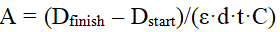, where molar absorption coefficient equal to 13.6 × 10³ M⁻¹·cm⁻¹.
The vitality of digestive gland tissue as sign of cytotoxicity was evaluated by assessing lysosomal membrane stability [6]. This test, Neutral Red Retention (NRR) assay, is based on the ability of healthy lysosomes to accumulate and retain the Neutral Red dye according to the following procedure:
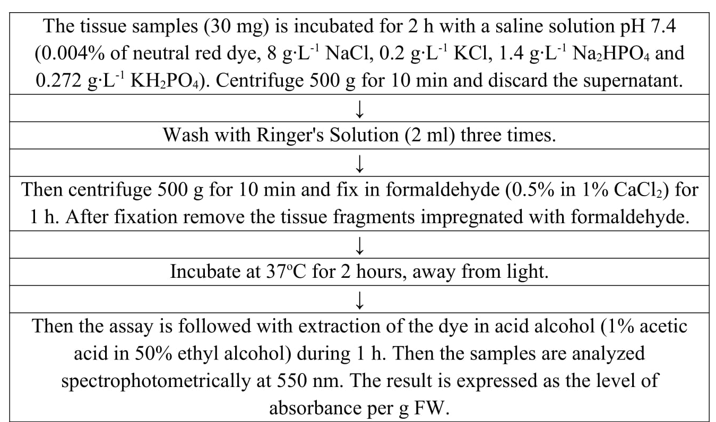
To assess biotransformation capability, ethoxyresorufin O-deethylase (EROD) activity, associated with cytochrome P450 (CYP450), was measured in the supernatant of the 10% homogenate [29]. This was done by detecting the resorufin formation at D=572 nm, using absorption coefficient of .
The glutathione S-transferase (GST, EC 2.5.1.18, nmol min⁻¹·mg⁻¹ soluble protein) activity was assayed by Habig et al., 1974 [22]. Enzyme activity is determined by monitoring changes in absorbency at 340 nm (which translates to the rate of CDNB conjugation with GSH as substrate (ε₃₄₀ CDNB-GSH conjugation = 9.6 mM⁻¹ cm⁻¹).
The caspase-3 activity detection was based on the following reaction:
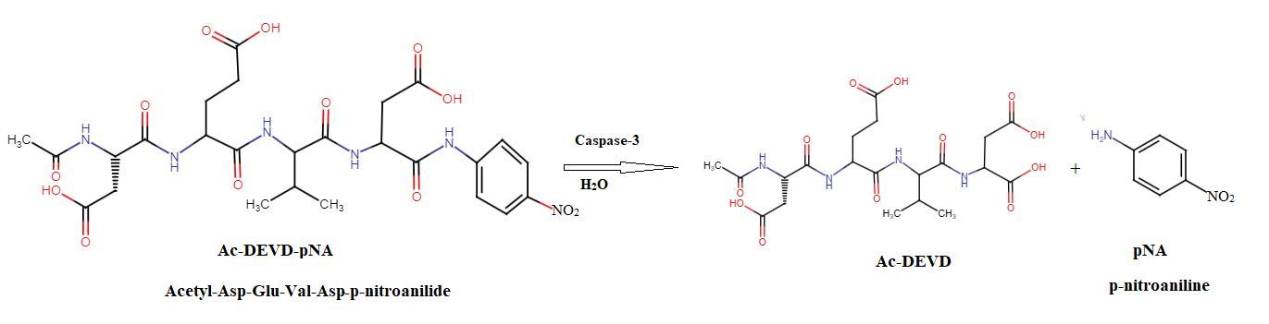
This reaction released p-nitroaniline (pNA), a colored product that was then detected, following the procedure outlined in [8]:
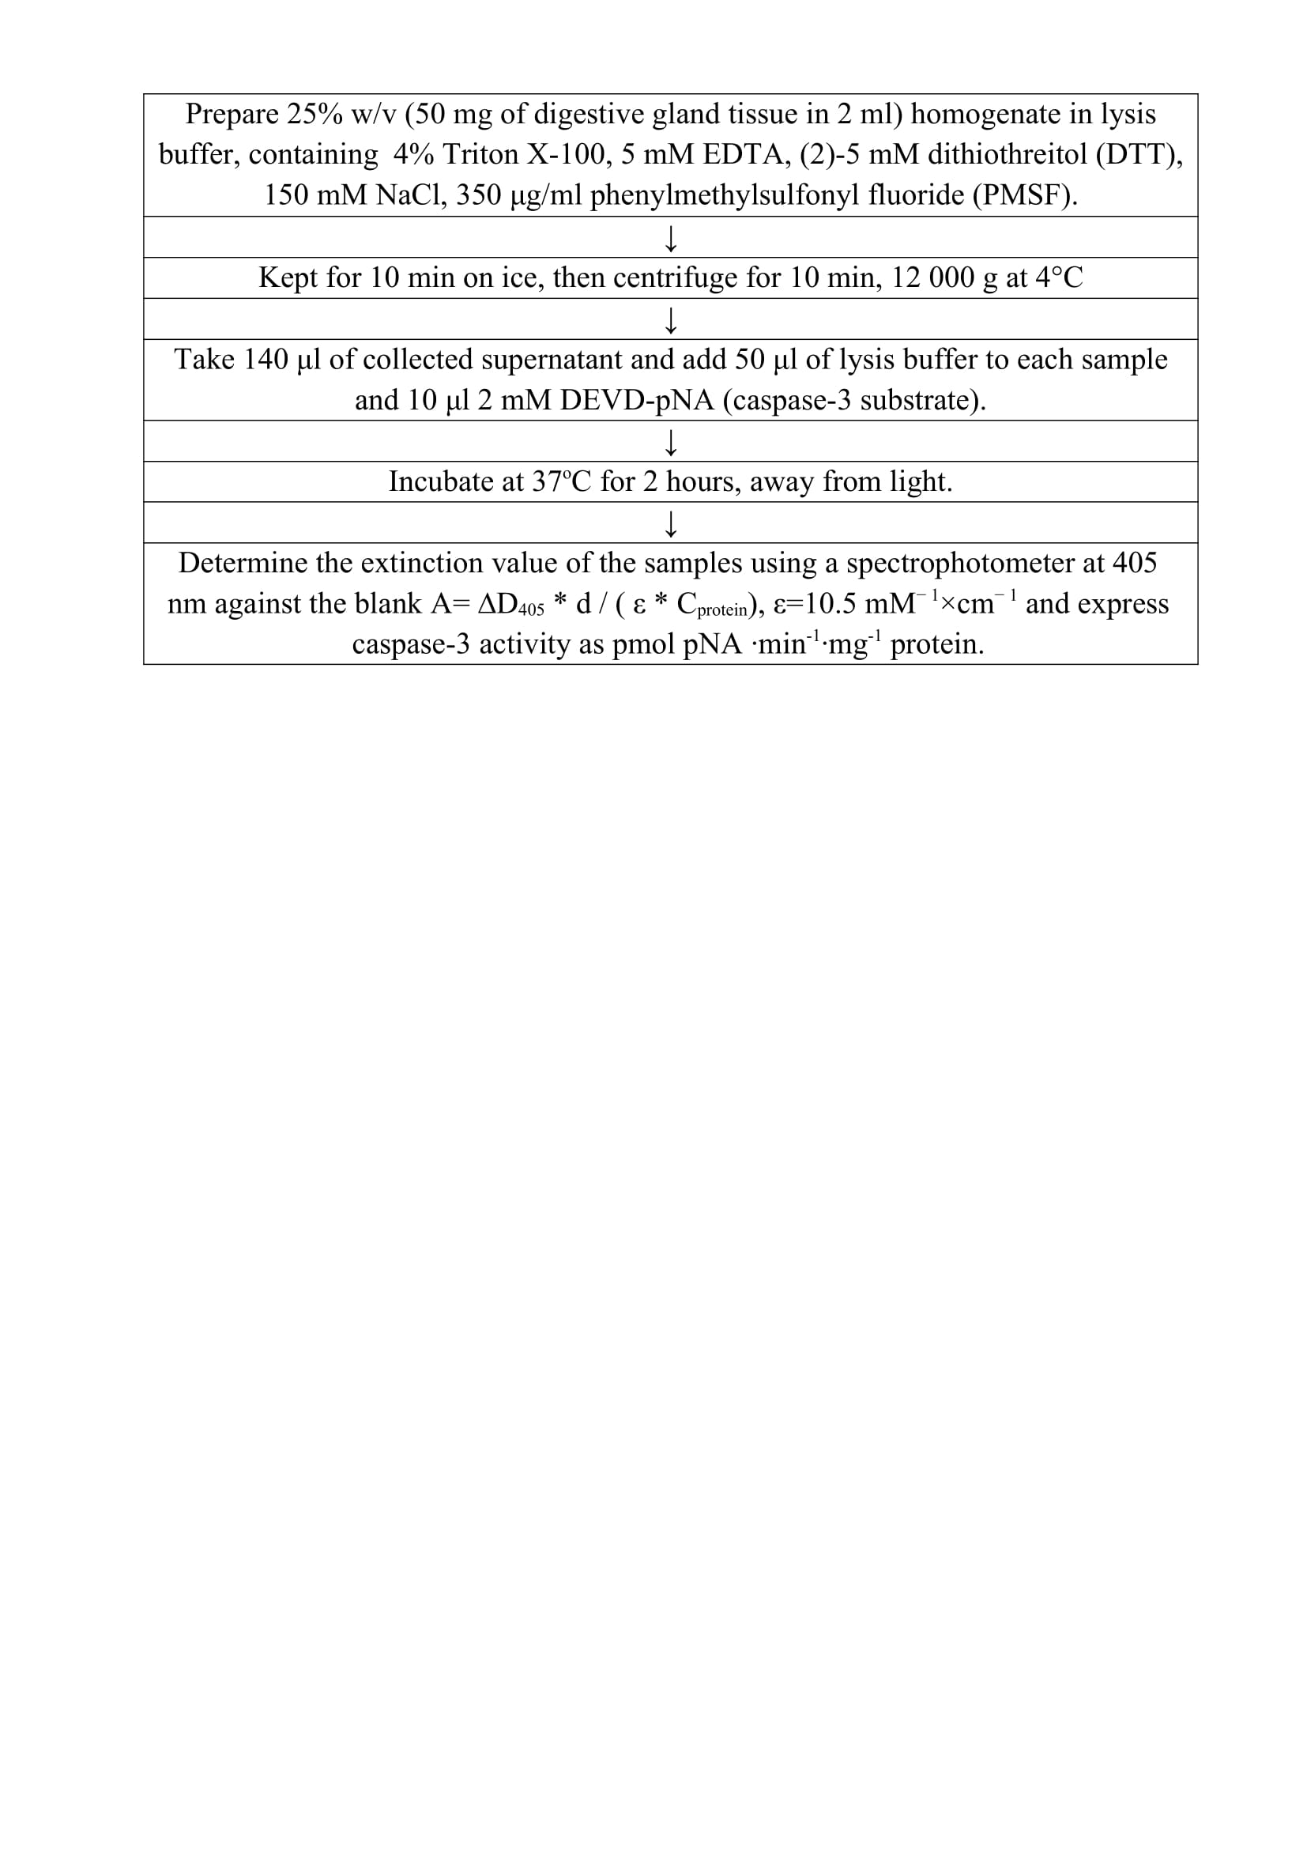
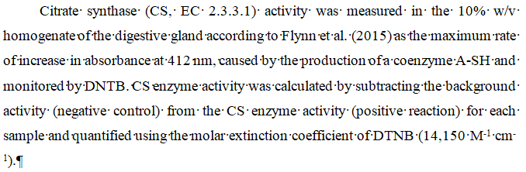
The content of proteins to calculate the activity of enzymes in the tissue was determined in the soluble phase of the homogenate according to the method of Lowry et al., 1951 [36], which is based on the reaction:
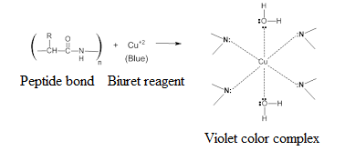
2.4. Statistical evaluation of data
Data for all measured parameters are presented as the mean value with its corresponding standard deviation (mean ± SD). The sample size for each trait was consistent, with measurements taken from eight individual organisms (n = 8). Data were analyzed according to the following test and analysis (Table 2.3).
Table 2.3. Statistical evaluation of data based on using IBM SPSS Statistics version 26 software for Windows
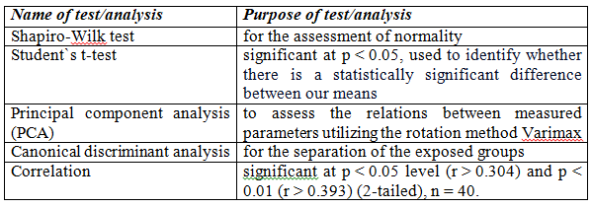
Computational methods for in silico studies, including the SwissTargetPrediction, BioTransformer 3.0, Molsoft, ADMET lab 3.0, and AdmetSAR 3.0 web server, were utilized to predict various aspects of a molecule's behavior, interactions, and fate in biological and environmental systems for the environmental risk assessment based on ADME parameters.
The Integrated Biomarker Response (IBR), developed by Beliaeff and Burgeot in 2002 [7], serves as a valuable tool for ecological risk assessment, indicating environmental stress was calculated as described in Table 2.4:
Table 2.4. Principle of Integrated Biomarker Response (IBR) calculation
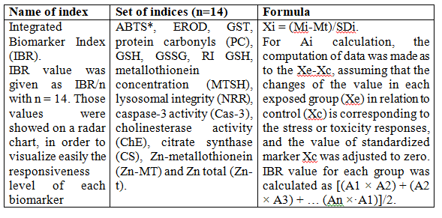

Chapter ІІІ. RESULTS AND DISCUSSION
3.1. Toxicological and environmental impact of chlorpromazine: in silico approaches to assess ecological risks of pharmaceutical pollutants
Pharmaceuticals, while essential for human health, have increasingly been recognized as emerging environmental contaminants due to their widespread use and persistence in aquatic ecosystems. Among these, chlorpromazine (Cz), a first-generation antipsychotic drug, has garnered attention for its potential ecological and toxicological impacts. Despite its therapeutic benefits, Cz can enter water bodies through wastewater discharge, posing risks to aquatic life and potentially affecting human health through contaminated water sources. The environmental fate of physocoactive substance, including its persistence, bioaccumulation, and transformation into potentially more toxic metabolites, remains a significant concern.
In silico studies, which leverage computational tools to predict the physico-chemical and pharmacological properties of compounds, offer a powerful approach to understanding the behavior of Cz in the environment. These studies are particularly valuable for assessing the risks associated with pharmaceutical pollutants, as they provide insights into degradation pathways, toxicity mechanisms, and interactions with environmental matrices. Furthermore, in silico methods can guide the development of effective water treatment strategies by predicting the adsorption and removal efficiency of Cz from contaminated water.
Table 3.1. Physicochemical properties of chlorpromazine calculated with ADMETlab 3.0 web server
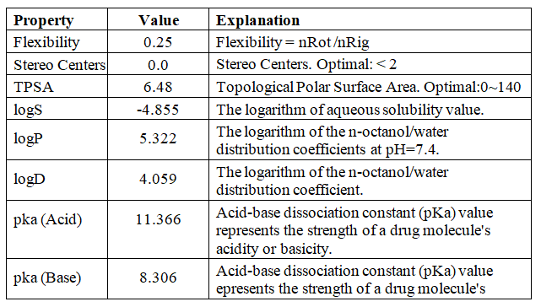
Chlorpromazine exhibits a combination of favorable and limiting physicochemical properties (Table 3.1). Its high lipophilicity (logP = 5.322) and moderate distribution coefficient logD suggest good membrane permeability, which facilitates its ability to cross lipid membranes, including the blood-brain barrier, making it effective in central nervous system treatments. However, its low aqueous solubility (logS = -4.855) may hinder its oral bioavailability, potentially requiring formulation strategies to enhance solubility for effective absorption. The compound’s weak acid-base properties with pKa values of 11.366 and 8.306 correspondingly indicate partial ionization at physiological pH, influencing its solubility and permeability. Overall, while Cz’s lipophilicity supports its action in the brain, challenges related to poor solubility must be addressed to optimize its oral administration.
Table. 3.2. Absoption characteristic for chlorpromazine calculated with ADMETlab 3.0 web server
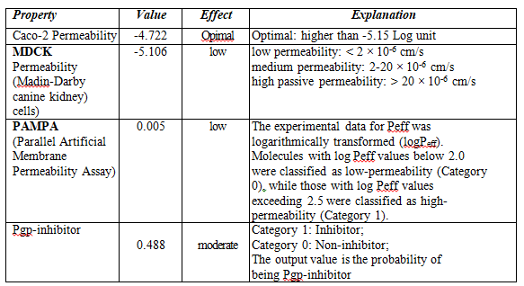
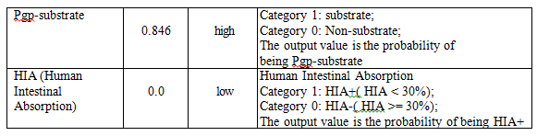
Chlorpromazine shows optimal Caco-2 permeability, suggesting good potential for absorption in the intestines, but its low MDCK (Madin-Darby Canine Kidney cells) and PAMPA (Parallel Artificial Membrane Permeability Assay) permeability indicates challenges in passive diffusion across cell membranes (Table 3.2). Value of Pgp-substrate means active efflux by the Pgp pump that could further reduce its absorption, impacting its overall bioavailability. The HIA (Human Intestinal Absorption) value of 0.0 further supports that chlorpromazine has poor intestinal absorption, indicating it may not be well absorbed when taken orally. Additionally, Cz is not a strong Pgp-inhibitor, which means it is unlikely to significantly alter the absorption of other Pgp substrates.
Although Cz has some potential for absorption, its low passive permeability, Pgp efflux, and poor intestinal absorption suggest that oral bioavailability may be limited. Other delivery methods or modifications might be required to enhance its effectiveness in oral formulations.
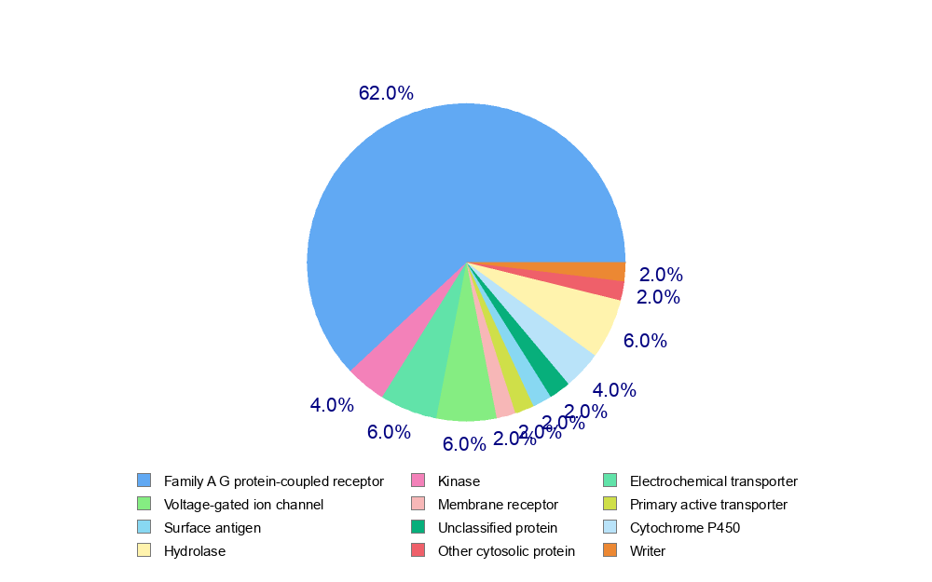
Fig. 3.1. Human target prediction indicates that the chlorpromazine possesses a high probability to targeting different molecules, based on a combination of 2D and 3D similarity using SwissTargetPrediction tool
As shown in Fig. 3.1, Table 3.3, the primary targets of chlorpromazine include membrane protein receptors associated with G-proteins (62%), which play a key role in various signaling pathways. Additionally, Cz interacts with voltage-gated ion channels (6%) and electrochemical transporters (6%), which are involved in ion transport and cellular electrical activity. The drug also targets hydrolases, mainly acetylcholinesterase, along with mucosa-associated lymphoid tissue lymphoma translocation protein 1 and butyrylcholinesterase (6%). Further, Cz affects the cytochrome P450 system, particularly the CYP2D6 and CYP1A2 isoenzymes (4%), which are involved in drug metabolism and associated with EROD activity. Finally, Cz impacts kinases (4%), which are important in regulating cellular signaling and various physiological processes.
Table 3.3. Selected target molecules predicted for chlorpromazine by SwissTargetPrediction online tool
Target | Common name | Uniprot ID | ChEMBL ID | Target Class | Probability* | Known actives (3D/2D)
1 | 2 | 3 | 4 | 5 | 6 | 7
Muscarinic acetylcholine receptor M4 | CHRM4 | P08173 | CHEMBL1821 | Family A G protein-coupled receptor | 1.0 | 58/9
Serotonin 2b (5-HT2b) receptor | HTR2B | P41595 | CHEMBL1833 | Family A G protein-coupled receptor | 1.0 | 118/12
Tyrosine-protein kinase FYN | FYN | P06241 | CHEMBL1841 | Kinase | 1.0 | 3/4
Dopamine D5 receptor | DRD5 | P21918 | CHEMBL1850 | Family A G protein-coupled receptor | 1.0 | 27/3
HERG | KCNH2 | Q12809 | CHEMBL240 | Voltage-gated ion channel | 1.0 | 203/7
Muscarinic acetylcholine receptor M3 | CHRM3 | P20309 | CHEMBL245 | Family A G protein-coupled receptor | 1.0 | 71/9
Sigma opioid receptor | SIGMAR1 | Q99720 | CHEMBL287 | Membrane receptor | 1.0 | 405/12
Serotonin 7 (5-HT7) receptor | HTR7 | P34969 | CHEMBL3155 | Family A G protein-coupled receptor | 1.0 | 119/7
Serotonin 6 (5-HT6) receptor | HTR6 | P50406 | CHEMBL3371 | Family A G protein-coupled receptor | 1.0 | 538/15
P-glycoprotein 1 | ABCB1 | P08183 | CHEMBL4302 | Primary active transporter | 1.0 | 1/2
Vanilloid receptor (by homology) | TRPV1 | Q8NER1 | CHEMBL4794 | Voltage-gated ion channel | 1.0 | 1/1
Cytochrome P450 2D6 | CYP2D6 | P10635 | CHEMBL289 | Cytochrome P450 | 0.509599763485 | 7/4
Serine/threonine- protein kinase PIM1 | PIM1 | P11309 | CHEMBL2147 | Kinase | 0.171978589411 | 15/6
Table 3.3. Continued
1 | 2 | 3 | 4 | 5 | 6 | 7
Cytochrome P450 1A2 | CYP1A2 | P05177 | CHEMBL3356 | Cytochrome P450 | 0.163737226168 | 1/3
Acetylcholinesterase | ACHE | P22303 | CHEMBL220 | Hydrolase | 0.106099949133 | 31/18
Mucosa-associated lymphoid tissue lymphoma translocation protein 1 | MALT1 | Q9UDY8 | CHEMBL3632452 | Hydrolase | 0.106099949133 | 1 / 1
Butyrylcholinesterase | BCHE | P06276 | CHEMBL1914 | Hydrolase | 0.0978745343258 | 18/60
These interactions highlight the multifaceted action of chlorpromazine, contributing to its therapeutic effects as well as potential side effects related to enzyme and receptor modulation.
Table 3.4. Metabolic prediction of chlorpromazine involving Phase I biotransformation by cytochrome P450 isoforms, as calculated using the BioTransformer 3.0 web server
# | Type of reaction | CytP450 Isoform | Biotransformation reaction | # | Type of reaction | CytP450 Isoform | Biotransformation reaction
1 | 2 | 3 | 4 | 1 | 2 | 3 | 4
1. | N-Dealkylation of mixed tertiary amine | 1A2 | 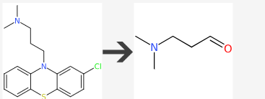 | 10. | Hydroxylation of aromatic carbon ortho to halide group | 1A2 | 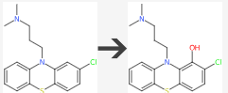
2. | N-Dealkylation of mixed tertiary amine | 1A2 | 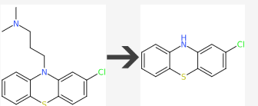 | 11. | N-Dealkylation of acyclic tertiary amine | 1A2 | 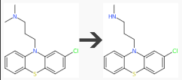
3. | Hydroxylation of acyclic aliphatic secondary carbon | 1A2 | 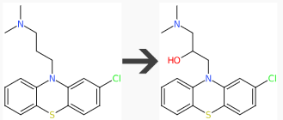 | 12. | N-Dealkylation of acyclic tertiary amine | 1A2 | 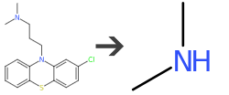
4. | S-Oxidation of diarylthioether to sulfoxide | 1A2 | 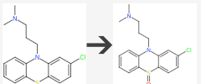 | 13. | N-Dealkylation of acyclic tertiary amine | 1A2 | 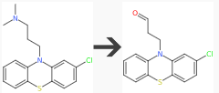
5. | Aromatic hydroxylation of fused benzene ring | 1A2 | 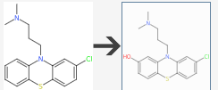 | 14. | Hydroxylation of aromatic carbon meta to halide group | 2A6 | 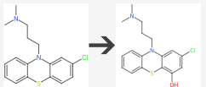
Table 3.4. Continued

1 | 2 | 3 | 4 | 1 | 2 | 3 | 4
6. | Aromatic hydroxylation of fused benzene ring | 1A2 | 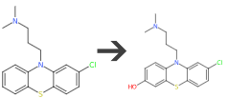 | 15. | Aliphatic hydroxylation of carbon alpha to secondary or tertiary alkyl-N | 2B6 | 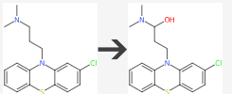
7. | Aromatic hydroxylation of fused benzene ring | 1A2 | 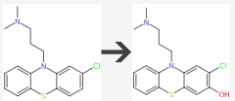 | 16. | Aliphatic hydroxylation of carbon alpha to secondary or tertiary alkyl-N | 2B6 | 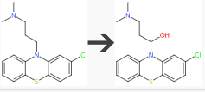
8. | N-Oxidation of aliphatic tertiary amine | 1A2 | 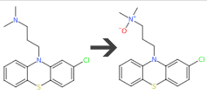 | 17. | N-Dealkylation from | 1A2 | 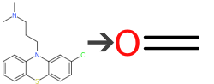
9. | Hydroxylation of aromatic carbon ortho to halide group | 1A2 | 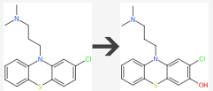

Based on the obtained results (Table 3.4), calculated using the BioTransformer 3.0 web server, we concluded that the main types of Phase I biotransformation reactions are:
  - 6 reactions of N-realkylation (involves both mixed and acyclic tertiary amines, catalyzed primarily by CYP1A2;
  - 5 reaction of aromatic hydroxylation (occurs on fused benzene rings and aromatic carbons near halide groups, catalyzed by CYP1A2 and CYP2A6);
  - 2 reaction of aliphatic hydroxylation (targets carbons alpha to alkyl-N groups, catalyzed by CYP2B6);
  - 1 reaction of S-oxidation (converts diarylthioether to sulfoxide, catalyzed by CYP1A2);
  - 1 reaction of N-oxidation (involves aliphatic tertiary amines, catalyzed by CYP1A2)

Table 3.5. Molecular properties based on the Blood-Brain Barrier (BBB) score and drug-likeness of chlorpromazine derivates using the Molsoft web
# | BBB score | Drug-likeness model score | Plotting of drug-likeness model scores for predicted metabolites | # | BBB score | Drug-likeness model score | Plotting of drug-likeness model scores for predicted metabolites
1 | 4.20 | -1.11 | 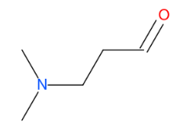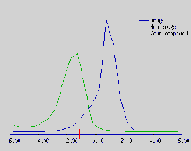 | 10. | 5.67 | 0.92 | 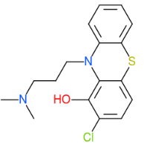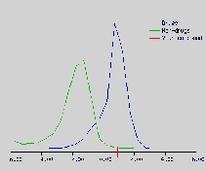
2 | 5.08 | -0.48 | 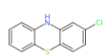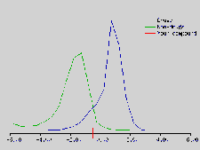 | 11. | 5.76 | 0.52 | 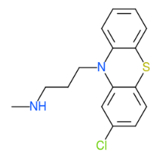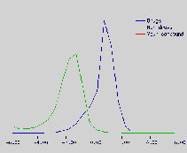
3. | 5.63 | 1.21 | 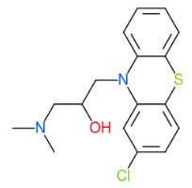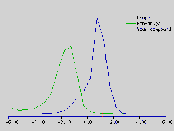 | 12. | 3.81 | -1.33 | 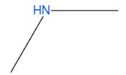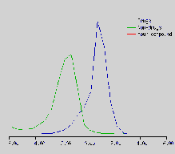
4. | 5.69 | 0.92 | 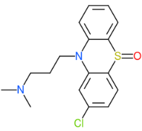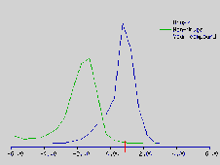 | 13. | 5.25 | -0.06 | 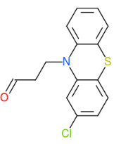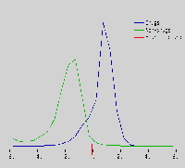
5. | 5.66 | 1.03 | 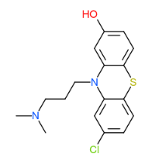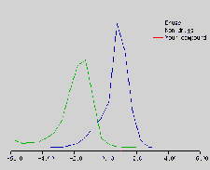 | 14. | 5.67 | 0.88 | 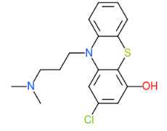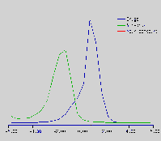
6. | 5.66 | 0.99 | 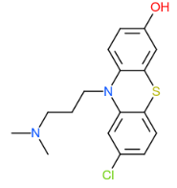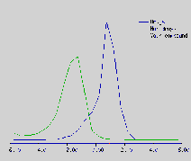 | 15. | 5.67 | 1.02 | 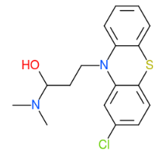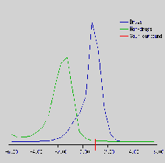
7. | 5.67 | 1.03 | 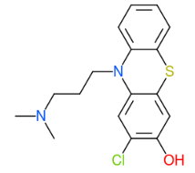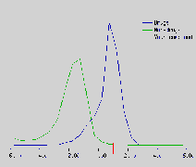 | 16. | 5.66 | 1.35 | 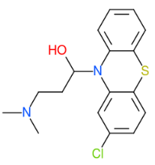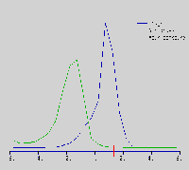
8. | 4.91 | 0.87 | 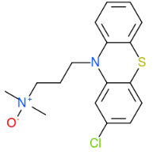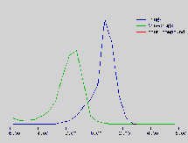 | 17 | 3.04 | -0.50 | 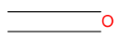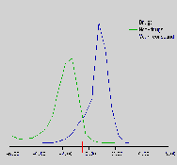
9. | 5.67 | 1.03 | 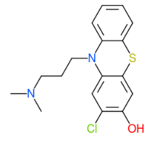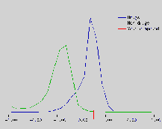
The predicted results for the drug-likeness model scores are presented in Table 3.5. The drug-likeness score is determined based on both positive and negative values. A positive drug-likeness score indicates that the compound is likely to have drug-like properties, whereas a negative score suggests the compound is non-drug-like [18]. According to the predictions, all of the tested metabolites, with the exceptions of 1c, 2c, 12c, 13c, and 17c, exhibited positive drug-likeness scores ranging from 0.87 to 1.03. Therefore, these compounds can be considered drug-like in nature.
Based on the provided Blood-Brain Barrier (BBB) scores, we can conclude that the majority of the compounds tested show relatively high BBB scores, with values predominantly ranging from 4.20 to 5.76 (Table 3.5). These scores suggest that most of the compounds have the potential to cross the blood-brain barrier, which is a key consideration for drug development, particularly for central nervous system (CNS)-targeting drugs. However, there are two compounds with notably lower scores (3.04 and 3.81), indicating that these derivates may have more difficulty penetrating the BBB and thus may be less likely to affect the CNS directly. Overall, the high BBB scores observed for most of the compounds suggest a strong likelihood of CNS bioavailability, making them promising candidates for further investigation in neuropharmacological applications.
Chlorpromazine shows significant toxicity potential in several areas (Fig. 3.2). Thus, the chlorpromazine exhibits a high risk of cytotoxicity in multiple cell types (A549, HEK293) and a very high risk of neurotoxicity (0.91-0.98), suggesting that it could pose serious risks to cell health and the nervous system. It also shows high nephrotoxicity (0.74-0.87), which is a major concern for kidney health. There is a moderate risk of hepatotoxicity (0.67-0.69) and hematotoxicity (0.64), meaning it could also impact liver and blood function. On the other hand, chlorpromazine has a low probability of causing genotoxicity, cancer, mutagenic effects, or cell toxicity. However, its moderate ecotoxicity suggests that environmental safety measures should be considered. The calculation of potential immunotoxicity, as determined by the two programs (ADMETlab 3.0 and ProTox-3.0), reveals conflicting effects that require further investigation.

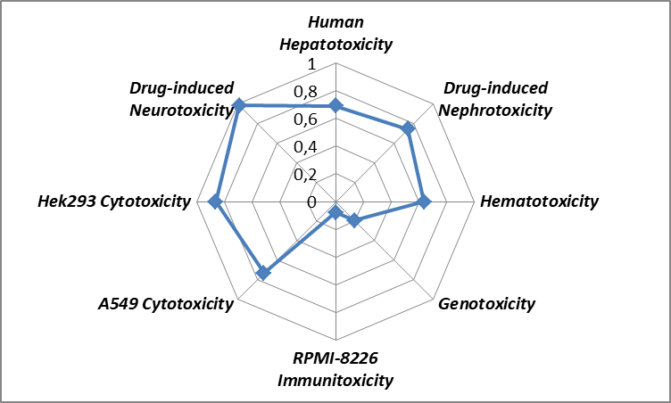 | 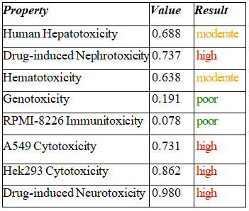A
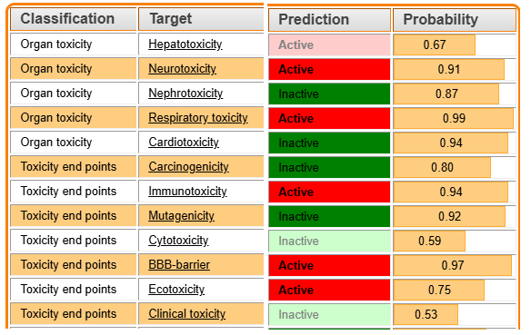 |  | B
Fig. 3.2. Predicted toxic effect of chlorpromazine calculated with ADMETlab 3.0 (A) and ProTox-3.0 (B) web server. Note. Category 0: non-neurotoxic (-); Category 1: neurotoxic (+). The output value is the probability of being neurotoxic (+), within the range of 0 to 1
Overall, the substance shows significant toxicity concerns, particularly regarding cell, kidney, and neurotoxicity. Further testing and risk mitigation strategies are essential before considering its use in clinical or environmental applications.
A bioconcentration factor (BCF) of Cz is 2.51 meaning that the substance is present in the organism's tissues at a concentration 2.51 times higher than in the surrounding environment (e.g., the water it inhabits) (Table 3.6). Essentially, this suggests that the organism is accumulating this substance to a moderate extent, as the BCF is relatively low. For substances with a BCF significantly higher than 1, there's concern that the organism may be accumulating harmful amounts of the substance over time, which could lead to toxicity or other ecological impacts. In this case, a BCF of 2.51 might not be extremely high, but it still indicates a certain degree of potential accumulation in organisms, which can be relevant for assessing environmental and health risks. However, a comprehensive environmental risk assessment would need to consider other factors like bioaccumulation through the food web, persistence, and potential toxicity.
Table 3.6. Ecological Risk Assessment of chlorpromazine calculated with admetSAR 3.0 web server
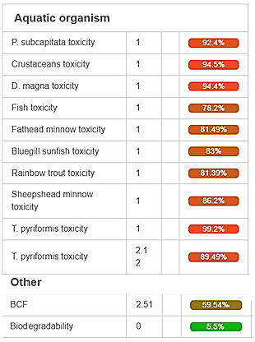
Additionally, with a biodegradability value of Cz of 0, means that it is not readily biodegradable under standard environmental conditions. These properties suggest that Cz may persist in the environment and accumulate in aquatic organisms as bioconcentration factor is 2.51, which could have implications for its environmental impact and toxicity.
3.2. Concentration of cellular soluble thiols and redox-potential in the model organism of U.tumidus exposed to chlorpromazine and modulated by the effect of glyphosate
This study aimed to identify the expected biochemical responses of bivalve molluscs when exposed to aquatic pollutant such as pharmaceuticals and pesticides at environmentally relevant low concentrations. We also investigated the role of cellular soluble thiol concentrations and redox potential as potential biomarkers of oxidative stress and cellular damage. Furthermore, we explored the distinct biological pathways and impacts on bivalves subjected to a mixture of pollutants. This approach highlights how the balance between oxidative stress markers and pollutant exposure may contribute to the overall biochemical response of bivalves.
Quantifying the GSH/GSSG ratio in pathological tissues and experimental models is a widely recognized and valuable method for assessing the efficacy of potential therapeutic interventions in preserving cellular redox homeostasis. This ratio, reflecting the balance between reduced glutathione (GSH) and oxidized glutathione (GSSG), serves as a critical biomarker of cellular health. Under physiological conditions, GSH typically constitutes approximately 98% of total cellular glutathione, highlighting its pivotal role in maintaining the reducing environment essential for cellular function [21, 55]. Therefore, deviations from this norm in pathological states often indicate oxidative stress and cellular dysfunction, making the GSH/GSSG ratio a key target for therapeutic modulation.
In our experiment the level of GSH was elevated in all exposed groups, except for the glyphosate (Glp) group, with a notable increase of 2.0 times observed in the Mix group. In this particular group, the level of GSSG also showed a significant rise. Consequently, the redox status expressed as GSH:GSSG ratio (RI GSH) was higher in all experimental groups compared to the reference group, with an increase ranging from 36.0% to 39.0%, except for the Glp group (Fig. 3.3). These findings indicate a significant alteration in antioxidant status following exposure, with the Mix group exhibiting the most pronounced effect, largely driven by the environmental pollutant. This observation aligns with research by Ficarra et al. (2016), which demonstrated that treating erythrocytes with 100 μM Cz for 2 hours did not affect total glutathione levels. However, they reported a reduction in reduced glutathione to approximately 1.5 times lower than controls, and a decrease in the GSH/GSSH redox ratio from 10.7 in controls to 5.5 in cells treated with 50 μM Cz [16].
Fig. 3.3. Concentrations of soluble thiols in the digestive gland of U. tumidus exposed to chlorpromazine (Cz), glyphosate (Glp), and glyphosate-chlorpromazine mixture (Mix) during 14 days. A: reduced glutathione, GSH; B: oxidized glutathione, GSSG; C: redox index of glutathione, RI GSH. Results are expressed as means ± standard deviations (n = 8). Columns with different letters indicate statistically significant differences (P < 0.05)
Metallothioneins (MTs) are a family of low molecular weight, cysteine-rich (approximately 30%), and redox-active metalloproteins that play crucial roles in cellular physiology. These proteins are central to the homeostatic regulation of essential metals, particularly zinc and copper, and provide critical protection against the cytotoxic effects of heavy metals, notably cadmium, and oxidative stress. MTs exert their diverse functions through the dynamic processes of metal donation, sequestration, and redox modulation, thereby influencing a wide array of metabolic pathways. Given the physiological importance of zinc as a potent inducer of MTs, and the potential toxicity of other metals, we have centered our study on the role of zinc in MT expression.
Fig. 3.4. Concentrations of thiol-containing protein and its Zn content in the digestive gland of U. tumidus exposed to chlorpromazine (Cz), glyphosate (Glp), and glyphosate-chlorpromazine mixture (Mix) during 14 days: (A) – Metallothionein (MT) in tissue; (B) – Zn ions in metallothioneins (Zn-MT); (C) – Zn in the tissue (Zn-t). Results are expressed as means ± standard deviations (n = 8). Columns with different letters indicate statistically significant differences (P < 0.05)
Thus, following exposure to glyphosate-containing treatments, tissue metallothionein (MT) concentrations demonstrated a significant elevation, ranging from 34.0 % to 40.0 % across all groups. Conversely, exposure to Cz did not induce any discernible changes in MT levels relative to the control group (Fig. 3.4 A). Notably, tissue zinc (Zn-t) levels in the Cz group were significantly reduced, decreasing by 24.3% compared to the control. However, despite the reduction in total tissue zinc, zinc bound to metallothioneins (Zn-MT) showed a marked increase in all treatment groups. Specifically, the Cz group displayed the most substantial elevations, approximately 53% above control levels (Fig. 3.4 B, C). These results suggest a complex disruption of metal homeostasis in response to the applied treatments, illustrating distinct effects on MT and zinc partitioning contingent upon the specific exposure.
In summary, the study concludes that exposure to chlorpromazine and glyphosate, both individually and in combination, significantly impacts the molluscs on the molecular level, particularly within their digestive glands. Notably, only glutathione showed a significant increase in concentration following experimental treatments. Therefore, antioxidant activity in response to low concentrations of the tested factors appears to be primarily associated with non-enzymatic antioxidants, specifically low-molecular-weight thiols.

3.3. Indexes of prooxidant–antioxidant balance and biotransformation system in the model organism of U.tumidus exposed to chlorpromazine and modulated by the effect of glyphosate.
A comprehensive evaluation of the antioxidant defense system necessitates a meticulous assessment of the dynamic equilibrium between antioxidant and prooxidant activities [55]. Thus, cellular redox homeostasis is not solely determined by antioxidant presence, but by the dynamic interaction of both antioxidant and prooxidant factors.
In our study total antioxidant activity, measured by ABTS* scavenging, was also evaluated. Thus, exposure to all factors resulted in a significant increase across all experimental groups compared to the control group (Fig. 3.5 A). The most pronounced enhancement, a 1.5-fold increase, was observed with chlorpromazine treatment, while the smallest, yet statistically significant, increase was seen with glyphosate exposure, at 1.2-fold. The analysis of oxidative protein modifications (PC) also demonstrated pronounced changes. Specifically, a significant elevation in its levels was observed in Cz-containing groups, while no significant changes were detected in the group exposed to glyphosate (Fig. 3.5 B). In contrast, the assessment of lipid peroxidation (LPO) product formation in the digestive gland tissue of the mollusk via thiobarbituric acid-reactive substance (TBARS) following exposure to chlorpromazine and other factors revealed a statistically significant, albeit modest, increase in LPO levels across all experimental groups, ranging from 12.6% to 16.3% compared to the control (Fig. 3.5 C).
Fig. 3.5. Oxidative stress parameters (A: total antioxidant activity, ABTS* radical scavenging; B: protein carbonyls production (PC); C: lipid peroxidation (TBARS) in the digestive gland of U. tumidus exposed to chlorpromazine (Cz), glyphosate (Glp), and glyphosate-chlorpromazine mixture (Mix) during 14 days. Results are expressed as means ± standard deviations (n = 8). Columns with different letters indicate statistically significant differences (P < 0.05)
Xenobiotics of organic origin, particularly pharmaceutical drug, undergo biotransformation in the digestive systems of animals. The first stage of this process is monooxygenase oxidation mediated by cytochrome P-450 dependent enzymes of the endoplasmic reticulum [55]. The presence of these xenobiotics in an organism can therefore induce ethoxyresorufin-O-deethylase (EROD) activity, a well-established biomarker for their toxicity. Although information regarding the effects of the investigated pharmaceuticals on mollusks has been scarce, an in silico approach using SwissTargetPrediction provides preliminary evidence. This analysis indicates that cytochrome P450, specifically the CYP2D6 and CYP1A2 isoenzymes, is a potential target of chlorpromazine action with a 4% probability (Fig. 3.1).
Our experiment demonstrated (Fig. 3.6 A) that exposure to nearly all the investigated factors induced a remarkably strong activation of EROD ranging from 116% to 192%. In contrast, glyphosate alone did not elicit any change in its activity. Therefore, chlorpromazine and its combined exposures induce the first phase of the biotransformation system in the digestive gland tissue of the mollusk.
Fig. 3.6. Biotransformation parameters (A: 7-ethoxyresorufin-O-deethylase (EROD) activity; B: glutathione S-transferase (GST) activity) in the digestive gland of U. tumidus exposed to chlorpromazine (Cz), glyphosate (Glp), and glyphosate-chlorpromazine mixture (Mix) during 14 days. Results are expressed as means ± standard deviations (n = 8). Columns with different letters indicate statistically significant differences (P < 0.05)
Glutathione S-transferase (GST) activity is characteristic of the second phase of biotransformation of organic xenobiotics. This enzyme facilitates the conjugation of partially oxidized products from the first phase with the thiol group of glutathione, leading to their detoxification and subsequent removal from metabolically active tissue and the organism [26]. However, specific information regarding the ability of the substances we investigated to undergo such a reaction, particularly in ectotherms, is lacking. Our study revealed (Fig. 3.6 B) that chlorpromazine inhibited this activity by 22%, while glyphosate even activated the enzyme by 26%. Thus, a comparison of the exposure conditions' effects on the enzymes of Phase I and Phase II biotransformation of xenobiotics indicates an imbalance between these two phases in every investigated case. Notably, microsomal oxidation is activated in most instances, while the glutathione S-transferase reaction does not appear to be significantly involved in the metabolism of these compounds.
Neurotoxins, including thiocarbamates, and organophosphates, are known to inhibit cholinesterase activity (ChE) [11]. We have previously observed the suppression of cholinesterase activity in mollusks exposed to other environmental stressors [20, 28]. In our current study, however, we did not detect a decrease in ChE activity following exposure to chlorpromazine and 36 nM glyphosate (Fig. 3.7 A). Conversely, we found a significant increase in ChE activity compared to the control group after exposure to chlorpromazine, as well as to glyphosate and their mixture, ranging from 17.8% to 32.3%. In addition, while chlorpromazine does not directly cause nerve destruction like some classical neurotoxins, it has the potential to induce adverse effects on the nervous system. The observed effect contrasts with how typical neurotoxins behave, indicating the need for further investigation.
The Neutral Red Retention (NRR) assay, which measures the stability of lysosomal membranes, is considered one of the most reliable tests for assessing cell viability [24]. Damage to these membranes leads to the release of hydrolytic enzymes from lysosomes into the cytoplasm, ultimately causing cellular breakdown. We applied the NRR test on digestive gland cells. The results showed that lysosomal integrity increased in the Cz-group by 17.0% and remained unchanged in the other experimental groups (Fig. 3.7 B).
A key feature of apoptosis in mollusks is its high efficiency in the digestive gland, enabled by their ability to widely modulate caspase gene expression, ranging from extremely high activity to complete suppression. Caspase-3, a central executioner caspase activated by both intrinsic factors (such as DNA and mitochondrial damage) and extrinsic signals [51]. In our investigation assessment of caspase-3 activity in the mollusk digestive gland (Fig. 3.7 C) indicates its selective sensitivity to the applied factors. Consequently, glyphosate (by 36.3%) and the mixture significantly increased caspase-3 activity (by 36.4%), while other treatments had no effect.
The metabolic status of mollusk digestive gland cells was evaluated by measuring citrate synthase activity (Fig. 3.7 D). This analysis indicated that all investigated factors, with the exception of glyphosate when applied individually, led to an increase in this enzymatic activity. Notably, chlorpromazine induced the most significant activation, reaching 44.2%. The observed range of differences highlights chlorpromazine as a key initiator of enhanced mitochondrial energy production across the experimental groups.
Fig. 3.7. Sign of cytotoxicity (A: cholinesterase (ChE) activity; B: Lysosomal membrane stability (NRR); C: caspase-3 activity) and metabolism parameters (D: Citrate synthase (CS) activity) in the digestive gland of U. tumidus exposed to chlorpromazine (Cz), glyphosate (Glp), and glyphosate-chlorpromazine mixture (Mix) during 14 days. Results are expressed as means ± standard deviations (n = 8). Columns with different letters indicate statistically significant differences (P < 0.05)
This study provides a comprehensive assessment of the impact of chlorpromazine and glyphosate, both individually and in combination, on the antioxidant defense system, biotransformation processes, neuroenzyme activity, cellular viability, and apoptosis in mollusks. While total antioxidant activity was generally enhanced, evidence of oxidative damage was also observed, indicated by increased lipid peroxidation and protein oxidation and suggesting a complex interplay between prooxidant and antioxidant effects. The biotransformation pathways showed an imbalance, with Phase I induction contrasting with varied Phase II responses. Notably, chlorpromazine and glyphosate unexpectedly increased cholinesterase activity, diverging from typical neurotoxin effects. Cellular viability and apoptosis markers exhibited selective sensitivity to the different exposure conditions, highlighting the multifaceted impact of chlorpromazine. Thus, the observed imbalances in detoxification phases and the selective activation of apoptosis highlight potential risks associated with the presence of these pharmaceuticals in aquatic environments for aquqtic animals. The study emphasizes the need for further research to fully understand the long-term ecological consequences of such exposures, particularly concerning combined effects with other damaging fators and the specific mechanisms underlying the observed responses.
3.4. Generalization and discussion of research results
The interplay between the extent of damage and the specific impacts of pharmaceuticals is governed by exposure conditions. This research sought to identify the anticipated specific responses of bivalve molluscs to two aquatic pollutants at environmentally relevant low concentrations. Additionally, we aimed to trace their unique effects in bivalves exposed to a mixture of pollutants.

Table 3.7. Pearson correlation matrix for the measured traits in Unio tumidus.
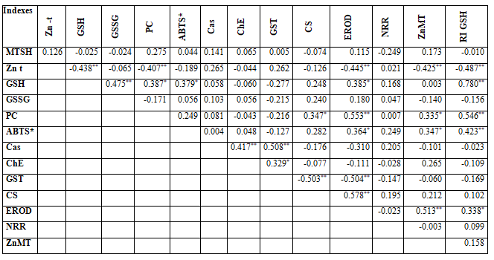
Note. r = 0.288 (p = 0.05); r = 0.372 (p= 0.01) (N = 40). * - Significant сorrelation > 0.05; ** - Significant сorrelation > 0.01 (2-tailed).
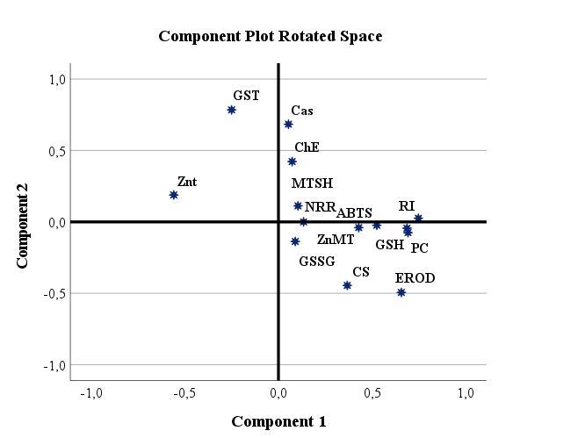A AABBB
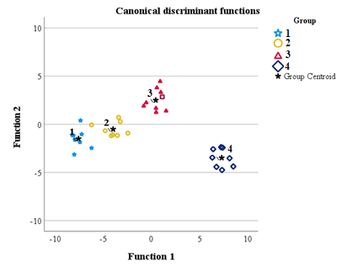B
Fig. 3.8. Principal Component Analysis (PCA) was conducted to explore the interrelationships among the measured parameters (A). To differentiate between the exposed groups, scatter plots of the canonical values along the first two canonical discriminant axes were utilized (B): experimental groups included control group (1); groups exposed to glyphosate (2), glyphosate and chlorpromazine (3), and chlorpromazine (4) for a 14-day duration
Pearson correlation analysis of measured biochemical parameters in a model organism U. tumidus across all experimental groups (Table 3.7) uncovered numerous interdependence among all parameters. Thus, oxidative stress markers and reduced GSH exhibited the most extensive network of correlations. Specifically, GSH, PC, and ABTS* showed positive correlations, including their interrelationships with Zn-MT, EROD and CS. Conversely, MT and NRR displayed no significant correlations. Zn-t was characterized solely by negative correlations, including its relationships with other zinc-related parameters (Zn-MT and GSH), as well as PC and EROD. Notably, the biotransformation enzymes EROD and GST were negatively correlated, while GST, ChE, and caspase-3 formed a cluster of positive association.
Canonical discriminant analysis effectively differentiated the experimental groups, with perfect classification of the C-, Mix -, and Cz-groups and 75% accuracy for the Glp-groups. Figure 3.8 B reveals a clear separation on the first discriminant axis between the control (C-) and Glp-groups, and the contrasting Cz-group. Interestingly, the groups exposed to combined treatments (Mix) were positioned between these extremes along axis 1 and showed similar locations along axis 2, suggesting a combined effect of the exposures on the discriminant variables.
Moreover, biological responses were integrated calculating Integrated biological response (IBR coefficient) that was obtained by adding the standardized values of each biomarker (IBR = ΣAi) and dividing by the biomarkers number used (IBR/n) [7]. Thus IBR reflected the overall biological response relative to the control, yielded the following values: 1.84 (Cz-), 0.54 (Glp-), and 1.71 (Mix-). The highest overall responses, as indicated by IBR/n, were observed in the Mix- and Cz-groups, which also showed the most consistent increases in the magnitude of change (A values) for the measured parameters (Fig. 3.9). Zn-MT consistently played the largest role in the IBR/n across all groups. Interestingly, the Cz group displayed changes in A values opposite to those seen in other groups for multiple indices. In contrast, the Glp-group generally showed smaller changes compared to the control for most indices, except for Zn-MT and GSH.
It demonstrated that exposure to chlorpromazine and its combination with glyphosate resulted in the most substantial biological effects, with Zn-MT and EROD being key contributors (Fig. 3.9). This integrated analysis enabled the identification of both specific and common response patterns and the assessment of their strength.
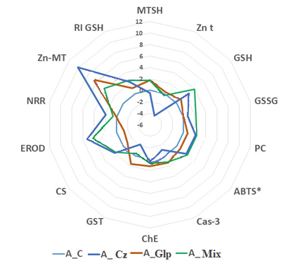
Fig. 3.9. Biomarker star plots (Ai variables) of multiple biomarker responses of U. tumidus exposed to chlorpromazine (Cz), glyphosate (Glp), and glyphosate-chlorpromazine (Mix) during 14 days compared to control values considered as zero values (C)
In summary, discriminant analysis showed that the Glp-group exhibited the least distinction from the control, suggesting that the concentration 36nM had a minimal effect. The Cz-group displayed the greatest difference (Fig. 3.8). Notably, the combined exposure groups (Mix-) elicited similar responses. However, each groups also showed unique individual effects.
Chlorpromazine's antagonism of calcium-dependent processes is expected to impact zinc homeostasis, as zinc can enter cells via calcium channels [23, 61]. Although the direct impact of chlorpromazine on zinc uptake is largely unknown, our study revealed a reduction in zinc uptake in Cz-treatment groups (Fig. 3.4 C). Significantly, in our study, a 36 nM concentration of glyphosate alone did not alter zinc levels. Furthermore, higher concentrations of glyphosate also showed no change [27].
In contrast to the Glp-group, the observed zinc depletion in the Cz-group might be a specific response to the pharmaceutical, potentially resulting from the blockage of zinc uptake transporters and channels [9, 23]. This specific effect of pharmaceuticals on mollusks is further supported by the presence of a dopamine D1-like receptor in the tissue of the freshwater species Helisoma duryi [23]. However, this chlorpromazine-induced zinc depletion was not evident in our study when U. tumidus was exposed to a combination of glyphosate and chlorpromazine.
The increased accumulation of Zn in MT was a common observation (Fig. 3.4B), but its ability to chelate Zn in thiolate clusters depend on the redox state of thiols [31]. In this study, the rise in Zn-MT was positively correlated with total antioxidant activity, measured by Radical Scavenging Assay (ABTS*) and redox state of thiols (GSH levels) (Table 3.7). Notably, the loss of MT metalation is often associated with multiple signs of toxicity. For instance, in our recent study [27], exposure to 33.6 µg/L of glyphosate led to a depletion of Zn-MT, accompanied by reduced ChE and GST activities, compromised lysosomal integrity, and an increase in GSSG levels. However, in this study, signs of toxicity were nearly absent, suggesting that low molecular weight thiols are effective biochemical drivers providing redox power during low-level toxicity exposures.
Information about how glyphosate and chlorpromazine are metabolized by phase I and II enzymes is limited and often inconsistent. Pesticide formulations that contain phosphonates are known to lower CYP450 enzyme levels in mammals [40]. In particular, when rats were given glyphosate in their drinking water, EROD enzyme activity decreased in males [40]. There is a noted lack of research focused on understanding how tricyclic drugs with antipsychotic action behave in the environment. However, it has been predicted based on in silico research data that chlorpromazine can enter water systems through wastewater discharge and persist in the environment, potentially leading to bioaccumulation and transformation into more toxic metabolites. Moreover, the in silico analysis using tools like BioTransformer 3.0 has provided valuable insights into the Phase I biotransformation reactions of chlorpromazine. The most prevalent reactions include N-dealkylation, aromatic hydroxylation, and aliphatic hydroxylation, with CYP1A2 and CYP2B6 being major cytochrome P450 isoforms involved. These transformations can influence the drug’s environmental persistence and toxicity. Additionally, the drug-likeness and Blood-Brain Barrier (BBB) scores indicate that many of the metabolites of chlorpromazine retain drug-like properties and have the potential to cross the BBB, suggesting possible central nervous system effects. However, the relatively low BBB scores for some metabolites raise concerns about their ability to reach the CNS effectively.
Chlorpromazine has consistently failed to degrade in standard biodegradation tests using aquatic bacteria, and thus is classified as non-biodegradable [25, 56] and also was proven by computational modeling prediction suggesting degradation with a biodegradability value of 0 (Table 3.6.). However, its transformation products have been identified using advanced mass spectrometry techniques [56]. In the current study, the rise in EROD activity was not an isolated occurrence. A strong relationship between EROD activity and various markers of antioxidant defense, metabolic function, and zinc-metallothionein (Zn-MT) suggests that this increase is part of a coordinated protective response (Fig. 3.4 A).
In this and other studies involving aquatic animals from polluted environments or exposed to various substances, GST activity did not show a correlation with EROD activity [11]. A reduction or lack of GST activity has been observed in molluscs exposed to higher concentrations of glyphosate. Conversely, GST activation has been noted in Sertoli cells from the testes of rats treated with glyphosate [27, 38]. In the current study, a notable decrease in GST activity was one of the most distinct responses observed following chlorpromazine exposure, a finding that has also been demonstrated in vitro [57]. Among the tested drugs, chlorpromazine proved to be the most effective inhibitor of the GST enzyme. Therefore, the reduction in both GST and zinc levels seen in our study may represent specific effects of this drug. However, these effects were no longer present when glyphosate and chlorpromazine were administered together in Mix-group.
In this study, GST activity was aligned with changes in ChE and caspase-3 (Table 3.7). GST and ChE are often studied together as valuable biomarkers in molluscs [11]. While high glyphosate levels and short-term organophosphate exposure usually suppress ChE, its increase in our study may indicate a non-toxic glyphosate dose. In vertebrates, concurrent rises in ChE and caspase-3 have been linked to apoptosis [64], a pattern also observed in invertebrates like Locusta migratoria [30] and freshwater mussels exposed to stressors [27]. However, the coordinated changes in GST, ChE, and caspase-3 in our study suggest an exposure-specific response, unlike EROD, which appears part of a general stress reaction.
Toxicological predictions using in silico approach highlight significant concerns, particularly with cytotoxicity, neurotoxicity, nephrotoxicity, and moderate hepatotoxicity, making it important to assess potential risks in both environmental and clinical contexts (Fig. 3.2). In contrast in vitro approach based in the analysis of each biomarker confirmed that the xenobiotic concentrations used were low enough to avoid clear signs of cellular toxicity. The observed antioxidant activation and metabolic changes suggest a mild stimulatory, or hormetic response [33]. It was supported by results from the ABTS* assay and CS activity. A moderate increase in protein carbonylation may have served as a signal to trigger antioxidant defenses. Similarly, EROD activation may contribute to this response, particularly through the role of low-molecular-weight thiols. Strong correlations were observed among EROD, CS, ABTS*, Zn-MT, GSH, RI GSH (Table 3.7).
In molluscs, destabilization of the lysosomal membrane is a recognized indicator of toxicity [24]. In this study, U. tumidus exposed to chlorpromazine showed improved lysosomal stability – an unusual effect also reported with the calcium channel blocker nifedipine [27]. Both compounds may influence lysosomal function through calcium-related mechanisms. Studies have shown that lysosomal and late endosomal pH remains stable in the presence of cationic amphiphilic drugs, including chlorpromazine, even with prolonged exposure [23].
In conclusion, while chlorpromazine’s therapeutic benefits are well-established, its environmental persistence, potential for bioaccumulation, and toxicological risks necessitate further investigation and risk mitigation strategies. This study highlights the need for more comprehensive environmental monitoring to minimize the ecological impact of pharmaceutical pollutants, particularly when combined with other xenobiotics such as pesticides.

CONCLUSIONS
The applied low subchronic exposures to widespread aquatic pollutants (pharmaceuticals and herbicides) allowed indicating common and specific biochemical response in the sentinel aquatic invertebrate species.
- GSH levels increased in all groups except glyphosate (Glp), with the combined exposure to chlorpromazine and glyphosate (Mix) showing a 2-fold increase. GSSG also increased in the Mix-group, raising the GSH:GSSG ratio by 36–39% almost in all groups. Glyphosate-containing treatments elevated metallothionein (MT) levels (up to 58%), while chlorpromazine (Cz) had no effect. Total zinc concentration decreased and Zn bound to MT (Zn-MT) increased in groups exposed to chlorpromazine. These findings indicate disrupted metal homeostasis, varying by treatment.
- All treatments significantly increased antioxidant activity (ABTS* scavenging), with chlorpromazine showing the highest (1.5-fold) and glyphosate the lowest (1.2-fold) increase. Protein oxidation rose significantly in all groups, exept glyphosate action alone. Lipid peroxidation also increased modestly (6.9%–16.3%) across all groups.
- In silico studies showed that chlorpromazine can enter water systems via wastewater, persist in the environment, and potentially bioaccumulate or transform into more toxic. It also revealed key Phase I biotransformation reactions: N-dealkylation, aromatic and aliphatic hydroxylation, mainly mediated by CYP1A2 and CYP2B6. Moreover, in vitro study demonstrated that exposure to nearly all the investigated factors induced a remarkably strong activation of EROD ranging from 116% to 192%, except of glyphosate.
- Cz exposure notably reduced GST activity and zinc levels, suggesting drug-specific effects. However, these changes disappeared in the combined glyphosate–chlorpromazine (Mix) group. GST activity also positively correlated with changes in ChE and caspase-3 acivity.
- Toxicological predictions using in silico approach highlight significant concerns, particularly with cytotoxicity, neurotoxicity, nephrotoxicity, and moderate hepatotoxicity, making it important to assess potential risks in both environmental and clinical contexts. In contrast in vitro approach based on the biomarkers analysis confirmed that the environmental relevant concentration of chlorpromazine and glyphosate used were low enough to avoid clear signs of cellular toxicity. The results showed that lysosomal integrity increased in the Cz-group by 17.0% and remained unchanged in the other experimental groups. While high glyphosate levels and short-term organophosphate exposure usually suppress ChE, its increase in our study may indicate a non-toxic glyphosate dose.
- Assessment of caspase-3 activity in the mollusk digestive gland indicates its selective sensitivity to the applied factors. Consequently, glyphosate (by 36.3%) and the mixture significantly increased caspase-3 activity (by 36.4%), while other treatments had no effect.
- Citrate synthase activity, used to assess metabolic status, increased with all treatments except glyphosate alone. Chlorpromazine triggered the highest rise (44.2%), highlighting its strong impact on mitochondrial energy production.
- The integrated analysis (IBR calculations and Discriminant analysis) underscored the value of multi-biomarker approaches in assessing response strength and specificity. Exposure to chlorpromazine and its combination with glyphosate resulted in the most substantial biochemical effects, with Zn-MT and EROD being key contributors. Discriminant analysis showed that the glyphosate-group exhibited the least distinction from the control, suggesting a minimal effect, while Cz-group displayed the greatest difference. Notably, the combined exposure group (Mix) elicited similar responses.

REFERENCES
- Alkimin G. D., Daniel D., Frankenbach S., Serôdio J., Soares A. M. V. M., Barata C., Nunes B. Evaluation of pharmaceutical toxic effects of non-standard endpoints on the macrophyte species Lemna minor and Lemna gibba. Science of the Total Environment. 2019. Vol. 657. P. 926–937.
- Alkimin G. D., Nunes B., Soares А. M. V. M., Bellot М., Gómez-Canela C., Barata C. Daphnia magna responses to fish kairomone and chlorpromazine exposures. Chemico-Biological Interactions. 2020. Vol. 325, 109123.
- Amid C., Olstedt M., Gunnarsson J. S., Le Lan H., Tran Thi Minh H., Van den Brink P. J., Hellström M., Tedengren M., Additive effects of the herbicide glyphosate and elevated temperature on the branched coral Acropora Formosa in Nha Trang, Vietnam. Environmental Science and Pollution Research. 2018. Vol. 25. P. 13360–13372.
- Atama C. I., Nnaji E. C., Christian Ezeoyili I., Udeani F. O., Onovo C. J., Ike Ossai N., Oscar Aguzie I., Nwani C. D. Neuromodulatory and oxidative stress evaluations in African catfish Clarias gariepinus exposed to antipsychotic drug chlorpromazine. Drug and Chemical Toxicology. 2022. Vol. 45, no. 3. P. 1318–1324.
- Baresel C., Palm Cousins A., Hörsing M., Ek M., Ejhed H., Allard A. S., Magnér J., Westling K., Wahlberg C., Fortkamp U., Söhr S. Pharmaceutical residues and other emerging substances in the effluent of sewage treatment plants. IVL Swedish Environmental Research Institute. 2015. Report B, 2226.
- Bebianno M. J., Mello A. C. P., Serrano M. A. S., Flores-Nunes F., Mattos J. J., Zacchi F. L., Melo C. M. R. Transcriptional and cellular effects of paracetamol in the oyster Crassostrea gigas. Ecotoxicology and Environmental Safety. 2017. Vol. 144. P. 258–267.
- Beliaeff B., Burgeot T. Integrated biomarker response: a useful tool for ecological risk assessment. Environmental Toxicology and Chemistry. 2002. Vol. 21. P. 1316–1322. https://doi.org/10.1002/etc.5620210629
- Bonomini M., Dottori S., Amoroso A., Arduini A., Sirolli V. Increased platelet phosphatidylserine exposure and caspase activation in chronic uremia. Journal of Thrombosis and Haemostasis. 2004. Vol. 2. P. 1275–1281.
- Bouron A., Oberwinkler J. Contribution of calcium-conducting channels to the transport of zinc ions. Pflügers Archiv - European Journal of Physiology. 2014. Vol. 466, no. 3. P. 381–387.
- Dai J., Zhang S., Lin H., Qiao J.-Q., Lian H.-Z., Xu C.-X. Targeted and non-targeted metabolic analysis of chlorpromazine in grass carp as well as the in-silico and metabolomics toxicity assessment. Journal of Hazardous Materials. 2025. Vol. 487, 137195.
- Domingues I., Agra A. R., Monaghan K., Soares A. M., Nogueira A. J. Cholinesterase and glutathione-S-transferase activities in freshwater invertebrates as biomarkers to assess pesticide contamination. Environmental Toxicology and Chemistry. 2010. Vol. 29, P. 5–18.
- El Haj Y., Bohn S., Souza M. M. Tolerance of native and invasive bivalves under herbicide and metal contamination: an ex vivo approach. Environmental Science and Pollution Research. 2019. Vol. 26. P. 31198–31206.
- Ellman G. L., Courtney K. D., Andres V. J., Featherstone R. M. A new and rapid colorimetric determination of acetylcholinesterase activity. Biochemical Pharmacology. 1961. Vol. 7. P. 88–90.
- Escudero J., Muñoz J. L., Morera-Herreras T., Hernandez R., Medrano J., Domingo-Echaburu S., Barceló D., Orive G., Lertxundi U. Antipsychotics as environmental pollutants: An underrated threat? Science of the Total Environment. 2021. Vol. 769, 144634.
- Feng S., Zhang Y., Gao F., Li M., Zhu L., Wen H., Xi Y., Xiang X. Inhibitory effects of antipsychotic chlorpromazine on the survival, reproduction and population growth other than neurotransmitters of zooplankton in light of global warming. International Journal of Environmental Research and Public Health. 2022. Vol. 19, no. 23. 16167.
- Ficarra S., Russo A., Barreca D., Giunta E., Galtieri A., Tellone E. Short-term effects of chlorpromazine on oxidative stress in erythrocyte functionality: activation of metabolism and membrane perturbation. Oxidative Medicine and Cellular Longevity. 2016. Vol. 2016, 2394130.
- Frédéric O., Yves P. Pharmaceuticals in hospital wastewater: their ecotoxicity and contribution to the environmental hazard of the effluent. Chemosphere. 2014. Vol. 115. P. 31–39.
- Gad E. M., Nafe M. S., Eltamany E. H., Hammad M. S. A. G., Barakat A., Boraei A. T. A. Discovery of new apoptosis-inducing agents for breast cancer based on ethyl 2-amino-4,5,6,7-tetra hydrobenzo[b]thiophene-3-carboxylate: synthesis, in vitro, and in vivo activity evaluation. Molecules. 2020. Vol. 25, 2523.
- Giménez V., Nunes B. Effects of commonly used therapeutic drugs, paracetamol, and acetylsalicylic acid, on key physiological traits of the sea snail Gibbula umbilicalis. Environmental Science and Pollution Research. 2019. Vol. 26. P. 21858–21870.
- Gnatyshyna L., Khoma V., Mishchuk O., Martinyuk V., Spriņģe G., Stoliar O. Multi-marker study of the responses of the Unio tumidus from the areas of small and micro hydropower plants at the Dniester River Basin, Ukraine. Environmental Science and Pollution Research. 2020. Vol. 27. P. 11038–11049.
- Griffith O. W. Determination of glutathione and glutathione disulfide using glutathione reductase and 2-vinylpyridine. Analytical Biochemistry. 1980. Vol. 106. P. 207–212.
- Habig W. H., Pabst M. J., Jakoby W. B. Glutathione S-transferases. The first enzymatic step in mercapturic acid formation. Journal of Biological Chemistry. 1974. Vol. 249. P. 7130–7139.
- Hamaguchi R., Haginaka J., Tanimoto T., Kuroda Y. Maintenance of luminal pH and protease activity in lysosomes/late endosomes by vacuolar ATPase in chlorpromazine-treated RAW264 cells accumulating phospholipids. Cell Biology and Toxicology. 2014. Vol. 1. P. 67–77.
- Izagirre U., Errasti A., Bilbao E., Múgica M., Marigómez I. Combined effects of thermal stress and Cd on lysosomal biomarkers and transcription of genes encoding lysosomal enzymes and HSP70 in mussels, Mytilus galloprovincialis. Aquatic Toxicology. 2014. Vol. 149. P. 145–156.
- Jiménez J. J., Muñoz B. E., Sánchez M. I., Pardo R., Vega M. S. Fate of the drug chlorpromazine in river water according to laboratory assays. Identification and evolution over time of degradation products. Sorption to sediment. Chemosphere. 2016. Vol. 162. P. 285–292.
- Khoma V., Martinyuk V., Matskiv T., Gnatyshyna L., Baranovsky V., Gladiuk M., Gylytė B., Manusadži.anas L, Stoliar O. Environmental concentrations of Roundup in combination with chlorpromazine or heating causes biochemical disturbances in the bivalve mollusc Unio tumidus. Environmental Science and Pollution Research. 2022. Vol. 29, no. 10. P. 14131--14142.
- Khoma V., Gnatyshyna L., Martinyuk V., Mackiv T., Mishchenko L., Manusadžianas L., Stoliar O. Common and particular biochemical responses of Unio tumidus to herbicide, pharmaceuticals and their combined exposure with heating. Ecotoxicology and Environmental Safety. 2021. Vol. 208, 111695.
- Khoma V. V., Gnatyshyna L. L., Martinyuk V. V., Mackiv T. R., Mishchuk N. Y., Stoliar O. Metallothioneins contribution to the response of bivalve mollusk to xenobiotics. Ukrainian Biochemical Journal. 2020. Vol. 92. P. 87–96.
- Klotz A. V., Stegeman J. J., Walsh C. An alternative 7-ethoxyresorufin o-deethylase activity assay: A continuous visible spectrophotometric method for measurement of cytochrome P-450 monooxygenase activity. Analytical Biochemistry. 1984. Vol. 140. P. 138–145.
- Knorr D. Y., Georges, N. S., Pauls S., Heinrich R. Acetylcholinesterase promotes apoptosis in insect neurons. Apoptosis. 2020. Vol. 25. P. 730–746.
- Krężel A., Maret W. The biological inorganic chemistry of zinc ions. Archives of Biochemistry and Biophysics. 2016. Vol. 611. P. 3–19.
- Krstić M., Sovilj S. P., Borozan S., Rančić M., Poljarević J., Grgurić-Šipka S. N-alkylphenothiazines-synthesis, structure and application as ligands in metal complexes. Hemijska industrija. 2016. Vol. 70, no. 4. P. 461–471.
- Lefcort H., Freedman Z., House S., Pendleton M. Hormetic effects of heavy metals in aquatic snails: is a little bit of pollution good? EcoHealth. 2008. Vol. 5, 10.
- Li T., Zhou Q., Zhang N., Luo Y. Toxic effects of chlorpromazine on Carassius auratus and its oxidative stress. Journal of Environmental Science and Health, Part B. 2008. Vol. 43, no. 8. P. 638–643.
- Louis F., Rocher B., Barjhoux I., Bultelle F., Dedourge-Geffard O., Gaillet V., Bonnard I., Delahaut L., Pain-Devin S., Geffard A., Paris-Palacios S., David E. Seasonal monitoring of cellular energy metabolism in a sentinel species, Dreissena polymorpha (bivalve): effect of global change? Science of the Total Environment. 2020. Vol. 725, 138450.
- Lowry O. H., Rosebroungh H. J., Farr A. L., Randall R. J. Protein measurement with folin phenol reagent. Journal of Biological Chemistry. 1951. Vol. 193. P. 265–275.
- Matozzo V., Fabrello J., Marin M. G. The effects of glyphosate and its commercial formulations to marine invertebrates: a review. Journal of Marine Science and Engineering. 2020. Vol. 8, 399.
- Matozzo V., Munari M., Masiero L., Finos L., Marin M. G. Ecotoxicological hazard of a mixture of glyphosate and aminomethylphosphonic acid to the mussel Mytilus galloprovincialis (Lamarck 1819). Scientific Reports. 2019. Vol. 9, 14302.
- Mertens M., Höss S., Neumann G., Afzal J., Reichenbecher W. Glyphosate, a chelating agent – relevant for ecological risk assessment? Environmental Science and Pollution Research. 2018. Vol. 25. P. 5298–5317.
- Mesnage R., Antoniou M. N. Facts and fallacies in the debate on glyphosate toxicity. Frontiers in Public Health. 2017. Vol. 24. P. 316–323.
- Miller T. H., Ng K. T., Bury S. T., Bury S. E., Bury N. R., Barron L. P. Biomonitoring of pesticides, pharmaceuticals and illicit drugs in a freshwater invertebrate to estimate toxic or effect pressure. Environment International. 2019. Vol. 129. P. 595–606.
- Nałęcz-Jawecki G., Hajnas A., Sawicki J. Photodegradation and phototoxicity of thioridazine and chlorpromazine evaluated with chemical analysis and aquatic organisms. Ecotoxicology. 2008. Vol. 17. P. 13–20.
- Nelson M., Adams T., Ojo C., Carroll M. A., Catapane E. J. Manganese toxicity is targeting an early step in the dopamine signal transduction pathway that controls lateral cilia activity in the bivalve mollusc Crassostrea virginica. Comparative Biochemistry and Physiology Part C: Pharmacology, Toxicology and Endocrinology. 2018. Vol. 213. P. 1-6.
- Ohkawa H., Ohishi N., Yagi K. Assay for lipid peroxides in animal tissues by thiobarbituric acid reaction. Analytical Biochemistry. 1979. Vol. 95, no. 2. P. 351–358.
- Oliveira L. L. D., Antunes S. C., Gonçalves F., Rocha O., Nunes B. Evaluation of ecotoxicological effects of drugs on Daphnia magna using different enzymatic biomarkers. Ecotoxicology and Environmental Safety. 2015. Vol. 119. P. 123–131.
- Omotola E. O., Genthe B., Ndlela L., Olatunji O. S. Environmental risk characterization of an antiretroviral (ARV) lamivudine in ecosystems. International Journal of Environmental Research and Public Health. 2021. Vol. 18, no. 16, 8358.
- Plaze M., Attali D., Petit A.-C., Blatzer M., Simon-Loriere E., Vinckier F., Cachia A., Chrétien F., Gaillard R. Repurposing chlorpromazine to treat COVID-19: the reCoVery study. L'Encéphale. 2020. Vol. 46. P. 169–172.
- Re R., Pellegrini N., Proteggente A., Pannala A., Yang M., Rice-Evans C. Antioxidant activity applying an improved ABTS radical cation decolorization assay. Fee Radical Biology and Medicine. 1999. Vol. 26. P. 1231–1237.
- Reznick A.Z., Packer L. Oxidative damage to proteins: spectrophotometric method for carbonyl assay. Methods in Enzymology. 1994. Vol. 233. P. 357–363.
- Roesijadi G., Fowler B. Purification of invertebrate metallothioneins. Methods in Enzymology. 1991. Vol. 205 B. P. 263–273.
- Romero A., Estévez-Calvar N., Dios S., Figueras A., Novoa B. New insights into the apoptotic process in mollusks: characterization of caspase genes in Mytilus galloprovincialis. PLoS ONE. 2011. Vol. 6, no. 2, e17003.
- Séguin A., Mottier A., Perron C., Lebel J. M., Serpentini A., Costil K. Sub-lethal effects of a glyphosate-based commercial formulation and adjuvants on juvenile oysters (Crassostrea gigas) exposed for 35 days. Marine Pollution Bulletin. 2017. Vol. 117, no. 1-2. P. 348–358.
- Sharma K., Thakur I. S., Kaushik G. Occurrence and distribution of pharmaceutical compounds and their environmental impacts: A review. Bioresource Technology Reports. 2021. Vol. 16, 100841.
- Stip E., Rizvi T.A., Mustafa F., Javaid S., Aburuz S., Ahmed N.N., Abdel Aziz K, Arnone D., Subbarayan A., Al Mugaddam F., Khan G. The large action of chlorpromazine: translational and transdisciplinary considerations in the face of COVID-19. Frontiers in Pharmacology. 2020. Vol. 11, 577678.
- Stoliar O. B., Lushchak V. I. Environmental pollution and oxidative stress in fish. Oxidative Stress - Environmental Induction and Dietary Antioxidants / ed. by V. I. Lushchak : In: IntechOpen, 2012. P. 131–166.
- Trautwein C., Kümmerer K. Degradation of the tricyclic antipsychotic drug chlorpromazine under environmental conditions, identification of its main aquatic biotic and abiotic transformation products by LC-MSn and their effects on environmental bacteria. Journal of Chromatography B: Analytical Technologies in the Biomedical and Life Sciences. 2012. Vol. 889–890. P. 24–38.
- Türkan F., Calimli M. H., Kanberoğlu G. S., Karaman M. Inhibition effects of isoproterenol, chlorpromazine, carbamazepine, tamoxifen drugs on glutathione S-transferase, cholinesterases enzymes and molecular docking studies. Journal of Biomolecular Structure and Dynamics. 2021. Vol. 39, no. 9. P. 3277–3284.
- Viarengo A., Ponzano E., Dondero F., Fabbri R. A simple spectrophotometric method for metallothionein evaluation in marine organisms: an application to Mediterranean and Antarctic molluscs. Marine Environmental Research. 1997. Vol. 44. P. 69–84.
- Wang J., Niu Y., Zhang C., Chen Y. A micro-plate colorimetric assay for rapid determination of trace zinc in animal feed, pet food and drinking water by ion masking nd statistical partitioning correction. Food Chemistry. 2018. Vol. 245. P. 337–345.
- Water temperature in the Dniester River. URL: https://seatemperature.net/current/ukraine/dnestrovskiiy-kanon-ukraine-sea-temperature (date of access: 15.02.2024).
- Xu B., Xu Z. F., Deng Y., Yang J. H. Protective effects of chlorpromazine and verapamil against cadmium-induced kidney damage in vivo. Experimental and Toxicologic Pathology. 2010. Vol. 62. P. 27–34.
- Yang J. L., Li Y. F., Bao W. Y., Satuito C. G., Kitamura H. Larval metamorphosis of the mussel Mytilus galloprovincialis Lamarck, 1819 in response to neurotransmitter blockers and tetraethylammonium. Biofouling. 2011. Vol. 27. P. 193–199.
- Yuan S., Jiang X., Xia X., Zhang H., Zheng S. Detection, occurrence and fate of 22 psychiatric pharmaceuticals in psychiatric hospital and municipal wastewater treatment plants in Beijing, China. Chemosphere. 2012. Vol. 90, no 10. P. 2520–2525.
- Zhang X-J., Greenberg D. S. Acetylcholinesterase involvement in apoptosis. Frontiers in Molecular Neuroscience. 2012. Vol. 5, 40.
- Zhu X., Luo T., Wang D., Zhao Y., Jin Y., Yang G. The occurrence of typical psychotropic drugs in the aquatic environments and their potential toxicity to aquatic organisms - A review. Science of the Total Environment. 2023. Vol. 900, 165732.

